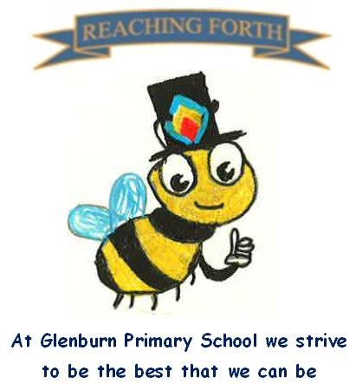

Buzzbee’s news about P4

What are we learning this term?
Maths: Our main focus this term will be ‘Time’. The children will revise telling the time using o’clock, half past and quarter to and past the hour. Minutes past and to the hour, durations and 24-hour clock will also be introduced. Pupils will learn the 7 times table and link this with division. They will revise all multiplication tables to ensure accuracy and recall for moving into Primary 5. These facts will be applied to help identify, continue and create number patterns. We will also investigate volume, tiling, weight, probability and some work in small groups to solve problem solving activities.
Literacy: In phonics we will look at prefixes and suffixes. We will continue to practise all the phonemes covered so far in primary 4 to consolidate reading and spelling. In reading, we will read more aloud and focus on using expression and an awareness of punctuation such as commas etc. Children will continue to have the opportunity to read for 10 minutes every day, and this should be encouraged at home and during the weekend / holidays to build up their confidence and fluency. This term we will be focusing on writing both descriptive and imaginative pieces through our topic of the Romans by applying what we have learned to create exciting texts of our own.

Interdisciplinary Topic: This term, the children will be learning about Romans. We will look at the history of the Romans and different aspects of their life. Furthermore, the children will produce some really eye-catching artwork.
School Trips This term the class will visit Dumfries House and The Farm Park. Further details to follow,
R.M.E: In our final term, our focus for RME is special buildings. We will look at the features of a Synagogue and Mosque.

Things to remember:
Dates to Remember – please refer to the school newsletter for ‘dates for the diary.’
Home Learning – Homework will be issued on a Friday and collected on a Wednesday.

School Uniform: Children are required to wear school uniform, please ensure items are labelled to reduce clothes getting mixed up.
‘X’ (formerly) Twitter: Follow our page @glenburnprimary for updates

P.E
P4S – Monday and Thursday
P4R – Monday and Friday
Please note, our focus this term will be field games and athletics.
In term 4, we try to take gym outdoors as much as possible. Please ensure your child has appropriate footwear.

