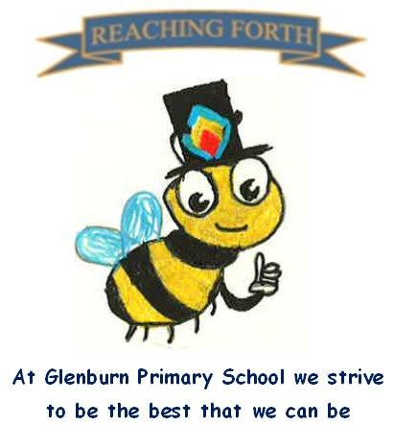

Buzzbee’s news about P3

What are we learning this term?
Maths: Pupils will continue to revise the 2,3,4,5,6 and 10 times table and related division facts. The children will also be learning about patterns and will apply their knowledge of the multiplication tables to continue, solve and create simple number patterns. We will also investigate shape and tiling, probability and area this term.
Literacy:
Phonics: Each week the children will learn a new sound and a set of common words. The children will work on reading and spelling words with the new sound/common words throughout the week.
Reading: This term we will be reading The Owl Who is Afraid of the Dark. We will be using this to answer and create questions and explore new vocabulary. We will also continue to develop our understanding using the comprehension box.
Grammar: We will be learning about commas, pronouns, apostrophes and exclamation marks.
Writing: We will continue to learn about paragraphs and experiment with ways to improve our stories such as varying our sentence openers, adding adjectives and adverbs and using connectives to vary the length of our sentences. During this term we will develop our research and note taking skills and apply these to creating fact files.

Interdisciplinary Topic: This term, the children will be learning about Vikings. We will look at the history of the Vikings and different aspects of their life.
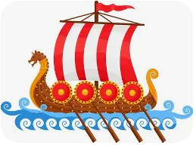

Things to remember:
P.E - Our P.E days will stay the same this term – P3S: Tuesday and Friday, P3I: Thursday and Friday. Please ensure your child has shorts and a different pair of shoes to change in to for P.E, especially when it is indoors P.E.
Water bottles: Children are encouraged to drink water throughout the day. Please remember it should only be water and not diluting juice.
Home Learning – Homework will continue to be given home on a Friday and collected on a Wednesday.
Dates to Remember – please refer to school newsletter and “Dates for your Diary” on the website.

