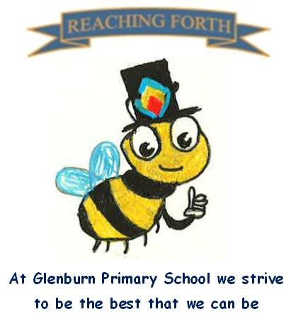

Buzzbee’s news about P2

What are we learning this term?
Maths: Pupils will be developing their skills in time, position and movement and directional language. Our focus is on telling the time (o’clock and half past), measuring area, following and giving instructions using directional language. We will continue to practise our 2, 5- & 10-times tables and division. We will continue to complete daily challenges to improve mental maths speed and agility.
Literacy: Pupils will continue to revise spelling patterns covered in P2. They will develop their reading strategies and grammar skills, such as punctuation, verbs and adjectives. We will also be revisiting all our Stage 2 common words.
In writing, pupils will experience opportunities to write imaginative stories, create information leaflets and fact files.
Interdisciplinary Topic: In Term 4 we will be learning about our local environment, Prestwick Town.

Things to remember:
P.E. - In P.E. we will be developing our athletics skills. Our P.E days this term are Tuesday & Thursday (P2S) and Thursday and Friday (P2M). On these days please ensure your child is dressed appropriately for PE (e.g. school polo, shorts and trainer/gym shoes). When outdoors children may need a hat and sunscreen on sunny days.
Water bottles - Children are encouraged to drink water throughout the day. Please remember it should only be water and not diluting juice. Children can refill their bottles at school.

Home Learning - Reading books and homework will be given home on a Friday and collected on a Wednesday.

Dates to Remember – please refer to school newsletter and “Dates for your Diary” on the website.

