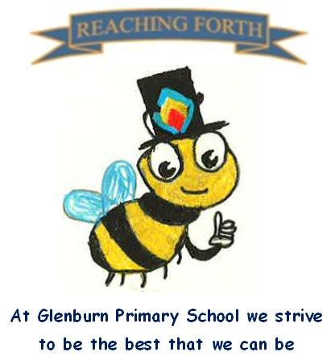
Buzzbee’s news about P1

What are we learning this term?
Literacy and English
We will be focusing on comprehension this term. However, we will continue to practise our diagraph sounds eg. ai, oa, ear. Pupils will also continue to learn new uncommon words and will be encouraged to use these in their independent writing.
In class we will continue to develop our reading skills and discuss books every day. Please ensure your child practises his/her reading at home.

Numeracy and Maths
We will be consolidating addition and subtraction within 20. We will also be exploring measure, money, fractions, symmetry and position and movement.
Numeracy and Maths will continue to be taught through hands on activities, play and discussion.

Interdisciplinary learning
Our topic this term will be ‘The Ocean’. The children chose this topic .

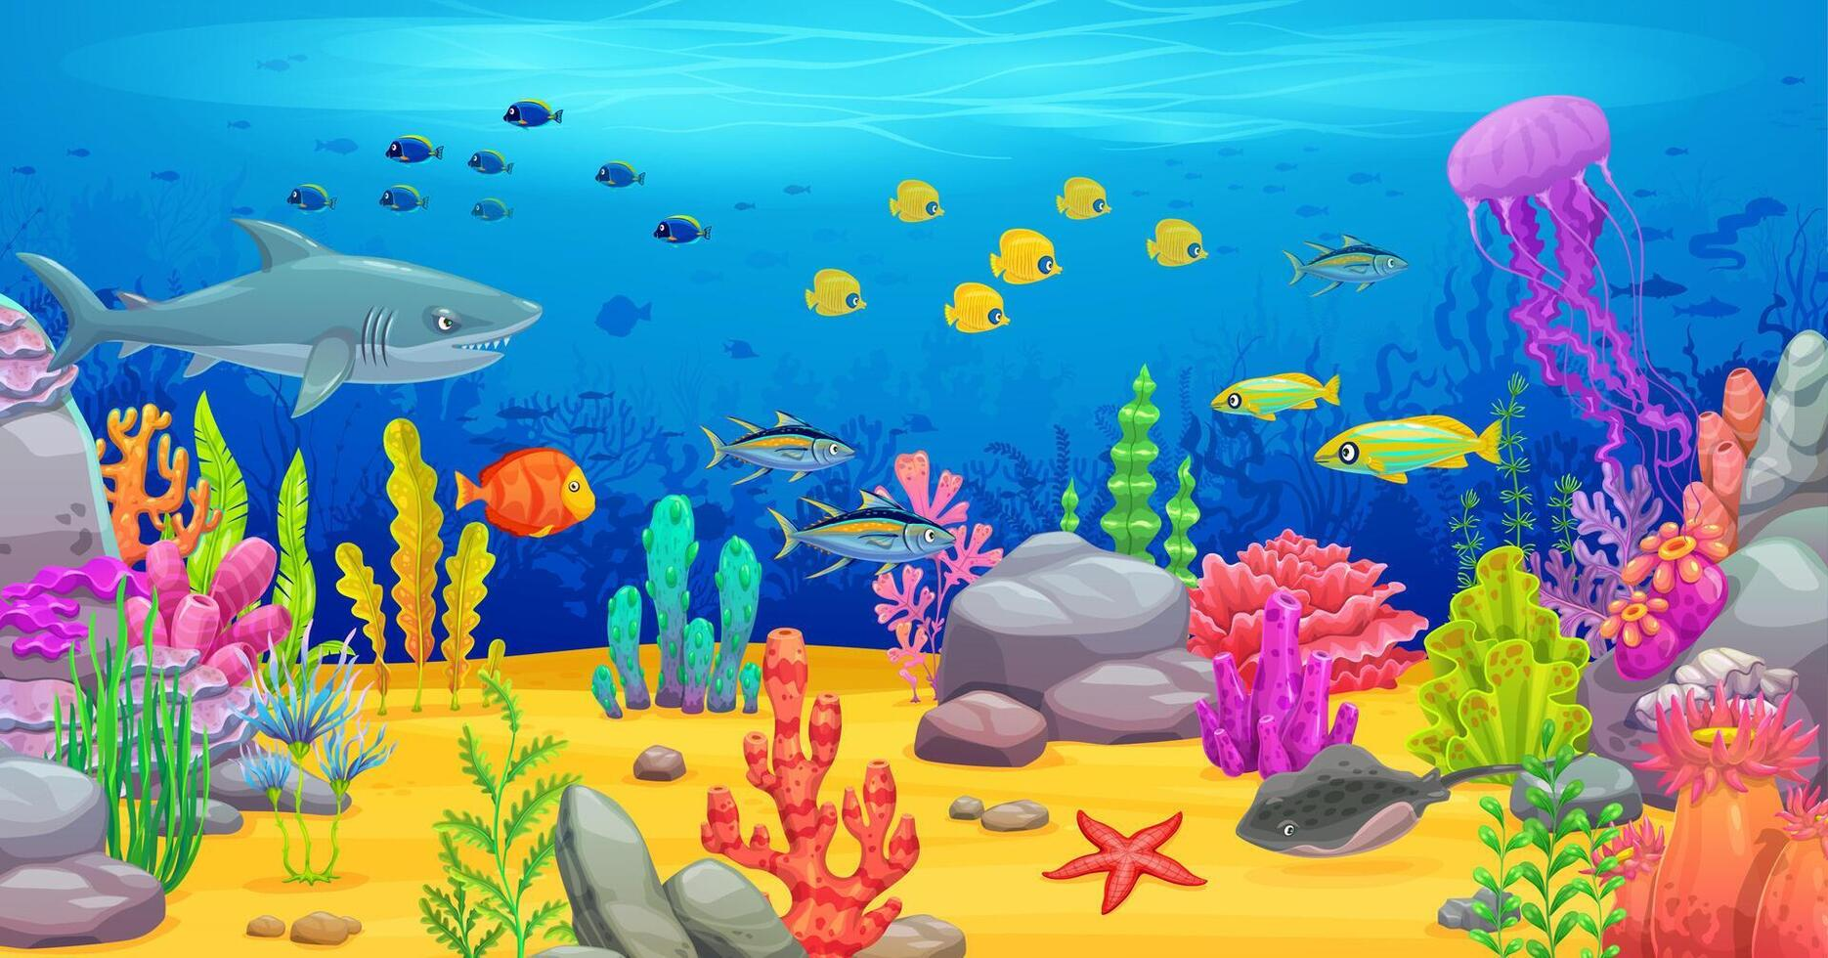
Home-Learning
Home-learning will continue to reinforce the learning completed in class. Children will receive their home-learning on a Friday and should return this on the following Wednesday. Could you please return home learning in the plastic wallet with your child’s reading book .

Things to remember:
PE - Our gym days are: Tuesday and Friday. We may be doing PE outside on our Astroturf pitch this term. Please ensure that your child has sun cream on/ appropriate clothing if need be.
Uniform – please ensure ALL items of clothing are clearly labelled.
Water bottles - children are encouraged to drink water throughout the day. Please remember it should only be water and not diluting juice. Bottles can be refilled at school.
Dates to Remember – please refer to school newsletter and “Dates for your Diary” on the website.

