Buzzbee’s news about P7
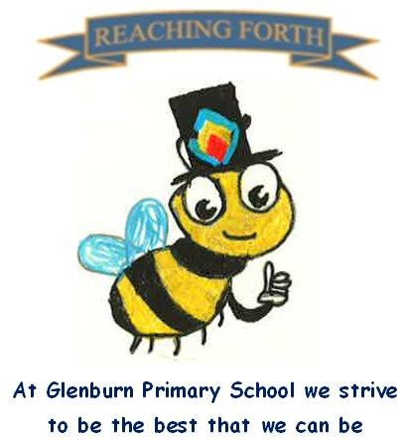

Term 3 - what are we learning this term?
Maths
We will continue to develop our mental maths skills with our daily lesson before our main maths lesson. Upcoming maths topics will include fractions, decimals and percentages, negative numbers, estimation and rounding, multiplication and division, probability, circles and scale. Various maths concepts will also be explored through our STEM topic.
Children are encouraged to continue to practise times tables and other mental strategies at home as often as possible. Much of the maths we learn relies on us knowing the times tables off by heart – please ensure your child knows them inside out and back to front!

Literacy
This term we will be reading a new class novel, ‘Show Us Who You Are’, by Elle McNicoll. This has been set as a transition novel from Prestwick Academy, through which we will explore the themes of ethics, equality, friendship and identity. Pupils will continue to set weekly reading targets for their individual books which will be read at home.
We will be working on more challenging comprehension tasks through the novel and unfamiliar texts. The children will apply their prior learning and skills with increased independence.
Taught Writing lessons will be once a week. This term the writing styles we will focus on are: narrative writing, personal writing and poetry.

Inter-disciplinary learning topic:
Our first topic in Term 3 will be The Rainforest and Icebergs with a particular focus on sustainability, land use and impact. We will then move on to our STEM topic with a focus on electrical circuits.

In RME we will look at the Jewish festival of Purim and how Easter is celebrated around the world.

In PE we will be focusing on badminton and fitness circuits.

Things to remember:
Uniform – Children are expected to come in to school wearing either a shirt and Glenburn tie or a Glenburn polo shirt/jumper.

PE Kits – Children should change at school on PE days.
PE Days – P7M: Wednesday and Friday;
P7A: Tuesday and Wednesday.
Children are expected to wear black or navy shorts or leggings with a polo shirt or white t-shirt. Children are also expected to bring a pair of gym shoes/trainers for PE. Please label all PE kit items. This can be kept in class or brought in on the day.

Home Learning - will be issued on a Friday and should be returned by the following Wednesday. Children are expected to take responsibility for their homework and ensure it is submitted on time and completed to a high standard. Following the long weekend in February, P7 pupils will be given a long term personal project to complete as part of their Home Learning. Details will be given about this in due course.

Water bottles: Children are reminded to bring in a water bottle. Please remember it should only be water and not diluting juice.

Twitter/X – Follow our page @glenburnprimary for updates.
Dates to Remember – please refer to school newsletter and “Dates for your Diary” on the website.

