Buzzbee’s News about P6
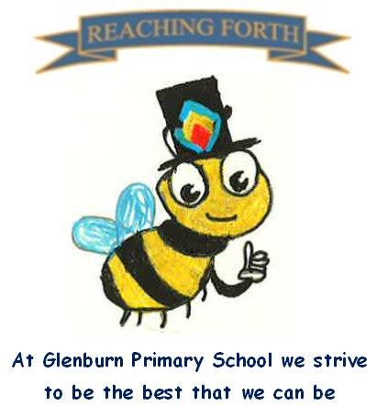

What are we learning this term?

Maths:
Children will be covering a range of mental maths strategies at the beginning of every maths lesson. We will be continuing to work with our mental maths resource ‘SAMSON Maths’ which will reinforce number bonds and number facts. This will be taught at the beginning of maths lessons for 10-20mins.
In Term 3, we will be learning about measurement, BODMAS, co-ordinates, weight, volume, time and will continue extending our understanding of place value, adding and subtraction.

Literacy:
This term we will be focusing on persuasive, explanation, and narrative writing. These genres have clear links to our IDL topic, Flight.
We’re excited to be introducing comprehension tasks in class to help strengthen pupils’ comprehension skills. These activities encourage children to read carefully, use context clues, and think more deeply about the text. We’re also continuing with our Literacy Boxes, which offer levelled tasks to support key reading strategies like inference and prediction. Both resources are helping to build confidence and boost reading skills—and the children are really enjoying the challenge!
We will continue to work on our encoding and decoding skills following the South Ayrshire Reads framework. We will also explore affixes, homophones, and prefixes respectively.

Inter-disciplinary learning topic:
Our topic this term is ‘Flight’. As part of our Flight topic, we’re looking forward to exploring a range of exciting activities, including research tasks, creative tasks, and some plane building to display what we have learned. We’re also excited to learn about Sustainability at the start of term and the importance of renewable energy and its impact on the environment.






Things to remember:

Our behaviour policy:
As a Rights Respecting School, our behaviour policy focuses on our school values. Honesty, Respect, Responsibility, Friendship, Teamwork and Inclusion.

Uniform:
Children are required to wear school uniform every day. PE kits can be kept in class and taken home at the end of each term.

Water bottles:
Children are encouraged to drink water throughout the day. Please remember it should only be water and not diluting juice.

X (Twitter) – Follow our page @glenburnprimary for updates.

Other:
Children are encouraged to continue to practise times tables and other mental strategies at home as much as possible.

P.E. days –
6A - Tuesday and Thursday
6N – Tuesday and Thursday
PE will take place in our big and small gym halls. Please make sure pupils have appropriate clothing and different gym shoes.

Home Learning – We have made changes to our homework days. Home Learning will be given out on a Friday and expected to be submitted on a Wednesday. This should hopefully allow for extra time for homework to be completed at a time that suits all families. Homework will consist of a short Literacy and Maths activity.
We strongly encourage children to read at home. They can share their books with us in class and let us know what they’ve been reading.

