Buzzbee’s News about P5
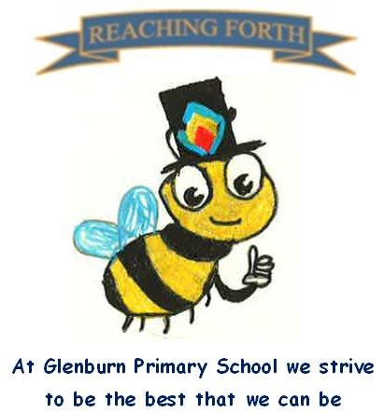

What are we learning this term?

Maths: Children will continue to cover a range of mental maths strategies and there will be a continued focus on Samson Maths during our Numeracy time. This term we will be learning about Data Handling, Algebra, BODMAS , Scale , Perimeter, Area and Weight

Literacy:
Writing: This term we will be focusing on Report, informational, narrative and explanation writing. We will also be touching on other genres as appropriate and our writing will have links to our IDL topic of Space.
Reading: Primary 5 continue to be allocated reading books each week that are read in class with their teacher and read for homework. They will continue to borrow books from the school library each week for ‘Reading for Enjoyment’. This term P5 will begin working on Literacy Boxes. These boxes will help to develop comprehension skills when reading an unknown text.
Spelling:
We are continuing with the SAR programme of spelling, focusing on phonics. Pupils are encoding and decoding words and creating their own word lists.

RME: Pupils will be learning about the Christian celebration of Easter and the Jewish celebration of Passover.

Interdisciplinary Learning: This term we will be doing a short topic on Scotland, looking at the Scottish landscape. We will also be studying Space in our STEM topic.

Primary 5 will be going Swimming to Prestwick Pool every Monday from Monday 12th January until Monday 23rd March inclusive.
Swimming will take the place of one P.E session each week.
Things to remember:
P.E. days –
P5C: Monday and Thursday
P5P: Monday and Thursday
P5S: Thursday and Friday

Home Learning – Homework is given out on a Friday and is due in on the Wednesday of the following week. Pupils should keep their homework in their blue folder.

Uniform and P.E. kit: Children are required to wear school uniform. On P. E days pupils should bring a P.E. kit to change into. Earrings and other jewellery should not be worn for gym.
Water bottles: Children are encouraged to drink water throughout the day. Please remember it should only be water and not diluting juice. They will have the opportunity to refill their bottles in school.
Dates to Remember – Please refer to school newsletter and “Dates for your Diary” on the website

