Buzzbee’s news about P4
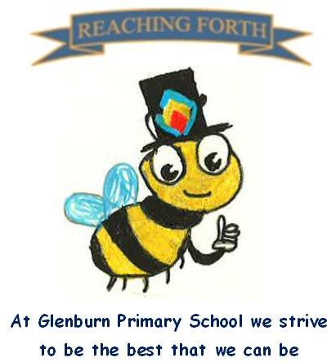

Term 3 - what are we learning this term?
Maths: Children will revise the 3- and 6-times table and learn the 9 times table. These facts will be used when we multiply 2/3-digit numbers with 3, 6 and 9. We will also divide by these numbers. We will be investigating money, fractions, measure and data handling where we will collect information and learn how to display in different formats. Furthermore, we will apply our data handling skills to using Microsoft Excel on the laptops. This term pupils will explore and work together to solve a range of mathematical problems.
Literacy: In spelling we will continue to work through the South Ayrshire Reads Phonics progression. We will learn one new sound each week while revising previously learned sounds. In reading, we will focus on decoding unseen texts which cover various genres and learning to use the text to help answer different types of questions. After the February weekend, we will be studying a class novel to develop our vocabulary and comprehension skills. Children are encouraged to read for enjoyment at home and are also given time each day to do this in school. This term we will be focusing on writing more informative pieces like science reports and instructions.
Interdisciplinary Topic: This term, the children will be doing two topics. For the first half of the term, we will look at our STEM topic which is the Human Body. We will look at how our body works and carry out a variety of cool science experiments to help show this. We will also work in small groups to plan and build 3D models of body parts. In second half of the term, we will learn about farming and the journey of food.
RME: Our RME topic this term is looking at important Spring festivals. The children will be learning more about Easter and Holi.
Music: Primary 4 will continue to receive a weekly music session from Mr Bentley.
Spanish: Mr Martin will continue to teach Primary 4 pupils Spanish.

Things to remember:
Dates to Remember – please refer to the school newsletter for ‘dates for the diary.’
Water bottles: Children are encouraged to drink water throughout the day. Please remember it should only be water and not flavoured water or diluting juice.

Home Learning –Reading books will be given home too. Homework will be issued on a Friday and collected on a Wednesday.

School Uniform: Children are required to wear school uniform, please ensure items are labelled to reduce clothes getting mixed up.
‘X’ (formerly) Twitter: Follow our page @glenburnprimary for updates

P.E
P4R gym days – Monday and Friday
P4S gym days – Monday and Thursday
Please note, our focus this term will be fitness and badminton.
We have noticed that not all children have a gym kit for P.E. It is important for health and safety that all children come appropriately dressed.

Children should have a change of shoes – these should not be the same shoes they wear outside at break and lunch. Again, this is for health and safety reasons.

