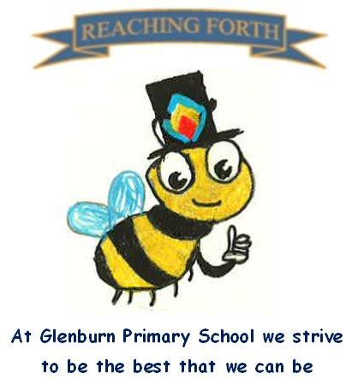

Buzzbee’s news about Primary 3

What are we learning this term?
Maths:
In Term 3 we will be covering multiplication and division. We will also be covering subtraction of two-digit numbers using mental and written methods. In addition, children will be learning about time with a focus on quarter past and quarter to and we will be exploring measurement and weight.

Literacy:
Spelling - Each week the children will learn a new sound and a set of common words. The children will work on reading and spelling words with the new sound/common words throughout the week.
Writing – This term the children will be focusing on improving their writing skills through using a variety of sentence openers, varying lengths of sentences and using a range of connectives. The pupils will also be working on using paragraphs in their writing. In addition to this we will have a look at nonfiction writing such as instructions and reports linked to STEM.
Reading – This term, reading books will be sent home weekly. Reading books should be brought to school each day for working within the class. Please try to read for a short time each night to improve fluency and confidence.

Inter-disciplinary learning topic: This term we will be looking at STEM with a focus on cars. We will look at this in a variety of ways through writing in literacy, and through design and technology. Through our cars topic we will look at sustainability and the benefits of electric cars.

Things to remember:
P.E. - P3I P.E. will be on a Thursday and Friday.
- P3S P.E. will be on a Tuesday and Friday.

Gym clothes can be kept in the classroom. All jewellery should be removed on gyms days. Earrings should either be removed or will be taped on gym days for safety.
Home Learning – Homework will continue be given out on a Friday. Pupils should have a reading book home each night. If this does not come home, please ask them to check their tray.
Water bottles: Children are encouraged to drink water throughout the day. Please remember it should only be water and not diluting juice. Children can refill their bottles at school.

Dates to Remember – please refer to school newsletter and “Dates for your Diary” on the website.

