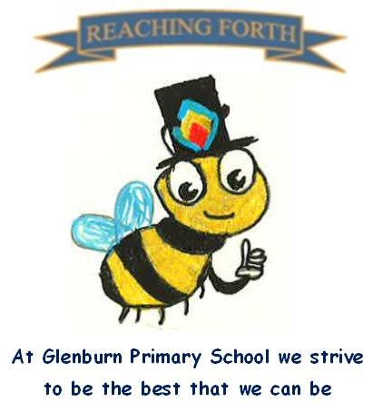

Buzzbee’s news about P2

Term 3 - what are we learning this term?
Maths: This term we are beginning with multiplication and we are starting to learn about the 2, 5 and 10 times table. Later on in Term 3, we will be learning about division and fractions.
Literacy: We will continue to learn two new sounds per week and new common words as well as revising prior learning. Through our grammar lessons, we will learn about nouns and verbs, alphabetical order, improving our vocabulary and using question marks. The children will apply their learning through our writing lessons which will cover functional and personal writing, some of which will be taught as part of our interdisciplinary topic. Reading books will continue to be handed out on a Monday and the children will be encouraged to read independently, as part of a group and with a partner.

Interdisciplinary Topic: We will start with our sustainability topic - learning how to reduce, reuse and recycle. Then we will explore Weather and Plants. Our main focus will be STEM (science, technologies, engineering and maths) where pupils will be designing, planning, measuring, building, evaluating and refining their designs related to plants and weather.

Things to remember:
P.E. - Our P.E days this term are P2S: Tuesday and Wednesday; P2M: Wednesday and Thursday. On these days please ensure your child is dressed appropriately for PE (e.g. school polo, shorts and trainers/gym shoes).
Water bottles: Children are encouraged to drink water throughout the day. Please remember it should only be water and not diluting juice. Children can refill their bottles at school.

Home Learning – Homework will be given on a Friday and collected on a Wednesday.

Dates to Remember – please refer to school newsletter and “Dates for your Diary” on the website.

