Buzzbee’s news about P1
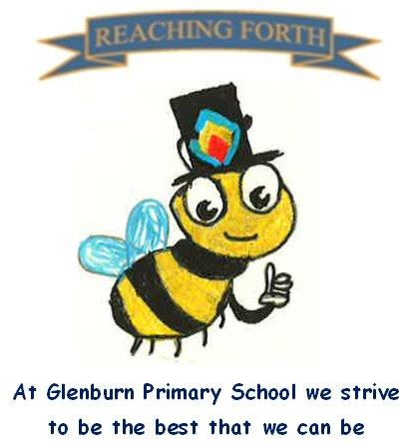

Term 3 - what are we learning this term?
Literacy and English
We will be learning double consonant blends, e.g. sh, th, ch. We will continue to learn two new sounds per week. Children will learn about instructional writing and writing poetry. We will continue to read in our reading groups and enjoy a whole class story each day.

Numeracy and Maths
We will be continuing to explore addition within 20. We will also be learning about time, subtraction within 20, measure and data handling.
Numeracy and Maths will continue to be taught through hands on activities, play, discussion and written tasks.

Interdisciplinary learning
Our topics this term are ‘Sustainability’ and ‘The Senses’. The children will be learning about sustainability through the characters of Little Miss Waste Less and Mr Go. We will be looking at the problems of litter, recycling and how we can look after our school environment. For our STEM topic ‘The Senses’, the pupils will engage in discovery sessions in which they will explore the five senses.
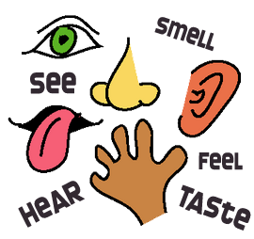

Things to remember:
- Our gym days are: Tuesday & Friday. This term we will be focusing on racquet skills as well as fitness.
- Homework is handed out on a Friday and should be returned on a Wednesday.
- Dates for your diary - please refer to school newsletter and “Dates for your Diary” on the website.

