Buzzbee’s news about P7
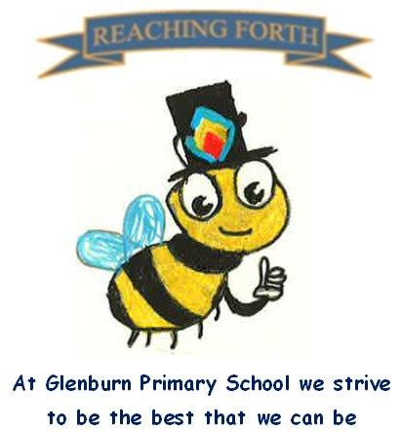

What are we learning this term?
Maths
We will continue with our daily mental maths focus before our main maths lesson. Upcoming maths topics will include time, data handling, fractions, decimals and percentages, negative numbers, numbers beyond 1,000,000, budgeting and profit and loss.
Children are encouraged to continue to practise times tables and other mental strategies at home as often as possible. Much of the maths we learn relies on us knowing the times tables off by heart – please ensure your child knows them inside out and back to front!

Literacy
This term, children will be reading a new class novel to help develop their language comprehension. Through this text, we will explore figurative language such as metaphors and similes, character development and the themes of identity, hope and courage. Pupils will set weekly reading targets for their individual books which will be read at home. We will also be focusing on developing comprehension skills through various unfamiliar texts and cloze passages.
Taught Writing lessons will focus on imaginative and persuasive pieces of writing. Nearer Christmas time, the pupils will plan and write their own short Christmas story for their buddies. These will be gifted to the P1s before the Christmas holiday.
Pupils will continue to develop their grammar skills on a weekly basis and spelling lessons will continue to be taught daily. We will also be reading and exploring the Read Woke novel ‘Ghost’ as part of our literacy and health & wellbeing lessons.

Interdisciplinary Topic: Scottish Parliament
Our new topic will be the Scottish Parliament with a particular focus on political parties. The children will participate in activities leading their own political party to make changes within Glenburn Primary. They will explore democracy, find out about elections and learn about the work of members of parliament.

In RME, we will learn about St. Andrew & St. Columba and, of course, Christmas (around the world).
PE – Children will develop their skills in athletics as well as learning the Flying Scotsman dance as part of our social dancing.

Things to remember:
Uniform – Children are expected to come in to school wearing either a shirt and Glenburn tie or a Glenburn polo shirt/jumper.

PE Kits – Children should change at school on PE days.
PE Days – P7M: Wednesday and Friday;
P7A: Tuesday and Wednesday.
Children are expected to wear black or navy shorts or leggings with a polo shirt or white t-shirt. Children are also expected to bring a pair of gym shoes/trainers for PE. Please label all PE kit items. This can be kept in class or brought in on the day.

Home Learning - will be issued on a Friday and should be returned by the following Wednesday.

Water bottles: Children are reminded to bring in a water bottle. Please remember it should only be water and not diluting juice.

Twitter/X – Follow our page @glenburnprimary for updates.
Dates to Remember – please refer to school newsletter and “Dates for your Diary” on the website.

