Buzzbee’s News about P6
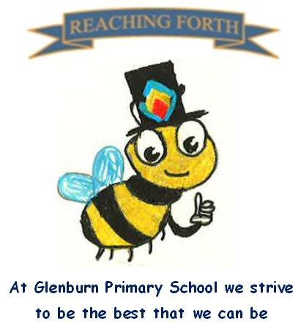

What are we learning this term?

Maths:
Children will be covering a range of mental maths strategies at the beginning of every maths lesson. We will be continuing to work with our mental maths resource ‘SAMSON Maths’ which will reinforce number bonds and number facts. This will be taught at the beginning of maths lessons for 10-20mins.
In Term 2, we will be learning about multiplication, percentages, angles, symmetry, decimals, fractions and extending our understanding of place value, adding and subtraction.

Literacy:
This term we will be focusing on poetry, instructional and descriptive writing. These genres have clear links to our IDL topic.
We’re excited to be introducing cloze reading passages in class to help strengthen pupils’ comprehension skills. These activities encourage children to read carefully, use context clues, and think more deeply about the text. We’re also continuing with our Literacy Boxes, which offer levelled tasks to support key reading strategies like inference and prediction. Both resources are helping to build confidence and boost reading skills—and the children are really enjoying the challenge!
We will continue to work on our encoding and decoding skills following the South Ayrshire Reads framework. We will also explore affixes, homophones, and spelling rules respectively.

Inter-disciplinary learning topic:
Our topic this term is ‘Scottish Inventors’. As part of our Scottish Inventors topic, we’re looking forward to exploring a range of exciting activities, including research tasks, creative tasks, and even some moviemaking to showcase what we’ve learned. We’re excited to learn about influential figures such as Alexander Graham Bell and hoping to invite some visitors in to class to help us learn about this topic too.






Things to remember:

Our behaviour policy:
As a Rights Respecting School, our behaviour policy focuses on our school values. Honesty, Respect, Responsibility, Friendship, Teamwork and Inclusion.

Uniform:
Children are required to wear school uniform every day. PE kits can be kept in class and taken home at the end of each term.

Water bottles:
Children are encouraged to drink water throughout the day. Please remember it should only be water and not diluting juice.

X (Twitter) – Follow our page @glenburnprimary for updates.

Other:
Children are encouraged to continue to practise times tables and other mental strategies at home as much as possible.

P.E. days –
6A - Tuesday and Thursday
6N – Tuesday and Thursday
*Currently a Wednesday and Thursday but will change back WB 17/10.
PE will take place in our big and small gym halls. Please make sure pupils have appropriate clothing and different gym shoes.

Home Learning – We have made changes to our homework days. Home Learning will be given out on a Friday and expected to be submitted on a Wednesday. This should hopefully allow for extra time for homework to be completed at a time that suits all families. Homework will consist of a short Literacy and Maths activity.
We strongly encourage children to read at home. They can share their books with us in class and let us know what they’ve been reading.

