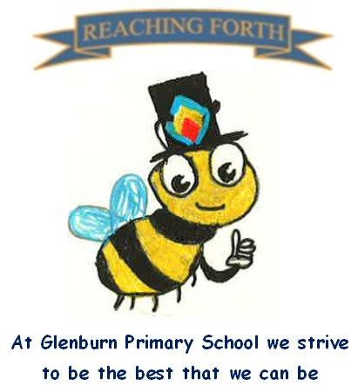

Buzzbee’s News about P5

What are we learning this term?

Maths: Children will be covering a range of mental maths strategies at the beginning of every maths lesson. Our Samson Maths programme is helping pupils to develop their mental math skills and number sense. We will be learning about fractions, decimals, and percentages as well as function machines, money and data handling this term.

Literacy:
Writing: This term we will be continuing to explore persuasive techniques as well as focusing on narrative and personal writing. These genres have clear links to our IDL topic. We will also be touching on other genres throughout the term as appropriate.

Reading: This term pupils are working on developing their reading skills through comprehension and cloze activities. They will continue to read for enjoyment daily, using their Accelerated Reading book and they will also develop their fluency at school and at home through reading aloud.

Spelling
We are taking part in SAR programme of spelling, focusing on phonics and morphology. Pupils are encoding and decoding words and creating their own word lists. They are also learning about affixes.

RME: This term we will be learning about Hindu Gods and Goddesses as well as the Christian celebration of Christmas.

Interdisciplinary Learning: This term the school has a whole school focus on Scotland and P5 will be learning about Scotland’s Kings and Queens (Robert the Bruce and Mary Queen of Scots). Our art will focus on Scottish landscapes.
We will also be preparing for our Christmas fayre with some festive songs and our school Christmas Enterprise day.

Other:

Home Learning – Homework is given out on a Friday and is due in on the Wednesday of the next week. Pupils should keep their homework in their blue folder.

P.E. days –
P5C- Monday and Friday
P5P- Monday and Friday
P5S – Thursday and Friday

Things to remember:
Uniform and P.E. kit: Children are required to wear school uniform and appropriate P.E. kit at all times.
Water bottles: Children are encouraged to drink water throughout the day. Please remember it should only be water and not diluting juice.

