Buzzbee’s news about P4
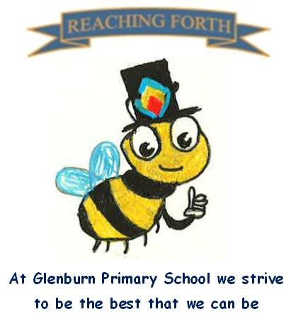

What are we learning this term?
Maths:
This term we will be learning about money, simple fractions, and percentages and we will be applying our knowledge of the 8 times table to divide with and without remainders. In addition, we will look at co-ordinates and grid references and learn how to play ‘Battleships’ to help consolidate understanding. The children will learn about angles and use these to follow and write directions.
Literacy:
In spelling, we will continue to learn a new sound each week and linking this into family of sounds. The pupils will practise sounds daily using activities such as blending, Elkonin boxes and diacritical marking. Children will continue to receive a new reading book weekly. They will read independently, within a group and with a partner in class and should be encouraged to read this at home. All children will be heard reading aloud throughout the week to encourage use of expression and punctuation. Children will develop their reading comprehension through reading a variety of unseen texts to answer different types of questions. In writing, our focus will be narrative (comic strips) by looking at well-known stories and then create our own. We will also explore poetry by both writing some and learning Scots language through our topic on Scotland.
Interdisciplinary Topic: This term we will be investigating ‘Scotland’ and more specifically famous Scots, including Charles Rennie Mackintosh, Sir Andy Murray and other famous Scots who interest the children. We will learn all about their life and achievements. In addition to that, we will explore Scots language and try to remember some words and phrases.
RME: Our RME topic this term is looking at the main beliefs, values and practices within Christianity and other world religions. We will learn all about traditions and the food different religions eat and why.
Music: Mr Bentley teaches the Primary 4 pupils’ music on a Tuesday morning. This term he will be focusing on singing in preparation for our Scottish Assembly and Christmas Fayre.

P.E
P4 will continue with their swimming this term. Please remember to bring swimming clothes and a towel on a Monday.

Please remember to tie up long hair and wear easy to change clothing.

We will be walking there and back each week, so a jacket and suitable shoes are required.

Other gym days are Thursday and Friday this term.

Things to remember:
Water bottles: Children are encouraged to drink water throughout the day. Please remember it should only be water and not flavoured water or diluting juice.

Home Learning –Reading books will be issued on a Monday. Homework will be issued on a Friday and collected the following Wednesday.

School Uniform: Children are required to wear school uniform, please ensure items are labelled to reduce clothes getting mixed up.
‘X’ (formerly) Twitter: Follow our page @glenburnprimary for updates.

