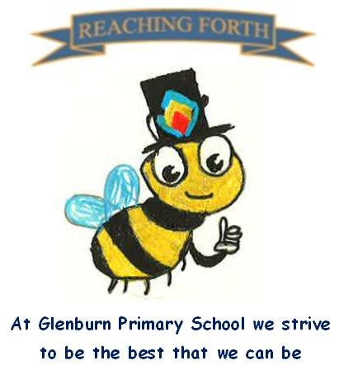

Buzzbee’s news about Primary 3

What are we learning this term?
Maths
Number
This term we will be continuing to learn about the addition of 2-digit numbers, with and without carrying and Place Value. We will be looking at money and will be learning more about position and movement, including directions. We will also continue to revise the 2,4,5 and 10 times tables.

Literacy
Spelling
Pupils continue to be taught a new sound each week along with their common words.
Writing
This term we will build on narrative and recount skills. Pupils will be encouraged to use paragraphs in their story writing. In grammar, we will be looking at question marks, plurals, adjectives and proper nouns. Pupils will begin to join their handwriting in our weekly handwriting lessons.
Reading
A new reading book will continue to be sent home each week. Please ensure these are brought to school each day as they are used regularly in class. Pupils will further develop their reading skills through Key Comprehension and Accelerated Reader.

Inter-disciplinary learning topics:
As part of a whole school focus on Scotland we will be exploring the topic of the Loch Ness Monster. We will learn about the legend and explore the evidence.

In I.C.T, we are going to be learning about word processing. We will be learning to copy and paste, insert text and images in a word document and finally they will learn to save their work.

As part of our science lessons we will be exploring forces through the use of magnets.

P.E. lessons will involve building on our gymnastics skills and revisiting some social dancing.

Things to remember:
P.E. - Our P.E days will be a Tuesday and Friday this term. Please remember to bring a full gym kit with a change of shoes. Outdoor trainers are not permitted. Please also remember to wear a polo shirt on this day or have a change of t-shirt. All jewellery, including earrings should be removed on gym days for your child’s safety.
Home Learning – Homework will continue be given out on a Friday. Pupils should have a reading book home each night. If this does not come home, please ask them to check their tray.
Water bottles: Children are encouraged to drink water throughout the day. Please remember it should only be water and not diluting juice. Children can refill their bottles at school.

Dates to Remember – please refer to school newsletter and “Dates for your Diary” on the website

