Buzzbee’s news about P1
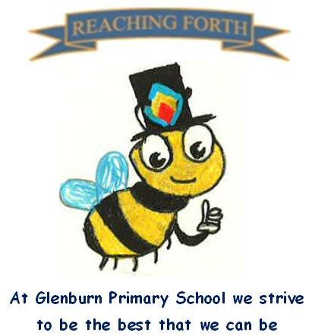

What are we learning this term?
Literacy and English
We will be continuing to explore initial sounds. We learn the sounds through songs, stories and play. In class we will practise reading and discussing books every day.
When your child brings a reading book home, please encourage him/her to look for familiar words and try to sound out and blend unfamiliar words.

Numeracy and Maths
We will be exploring how to add numbers through games and written tasks. The pupils will be learning how to memorise ‘double facts’, e.g. 3 + 3, etc. and recognise numbers from images without counting, e.g. the dots on dice.
We will be also be learning about measure and time.

Inter Disciplinary Learning
At the start of term, we will be learning all about Scotland. Primary 1 will learn the song ‘Three Craws’ to sing at our schools’ assembly.
This term we will also be busy learning all our songs and actions for our P1 and P2 Nativity. P1 will support P2 by singing the songs at our Nativity, while P2 will act out a performance. In class, we will be learning the story of Christmas. We are really excited for you to hear our beautiful signing!

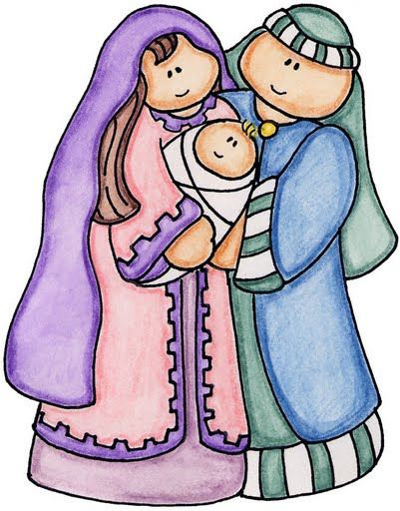

Things to remember:
- Our gym days are Tuesday & Friday. We are beginning to change into both our gym shorts and shoes. Please label all your child’s clothing.
- Homework is handed out on a Friday and should be returned on a Wednesday.
- Water bottles - children are encouraged to drink water throughout the day. Please remember it should only be water and not diluting juice. Bottles can be refilled at school.

