Buzzbee’s news about P7
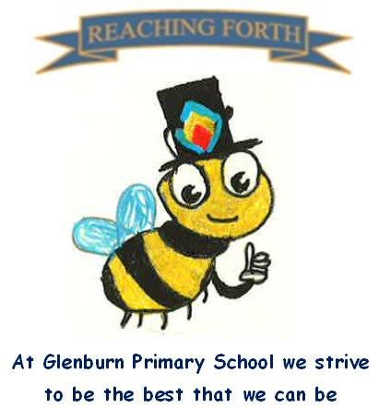

What are we learning this term?
Maths
We begin every Maths lesson with a mental maths focus. Upcoming topics will be addition, subtraction, multiplication and division including decimals by multiples of 10, multiples, factors and prime numbers, estimating and number sequences, expressions and equations. Once a week we will be focusing on problem solving.
Children are encouraged to continue to practise times tables and other mental strategies at home as often as possible. The sooner they know their multiplication facts off by heart, the easier other maths concepts become!

Literacy
In both P7 classes, we will be focusing on the novel, ‘The Boy in the Striped Pyjamas’. This will link in with our Term 1 topic of World War 2. The children will develop their reading comprehension skills, as well as skills in summarising, identifying the main ideas and inference through this novel. Pupils will be encouraged to read for pleasure every day by choosing books from our library or bringing books in from home. Reading Olympics certificates will be given out when children pass comprehension quizzes. Phonics will be taught and revised daily to ensure knowledge and understanding is secure in spelling and reading. Taught Writing lessons will be once a week. This term the writing styles we will focus on are narrative, persuasive and recount. Much of our writing will be taught through the context of WW2.

Interdisciplinary Topic: World War 2
Through this topic, the children will learn about the Home Front, rationing, the Blitz, propaganda, Anne Frank and other important events that took place during the Second World War.
In RME, we will look at Pilgrimage, researching the pilgrimage sites of the world’s major faiths and why they have become special to their followers.
PE – Children will develop their skills in team games, such as basketball and rugby.

Things to remember:

Uniform – Children are expected to come in to school wearing either a shirt and Glenburn tie or a Glenburn polo shirt and jumper/cardigan.

PE Kits – Children should change at school on PE days.
PE Days – P7M: Wednesday and Friday;
P7A: Tuesday and Wednesday.
Children are expected to wear black or navy shorts or leggings with a polo shirt or white t-shirt. Children are also expected to bring a pair of gym shoes/trainers for PE. Please label all PE kit items. This can be kept in class or brought in on the day.

Home Learning - It will be issued on a Friday and should be returned by the following Wednesday. Due to Dolphin House, P7 homework will not be issued until Friday 12th September.

Water bottles: Children are reminded to bring in a water bottle. Please remember it should only be water and not diluting juice.

Twitter/X – Follow our page @glenburnprimary for updates.
Dates to Remember – please refer to school newsletter and “Dates for your Diary” on the website

