Buzzbee’s News about P6
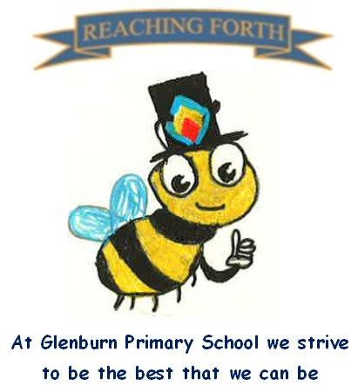

What are we learning this term?

Maths:
Children will be covering a range of mental maths strategies at the beginning of every maths lesson. We will be continuing to work with our mental maths resource ‘SAMSON Maths’ which will reinforce number bonds and number facts. This will be taught at the beginning of maths lessons for 10-20mins.
In Term 1, we will be learning about rounding and estimating, sequences and patterns, shape, decimals and extending our understanding of place value, adding and subtraction.

Literacy:
This term we will be focusing on narrative, informative and recount writing. These genres have clear links to our IDL topic.
We are all excited to be reading ‘The Wreck of the Zanzibar’ by Michael Morpurgo this term. We will be reading this together in class and focusing on our key strategies in preparation to begin working in groups next term. This novel also links with our IDL topic.
We will continue to work on our encoding and decoding skills following the South Ayrshire Reads framework. We will also explore affixes, homophones and spelling rules respectively.

Inter-disciplinary learning topic:
Our topic this term is ‘Extreme Weather’. The children will be monitoring and reporting on weather in their own environment and studying weather in other contexts. We will research impact of weather and natural disasters in both historical and modern-day life. We will also investigate the water cycle.
We are hoping to invite some visitors in to class to help us learn about this topic too.







Things to remember:

Our behaviour policy:
As a Rights Respecting School, our behaviour policy focuses on our school values. Honesty, Respect, Responsibility, Friendship, Teamwork and Inclusion.

Uniform:
Children are required to wear school uniform every day. PE kits can be kept in class and taken home at the end of each term.

Water bottles:
Children are encouraged to drink water throughout the day. Please remember it should only be water and not diluting juice.

X (Twitter) – Follow our page @glenburnprimary for updates.

Other:
Children are encouraged to continue to practise times tables and other mental strategies at home as much as possible.

P.E. days –
6A - Tuesday and Thursday
6N – Tuesday and Thursday
PE will take place in our big and small gym halls. Please make sure pupils have appropriate clothing and different gym shoes.

Home Learning – We have made changes to our homework days. Home Learning will be given out on a Friday and expected to be submitted on a Wednesday. This should hopefully allow for extra time for homework to be completed at a time that suits all families. Homework will consist of a short Literacy and Maths activity.
We strongly encourage children to read at home. They can share their books with us in class and let us know what they’ve been reading.

