Buzzbee’s news about P4
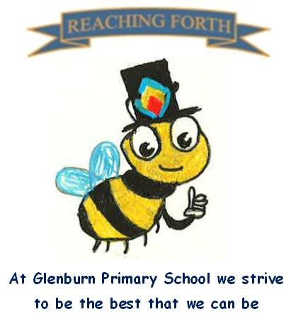

What are we learning this term?
Maths: Children will continue to reinforce their knowledge and recall of times table facts, with a focus on the 2, 4 and 8 times tables. The children will build on their multiplication skills to solve more complex problems and link this with division. Our first number topic is place value, where children will be learning to read, write and understanding numbers up to 9999. Children will also be adding and subtracting within 1000 using partitioning and a written method to help solve calculations. In addition, we will be looking at symmetry and 2D and 3D shape. We will be continuing Samson Maths this session to help develop our Mental Maths ability and understanding of number.
Literacy: In spelling, we will continue to learn a new sound each week while continually revising previously taught sounds. Children will be focusing on applying the sounds to read and spell words rather than memorising a word list. Children will continue to receive a new reading book weekly. They will read independently, within a group and with a partner in class and should be encouraged to read this at home. All children will be heard reading aloud throughout the week to encourage use of expression and to develop fluency. This term, the class will develop their reading comprehension skills through cloze passages and reading unseen texts with multiple choice questions covering understanding, vocabulary, spelling, and punctuation. Every child will have a school library book to read in class. Please encourage your child to read for enjoyment at home as this is the best way to improve reading and writing. This term, we will be focusing on writing recounts and narrative. We will be focusing on how to make our writing more interesting to our reader through adding descriptive phrases using adjectives and using a variety of sentence openers.
Interdisciplinary Topic: This term, the children will be doing a topic on sustainability, more specifically endangered species. We will learn about which animals are classed as endangered, what is causing them to be endangered and how we can help them. The children will have the opportunity to research a chosen endangered animal and will work together in collaborative groups.
RME: Our RME topic this term is looking at key figures in world religions. We will be learning about important people in Christianity, Judaism, Buddhism and Sikhism. Primary 4 pupils will also participate in our Harvest performance by supporting the Primary 3 pupils with the songs.
Music: Mr Bentley will teach the children how to play some simple chords on the ukulele and focus on learning songs for the Harvest assembly.

Things to remember:
Water bottles: Children are encouraged to drink water throughout the day. Please remember it should only be water and not flavoured water or diluting juice.

School Uniform: Children are required to wear school uniform, please ensure items are labelled to reduce clothes getting mixed up.
Lost Property: We have had a few children missing their jackets. Please check at home in case you have accidentally picked up someone else’s. Please ensure all jackets have a name on them.

P.E
P4S – Monday and Thursday
P4R – Monday and Friday

Remember to bring a gym kit. No outdoor shoes should be worn in the gym hall.

Home Learning
Home Learning will begin on Friday 5th September, and it is expected to be completed each week. Homework will be issued on a Friday and collected on a Wednesday. This is to allow longer to complete homework when children are busy with after school activities. Reading books will be sent home on a Monday and collected the following Monday.

