Buzzbee’s news about Primary 3
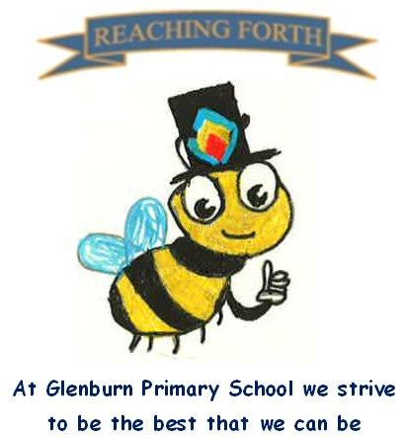

What are we learning this term?  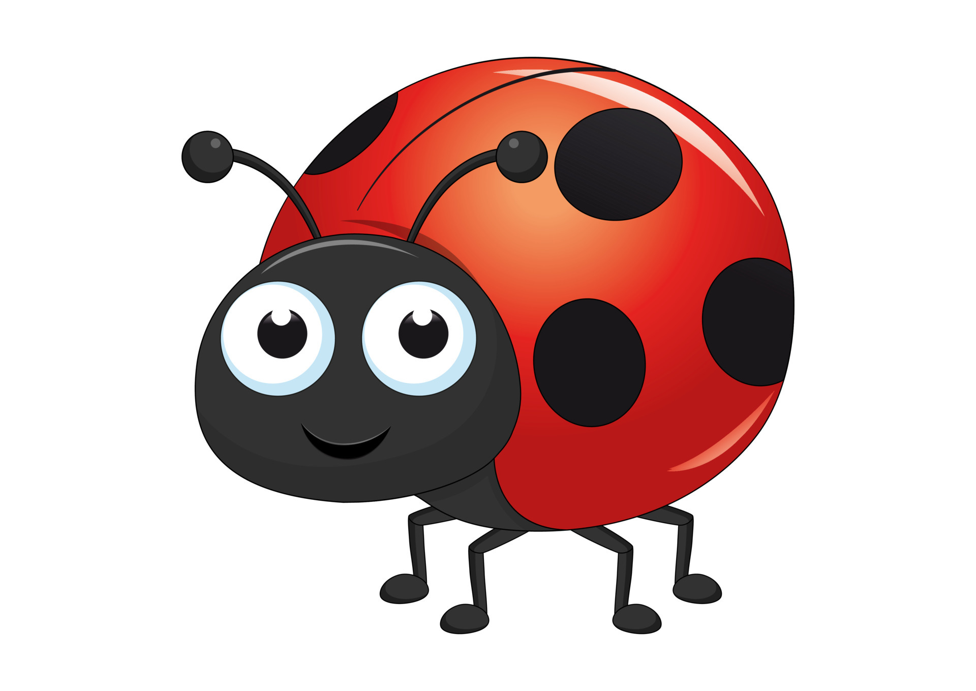
Maths:
In Term 1, we will be continuing to learn about multiplication with a focus on the 2x, 4x, 5x and 10x tables. The children will also be learning to round numbers to the nearest 10 and will be exploring numbers up to 1000 with a focus on understanding the value of each digit. Pupils will also be learning about symmetry and information handling where they will be exploring graphs and tables of information.

Literacy:
Spelling – This term starts with a short revision block where the pupils will revise previously taught sounds. Pupils will then move on to learning one new sound each week. The new sound and common words are practised in class throughout the week as well as in their homework.

Writing – This term the children will be focusing on improving their writing skills through using a variety of sentence openers, varying lengths of sentences using connectives and using simple adjectives. In grammar we will be learning about alphabetical order, using a dictionary and learning more about nouns and adjectives.

Reading – A new reading book will be sent home each week. Reading books should be brought to school each day as these are used regularly within the class. Please try to read for a short time each night to improve fluency and confidence. Through our Flat Stanley book study, we will be learning about prediction, characters and identifying the main events.

Inter-disciplinary learning topic: This term we will be learning about Minibeasts. Through our topic we will learn about classification of minibeasts, habitats, food chains and simple life-cycles.
R.E - Our RME topic this term is, The Church. We will be learning about the physical features of the church as well as exploring ceremonies and events that happen within the church. The pupils will also participate in our Harvest performance to the school.



Other:
Gym days
P3S - Tuesday and Friday
P3I - Thursday and Friday

Please ensure children have appropriate gym clothing and a change of shoes. These can be kept in school.

Things to remember:
Water bottles: Children are encouraged to drink water throughout the day. Please remember it should only be water and not diluting juice. Bottles can be refilled at school.
Home Learning – Homework allows pupils to revise what they have been learning in class and also allows parents to see what their child has been covering. Please support your child in completing and returning their homework on time. It will be issued on a Friday and should be returned on Wednesday of the following week.

