Buzzbee’s news about P2
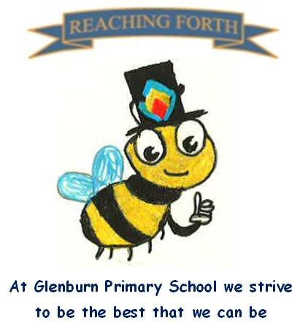

Welcome to P2
What are we learning this term?
Literacy and English
Spelling – This term, the children will be continuing the phonics progression and starting the Primary 2 sounds (ay, ea, ow etc.), We will cover 2 sounds per week, learning how to blend and spell these and continuing to practise at home using the blending books.
Writing – This term, the children will be focusing on improving their writing skills through developing sentence structure, adding connectives (e.g. and, because) and adjectives. We will also continue to practise letter formation and sizing through all written activities.
Reading – Reading books will be sent home on a Monday and collected the following Monday. Reading books should be brought to school every day for work in class. Please try to read for a short time each night to improve fluency and confidence. Through our Fairytales topic we will focus on understanding and retelling stories.

Numeracy and Maths
In Term 1 we will be covering addition and subtraction, estimation and place value. The children will also be learning about simple expressions and equations, 2D and 3D shapes and symmetry. We will also continue to focus on number formation throughout all written activities. Numeracy and Maths lessons will consist of mental agility , written and active tasks.

Interdisciplinary learning
Our first topic will be ‘Fairytales’. The children will experience a range of activities based on a variety of traditional and modern tales such as character comparisons, common themes and sequencing tasks.

Home-Learning
All aspects of home learning are reinforcement tasks to ensure children have daily practice of concepts taught in class. In Term 1, each week will focus on two new sounds to develop reading and spelling ability. The Blending Books are sent home and the activities to practise spelling these are at the front of the jotter. The home learning grid will also outline the spelling words for the week. We appreciate the involvement of our parents in completing these with their children. Maths tasks will be outlined in the home learning grid and will focus on a variety of concepts covered in class.

Things to remember:

PE - Our gym days P2S – Tuesday and Wednesday
P2M – Wednesday and Thursday

Please send a gym bag with a pair of dark shorts and sandshoes/ trainers in with your child. This will be kept in school and sent home regularly to be washed. Children should be dressed in a polo shirt on gym days for ease of changing. We will also be doing PE outside in all types of weather so please dress your child appropriately and with sun cream if need be. Please include a waterproof jacket as we will go out even when it rains.

Uniform – please ensure ALL items of clothing are clearly labelled.

Water bottles - children are encouraged to drink water throughout the day. Please remember it should only be water and not diluting juice. Bottles can be refilled at school.

