Buzzbee’s news about P1
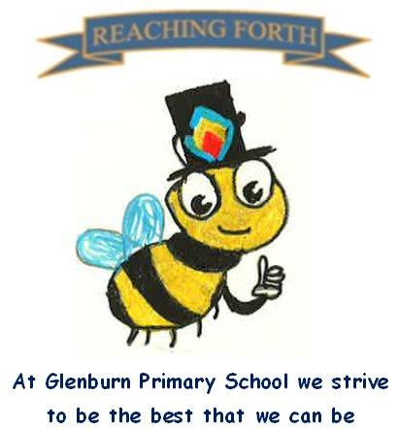

Welcome to P1
What are we learning this term?
Literacy and English
We will be introducing and practising initial sounds at a rate of two per week. The sounds we will be learning this term are: s, a, t, i, m, n, o, p, b, k, g, h, d, e. The sounds are mainly learned through actions, songs and rhymes. We focus on letter sounds as opposed to letter names as this helps when we begin to blend our sounds to make words e.g. c-a-t. Your child will receive a guide to letter and number formation to help at home.

We also learn common words. These are words with tricky spellings that cannot be sounded out e.g. ‘I’, ‘the’ etc. Again, these will be sent home for you to practise with your child.

In class we will practise reading and discussing books every day. After a settling in period your child will be encouraged to practise reading at home. Please encourage your child to look for initial sounds and talk about what’s happening in the story.

Numeracy and Maths
We will be exploring numbers to 10 through interactive games and written tasks. The pupils will be learning to recognise, form and order the numbers. Number formation is taught through a series of rhymes which will be sent home to allow for practice at home.
Numeracy and Maths will be taught through “hands on” activities, play and discussion. There will be a balance of number, pattern, measure, shape, and information handling.

Interdisciplinary learning
Our first topic will be ‘Our School’. The children will experience a range of activities, such as exploring our school building and grounds, meeting staff members and learning how we can respect our school and the people in it.

Home-Learning
After a settling in period your child will be sent home a Home-learning booklet to practise sounds, common words and number work. This will reinforce the learning completed in class. Home-learning is particularly important in Primary 1 as the children are beginning their learning journey and we appreciate the involvement of our parents in completing this with their children.

Music: Mr Bentley will teach Music lessons to the class every Wednesday afternoon.

P.E
Our P.E. days are on a Tuesday and Friday. Could you please put a gym kit in a bag that can be kept in school for gym time. Please label each gym shoe and shorts.

Things to remember:

Water bottles: Children are encouraged to drink water throughout the day. Please remember it should only be water and not flavoured water or diluting juice.

School Uniform: Children are required to wear school uniform, please ensure items are labelled to reduce clothes getting mixed up.
Lost Property: If lost and your child’s property does not have a name on it, it will be placed in the lost property box at our school office.

Home Learning
Home Learning will begin on Friday 12th September, and it is to be completed each week. Homework will be issued on a Friday and collected on a Wednesday. This is to allow longer to complete homework when children are busy with after school activities.

