 

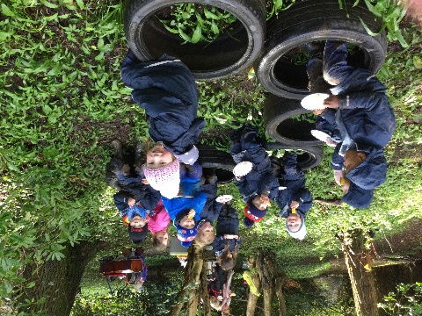 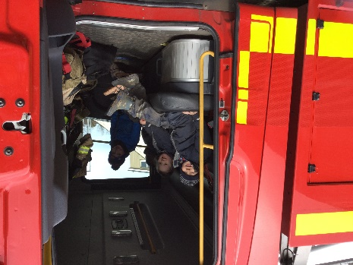

Standards and Quality Report

Girvan Early Years Centre 2023/24

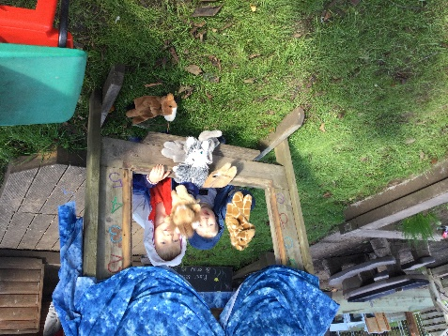 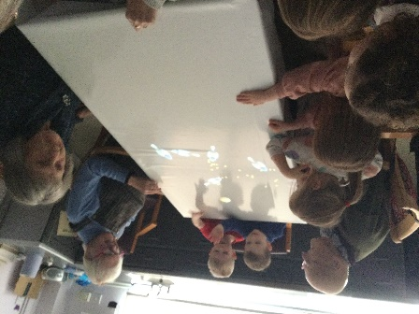

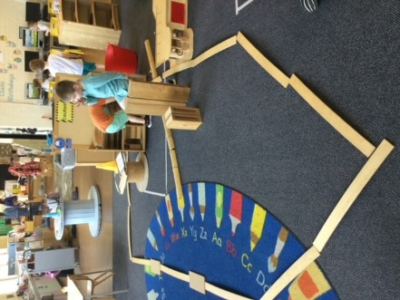

**Introduction**

At Girvan Early Years Centre (EYC) we will strive to support everyone in achieving their full potential in a vibrant, safe, inclusive, high quality learning environment.

We will achieve this by:

* Working in partnership with families, agencies, and the wider community.
* Ensuring the experiences we provide are of high quality and are available to every child.
* Using effective quality assurance systems to ensure continuous improvement.
* Be the best we can be to ensure our children thrive and be the best they can be.

**Values**

After consultation with staff, parents, carers and children, our refreshed values are shared with families and are at the heart of what we do every day to benefit the children we care for:

Quality

Respect

Fun

Consistency

Equity

Honesty

**Aims**

To provide children with:

* A safe, happy, nurturing environment which offers a variety of high-quality learning experiences, both indoors and outdoors.
* Experiences that meet children’s needs, develop curiosity and builds confidence to support us to close the poverty related attainment gap.
* Opportunities to be a part of the community and to be aware of the importance of caring about the environment and others.
* Smooth transitions throughout the Centre and with local primaries to ensure continuity and progression where information is shared and valued.

We are looking at our vision and aims in the new term as our values were refreshed last term. Staff, children and parents are aware of these changes and were included in making them.

**Context of Girvan Early Years Centre**

The catchment area is mainly Girvan but we work closely with our Cluster group which includes Barr, Barrhill, Colmonell, Ballantrae, Daily, Girvan Primary, Girvan Academy and Invergarven. We meet regularly and work together on a cluster priority which helps bring different expertise together building relationships and respect across the stages.

We are situated within Girvan Primary School Campus where we accommodate 3 playrooms, including two 3-5 playrooms, a 2-3 year old room, an outdoor area and a parent/family room. The building is located centrally within the town of Girvan, where families can access us easily. We have developed a sensory area within the family room which children can access at any time when they require a quiet space to relax and be calm.

Staffing at present comprises of:  
1 Manager

1 Depute Manager

1 Clerical Assistant

2 Teachers includes 1 Equity and Excellence(EEL) post

2 Senior Early Years Practitioner

19 permanent EYPs

2 School Assistants

All staff are registered with SSSC or GTCS.

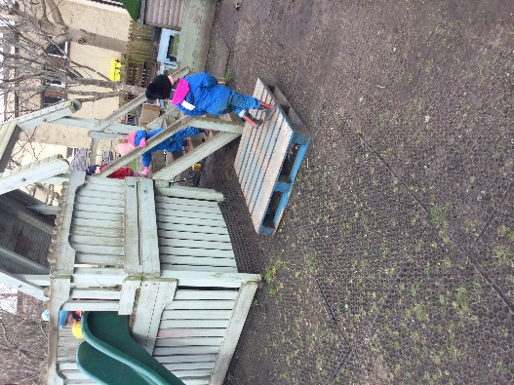 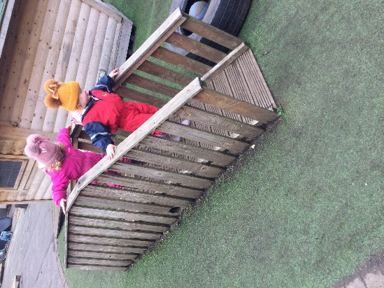

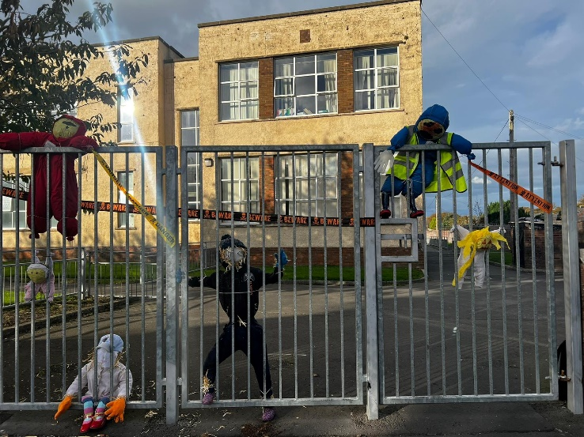

**What key outcomes have we achieved?**

|  |  |
| --- | --- |
| **School Priority 1 : TO IMPROVE ATTAINMENT IN LITERACY** | |
| **NIF Priority: Improvement in attainment, particularly in literacy** | **Links to HGIOELC 1.1 1.2 1.5 2.2 2.3 2.4 2.7 3.1 3.2 3.3** |
| **Progress and Impact;**  To improve children’s outcomes in communication and language and close the poverty related attainment gap we gathered developmental milestone data alongside attendance, SIMD and information on children who are care experienced. PEEP sessions also provide data to support the benefits of these groups, building links with staff throughout the stages.  Data collected from the children in the two rooms who were involved in Talk Boost has shown that this intervention has improved the children’s learning in all areas, as noted below. 17 children were supported and benefitted from the overall experience.  Rainbow Room  Sunshine Room  PEEP sessions, delivered by the Family Learning Practitioner, were well attended along with 2 members of staff from the Centre supporting these, one going on alternate weeks. This has proven to be really successful in helping children to transition into the Centre at either 2 or 3 years old.  There were 33 sessions delivered for the 1 to 2 age group this year and 30 families participated. Some of the families have attended the full year and some families have left the sessions once their child has moved on to playgroup, nursery or when parents have returned to work.  Feedback from parents include, ‘*my child has learned so much over the sessions we both enjoy getting out and meeting new mums and baby/toddlers”, “my child copies most the songs and actions”, “they are fun and lots of learning”,*  Book Bug sessions were held within the Centre for the 2 and 3 year old children. Parent’s were invited and the book bags were distributed to encourage learning and reading at home.  Staff took up opportunities to attend a variety of professional learning/CLPL. The whole Centre have taken part in the training related to The South Ayrshire Reads Strategy. This has supported the staff’s understanding of the fundamentals of reading.  https://learningjournalsuk.blob.core.windows.net/girvannursery/activity/bf170a5c-fe56-42fa-ad01-40995201da02.jpeg?sv=2018-03-28&sr=b&sig=v6tw%2FqcgdCOPutd8oahUUDuM6MnA7Ok%2BbzqbuiRmr64%3D&st=2024-07-04T19%3A45%3A49Z&se=2024-07-04T20%3A50%3A49Z&sp=r C:\Users\sa16milroya\AppData\Local\Microsoft\Windows\INetCache\Content.Outlook\HYXJBB6Q\IMG-20240513-WA0004.jpg  We have been involved in the Communication Friendly Environment framework and accreditation where we have achieved The Learning Environment award which recognises we have clearly labelled and resourced the environment to support learning throughout the Centre. We have 2 Communication Champions who are supporting staff with completing the stages of this.  The Potential of Block Play training was completed by another EYP, we now 2 staff trained.  Almost all of the staff took part in language and communication training lead by Autism Outreach, which gave a good insight into how to support children with barriers to their learning.  Looking at the data regarding achievements of milestones in literacy, we have noticed an increase in the number of children achieving 8 out of 10 from 66% to 75%. One of the most significantly improved milestones is ‘identifying rhyming words’ which has increased from 64% to 76%. Communication and language will continue to be a strong focus for next session as we continue on our journey with the South Ayrshire Reads strategy.  Some parents/carers were involved in using home link activities and bags promoting literacy in the 2 year old room. These resources were enjoyed and the feedback was positive.  Makaton was introduced to children and they are now aware and confident in using some signs which was evident at the end of term concert where one of the songs included Makaton.  **Next Steps:**   * **Continue involvement with SAR and the Communication Friendly team** * **Support the Communication Champion in leading the team with confidence building across literacy and language** * **Develop a robust strategy for using Makaton throughout the Centre** | |

|  |  |
| --- | --- |
| **School Priority 2 : TO IMPROVE OUTCOMES IN HEALTH AND WELL BEING** | |
| **NIF Priority: Improvement in children and young people’s health and well being** | **Links to HGIOELC**  **1.1 1.2 1.4 1.5 2.1 2.3 2.4 2.5 2.6 2.7 3.1 3.2** |
| **Progress and Impact;**  PEEP delivered 36 sessions this year and had 36 families participate within the sessions. Some families attended the full year and some families left the sessions when they returned to work and some families moved up to the older group throughout the year when their child turned one.  Feedback from parents included, *“welcoming environment, opportunity to socialise”,*  *“baby and I love the group. Something positive to look forward to”.*  Transition PEEP sessions had 12 families participate, 9 of the families who attended had previously attended baby or toddler PEEP sessions.  https://learningjournalsuk.blob.core.windows.net/girvannursery/activity/82c6b9dd-901b-4acd-95aa-42953fa909ba.jpeg?sv=2018-03-28&sr=b&sig=LyRTXDZBfXCIdmO8a%2BApqYWiMx0P9X7N63Dd1XwWon4%3D&st=2024-07-02T10%3A01%3A47Z&se=2024-07-02T11%3A06%3A47Z&sp=r  C:\Users\sa16milroya\AppData\Local\Microsoft\Windows\INetCache\Content.Outlook\HYXJBB6Q\processed-5AB859EE-D909-4CDB-8573-AF219F480E31.jpeg  Colour Monster was again used to support children’s wellbeing and this was supported through the PATHS programme as a way to empower children to develop the fundamental social and emotional learning skills that will enable them to make positive choices in life. PATHS was delivered to all preschool children. Parents/carers were informed of the programme and involved in it. The data proves that there has been an improvement in all areas. Senior EYPs who lead the sessions have reviewed the data and feel it would make more of an impact if they changed the time of year it was delivered. Leaving it to the third term instead of the second may be more beneficial and relevant to the primaries as part of transition data.  Forest Kindergarten (FK) moved to a different location this year as the previous place was proving to be unsafe and being used by the public. The new area has been a great success as it is on private land and is secure. This is going to be developed, as time goes on, by planting and growing our own vegetables etc. Two members of staff have now been trained and they took turns to lead alongside EYPs supporting. FK has been very successful in achieving an awareness of the local environment and children being more confident outdoors.  https://learningjournalsuk.blob.core.windows.net/girvannursery/activity/cf116bc9-4337-48ad-b063-2565d1d69308.jpeg?sv=2018-03-28&sr=b&sig=Iv0fTTUecWL%2FicGXo5oFUv9aPyWnXOqVC1NFwOGyTrI%3D&st=2024-09-04T14%3A37%3A31Z&se=2024-09-04T15%3A42%3A31Z&sp=r https://learningjournalsuk.blob.core.windows.net/girvannursery/activity/1fe38aec-9ae8-4092-b26a-3694c6209ba8.jpeg?sv=2018-03-28&sr=b&sig=%2BI6lJyndLMQH0%2FpZSwseWEifr%2F8QLsbfgFvdX5eX8mA%3D&st=2024-09-04T14%3A49%3A36Z&se=2024-09-04T15%3A54%3A36Z&sp=r https://learningjournalsuk.blob.core.windows.net/girvannursery/activity/7b89091d-fa8b-4e54-99d2-1e6008c82aae.jpeg?sv=2018-03-28&sr=b&sig=KIxPKTzhDntvl%2FbENslOGvDvXpfoKIlH0xad0f02yw4%3D&st=2024-09-04T14%3A49%3A36Z&se=2024-09-04T15%3A54%3A36Z&sp=r  Almost all children took part and the feedback from parents was positive. Some comments included, *‘My little girl absolutely loved forest kindergarden and she was very relaxed and happy after it’. ‘Going to bed earlier and getting a good night sleep. Coming home and eating all her dinner as well’.*  There have been improvements across the EYC in achievement of health and well being milestones. Increasing the number of children achieving 8/10 milestones from 60% to 71%. We had improvements across nearly all milestones where the most significant rise was in ‘Talking about my learning’ increasing from 67% to 75%. We aim to increase this next year in line with the others.  UNCRC has been introduced to all areas of the Centre and staff are now confident to go forward and apply for the bronze award next session. Children have a good understanding of their rights and parents have been made aware of these through evidence in Learning Journals and displays.  The amount of times Learning Journals were accessed by parents has increased this year. We will continue to encourage all parents to look at their child’s progress and will remind them through our newsletters and emails.  **Next Steps**   * **Proceed with achieving the UNCRC bronze award** * **Review the programme for Forest Kindergarten** | |

|  |  |
| --- | --- |
| **Cluster Priority:**  **TO FOCUS ON IMPROVING CONFIDENCE AND COMPETENCE OF STAFF TO EFFECTIVELY TEACH EXPRESSIVE ARTS AND PROVIDE LEARNERS WITH THE SKILLS, APPROACHES, KNOWLEDGE AND UNDERSTANDING THAT THEY REQUIRE THROUGHOUT THEIR LIVES:**  **Year 1 art and design; Year 2 dance and drama; Year 3 music.** | |
| **NIF Priority: Improvement in attainment** | **Links to HGIOELC**  **1.1, 1.2, 1.3, 2.2, 2.3, 2.4, 3.2** |
| **Progress and Impact;**  The steering group carried out a survey of staff confidence and identified areas of professional learning. Members then delivered a highly successful training event, with positive feedback received across all workshops. One of the tasks was to observe art activities/lessons in another establishment within the Cluster. Most trios (groups) visited at least once but skills development was not routinely observed. The decision was made by the Cluster to continue working on this priority next session due to not meeting the required outcomes.  **Next Steps**   * **To continue with art and design as part of the expressive arts priority** | |

|  |  |
| --- | --- |
| **School Priority 4: TO IMPROVE OUTCOMES IN NUMERACY** | |
| **NIF Priority: Improvement in attainment, particularly in numeracy** | **Links to HGIOELC**  **1.1 1.2 1.3 2.2 2.3 2.4 2.7 3.2 3.3** |
| **Progress and Impact;**  Due to more Block Play training being offered, we now have 2 EYPs to lead learning in this area where numeracy and other skills are being introduced through play. The block provision is an area that has been extended and where different learning experiences have been offered and added to attract and excite all children.  Staff led regular community walks which allowed the opportunity to talk about numeracy when out and about. This enabled children to learn in a different environment and incorporate size, shape and number at the same time. Some children related better to this kind of learning experience than to being inside working with numbers.  Forest Kindergarten was another environment which developed all areas of the curriculum and where numeracy was an area some children struggled with in the centre but were able to concentrate and learn more easily outside.  https://learningjournalsuk.blob.core.windows.net/girvannursery/activity/94749e1e-3e59-46c6-87e5-02a5b4668bd8.jpeg?sv=2018-03-28&sr=b&sig=AJGjGrLB017KJ36N3ID4joHQ3DypoBEaZbloN5K9Up0%3D&st=2024-07-04T19%3A43%3A35Z&se=2024-07-04T20%3A48%3A35Z&sp=rhttps://learningjournalsuk.blob.core.windows.net/girvannursery/activity/c5e01d74-6db8-4eee-8e5a-7fdc766a4401.jpeg?sv=2018-03-28&sr=b&sig=FnZ3mBHE%2BsYVhfUS62jbRh%2Ft4zVsRxFAPat2HLLzx8Y%3D&st=2024-07-04T19%3A57%3A50Z&se=2024-07-04T21%3A02%3A50Z&sp=r  One member of staff has been on the block of training for Nurturing Mathematical Thinkers in Early Years and the impact of this has not managed to be truly evidenced yet. Another 2 members of staff will hopefully be attending this training next session. So this will support the drive in the Centre to develop our pedagogy and approaches to maths and numeracy next session.  Data from the milestones shows that there is an improvement in the % of children achieving milestone, ‘using 2D shapes and 3D objects to build and create’ from 91% to 100%. This is evidence of the impact of the staff being trained on block play.  Another milestone showing significant improvement is, ‘understanding information in simple graphs and charts’ which has increased from 48% of children achieving to 76%.  **Next Steps**   * **Develop staff confidence in extending children’s numeracy skills through support from the Numeracy Champions who have been trained.** * **Provide different opportunities for progression to support children in their style of learning.** | |

**Evaluation Summary**

|  |  |
| --- | --- |
| Quality Indicator | School Self Evaluation |
| 1.3 Leadership of change | The Centre is led by a Manager with several years of experience who has become more confident during the last year. Parents and staff were involved in compiling new values during the 3rd term and these are now shared and becoming embedded as part of the Centre’s ethos. We aim to refresh aims and vision next year.  The leadership team has grown and the new Senior EYP has become a strong member of the team which has allowed us to support staff in a consistent and positive way. The impact of another Senior will continue to grow and develop next session.  All staff have leadership roles and are taking these forward and sharing the knowledge gained through related training. Staff have been empowered and able to show their initiative in taking these roles on.  Staff have become more confident in using Learning Journals and we will continue to work on developing their skills in this area.  We have a manageable improvement plan in place with clear targets and outcomes identified through observations and the needs of the children.  The improvement plan is a working document which staff are involved in compiling and they are aware of the roles they have within it and the outcomes we want to achieve. This is regularly reviewed and evaluated and priorities are shared with parents and the progress we are making is evidenced and displayed. We will continue to encourage staff to be confident in contributing to this.  We are looking to refresh our curriculum rationale in the new term as a whole Centre collaborating with parents/carers and the wider community.  Evaluation:- Satisfactory |
| 2.3 Learning and teaching | Children are happy to come to the Centre and are confident, motivated and engaged in learning. They are able to make choices and voice their needs. We are becoming more confident in enabling children to access their learning through their journals and they are able to add their views with support from adults.  Parents/carers have been involved in the children’s learning through visits to the playrooms and joining in with activities.  Children’s Rights continue to be shared with all children and staff are able to evidence this through activities and displays.  Forrest Kindergarten has developed children’s confidence outdoors and developed a deeper understanding of teaching children in a different environment.  Staff have high expectations of the children and are becoming more confident in offering opportunities to build on their learning.  Digital learning is an area for improvement and some investment is required to resource these opportunities.  Children benefit from a variety of pedagogical models including curiosity, awe and wonder.  Staff know children well. In our centre we use information gathered from tracking, observations and milestones. Care plans are individual to each child’s needs and parent’s play a vital role in compiling these. Attendance and assessment information is gathered and monitored regularly to ensure tracking of progress is in place. Plans are in place and targets set through working closely with outside agencies, parents and staff. Staff have had one to one meetings with management to discuss their children’s progress and the strategies in place for them. These happen termly to track progress of curriculum outcomes which will contribute to levels of progress when going on to Primary.  Pupil support meetings contribute to children’s Staged Intervention paperwork and informs the pupil support coordinator on progress and targets. Staged intervention paperwork has been reviewed regularly and staff are more confident in working with these. The Pupil Support Coordinator role has developed and is a robust and consistent way of supporting the children who require support.  Data is shared with staff and they are becoming more confident in analysing this in relation to attendance and SIMD and how this can affect outcomes. This information helps to support children and families as required.  Evaluation:- Good |
| 3.1 Ensuring wellbeing, equity and inclusion | PATHs programme has been a successful way for children to talk about their emotions and all were keen to take part in the small groups. Forrest Kindergarten continues to be a great success with positive feedback from children and parents/carers. The new venue has proven to be more secure and a safer environment to be in.  Continued close working relations with the Health Visitors has helped us to identify the needs of children coming in to the centre and they support us through attending TWTF meetings.  Working with outside agencies such as Aberlour, Stepping Stones, Children 1st and other services, autism outreach, speech and language, EAL and play therapist, has allowed us to support children develop in all areas.  Care plans are completed within 28 days as a statutory duty and reviewed every term.  Epilepsy training was taken up by nearly half of the staff due to the needs of children and the higher number of allergen related diagnosis. Staff have sought out ways to improve their knowledge to help reduce barriers including autism awareness training.  Crisis Prevention training was undertaken by staff who work closely with a child who needed support to de-escalate his behaviour.  Depute and Manager attended the GIRFEC refresh session which ensures we are aware of the latest updates and changes. This was fed back to staff.  Child Protection training has been completed by all staff.  All staff understand and contribute to chronologies.  Robust procedures in place to ensure safe storage and the recording of children’s medication are kept up to date and relevant.  Evaluation :- Good |
| 3.2 Raising attainment and achievement | As a team we reflect on the learning environment to ensure that is stimulating and engaging enough for the children to freely choose experiences which will support the development of skills for life and learning. See, Feel and Hear approach continues to be a way of evaluating the environment.  Attendance has improved slightly for the 3 to 5 year olds this year but the 2 year olds have seen a slight decline. Factors affecting child’s attendance have been addressed and supported as required. This has included home visits, home links and meetings with parents/carers.  We tracked children’s learning to ensure that over time they are accessing a broad and varied education. Staff are more confident in having conversations around this and there is now a robust plan in place for the recording of what has been shared.  Children’s achievements are recognised and celebrated by practitioners. Parents/carers have accessed Learning Journals more this past year to share achievements at home or out with the Centre and this has been evidenced in the Centre displays.  Good relationships and open communication between staff, parents/carers and partners allows for mutually agreed support and interventions to be put in place as required. We have a high level of engagement with external agencies which ensures that we can signpost families for appropriate support. This also supports us in reducing barriers to effective learning.  Overall children have made good progress in all areas and the number of children achieving 8 or more milestones has increased.  Evaluation:- Good |

**What are the key priorities for improvement in 2024/25**

* To improve attainment particularly in literacy and numeracy
* For the whole Centre to achieve The Promise Education Award
* To achieve the Bronze UNCRC award

**What is the capacity for improvement?**

Capacity to improve over the next year may be impacted by the loss of teachers and the reduction in School Assistants.

Staff have become more confident in taking on leadership roles and this will continue with more ownership of planning with the Senior EYPs supporting.

Overall we are looking to have positive outcomes and impact through rigorous tracking and monitoring.