The Lungs
Label the diagram with the words in the box
Draw an arrow from the word to the correct part.
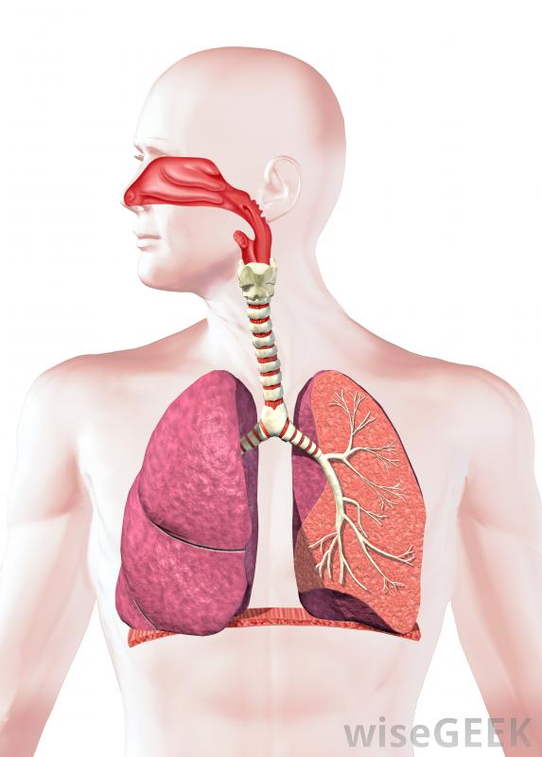
The Lungs
Label the diagram with the words in the box
Draw an arrow from the word to the correct part.
Diaphragm
Alveoli
Bronchioles
Bronchus
Trachea
Mouth
Diaphragm
Alveoli
Bronchioles
Bronchus
Trachea
Mouth

