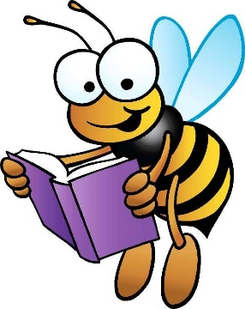
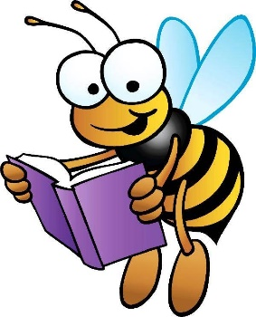
Spelling
Week Beginning
Monday 18th January 2021
Bananas
snap
swam
loud
cloud
found
now
crowd
sunflower
seventy
eighty

Apples
ooze
sneeze
cheese
choose
freeze
wheeze
breeze
noise
browse
bronze
pause
cause

Strawberries
ooze
sneeze
cheese
choose
freeze
wheeze
disease
bruise
applause
appraise
turquoise
mayonnaise

Write an imaginative story using as many of the spelling words as you can. | Create a word search using the spelling words. Ask someone at home to complete it. | Put the words in to elkonin boxes or diacritically mark the words (dots and dashes)
Write out each of the spelling words. Write vowels in red and consonants in blue. | Write the words in alphabetical order. You can use a dictionary to help you. | Write silly sentences with the spelling words. Underline the spelling word in each sentence.
Write a sentence with each of the spelling words. Use an adjective in each sentence. | Draw a picture. Hide the spelling words inside your picture. | Practise the spelling words outside using chalk.
Use a dictionary to find out what each of the spelling words mean. | Use look, cover, write, check to practise the spelling words. | Choose one of the spelling words. Write an acrostic poem using that word and draw a picture illustrating your poem.
Write the spelling words using cream or foam (ask an adult first). | Write the spelling words in dots. Connect the dots you’ve drawn by tracing over them with a coloured pencil. | Make the spelling words out of playdough or clay.

