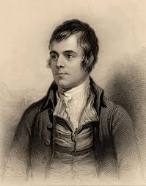
Willie Wastle
By Robert Burns

Willie Wastle dwalt on Tweed,
The spot they ca'd it Linkumdoddie;
Willie was a wabster gude,
Cou'd stown a clue wi' ony bodie;
He had a wife was dour and din,
O Tinkler Madgie was her mither;
Sic a wife as Willie had,
I wadna gie a button for her.

She has an e'e, she has but ane,
The cat’s got twa the very colour;
Five rusty teeth forbye a stump,
A clapper tongue wad deave a milkr;
A whiskin beard about her mou',
Her nose and chin they threaten ither;
Sic a wife as Willie had,
I wadna gie a button for her.

She's bow-hough'd, she's hem-shin'd,
Ae limpin' leg a hand-breed shorter;
She's twisted right, she's twisted left,
To balance fair on ilka quarter:
She has a hump upon her breast,
The twin o' that upon her shouther,
Sic a wife as Willie had,
I wadna gie a button for her.

Auld baudrans by the ingle sits,
An' wi' her loof her face a washin';
But Willie's wife is nae sae trig,
She dights her grunzie wi' a hushion.
Her wallie nieves like midden-creels,
Her face wad fyle the Logan-water:
Sic a wife as Willie had,
I wadna gie a button for her.

