Every pupil can access Office 365 (Microsoft Word, PowerPoint, Excel, plus other Microsoft packages) for FREE through Glow from the tile ‘Download Office Now’.
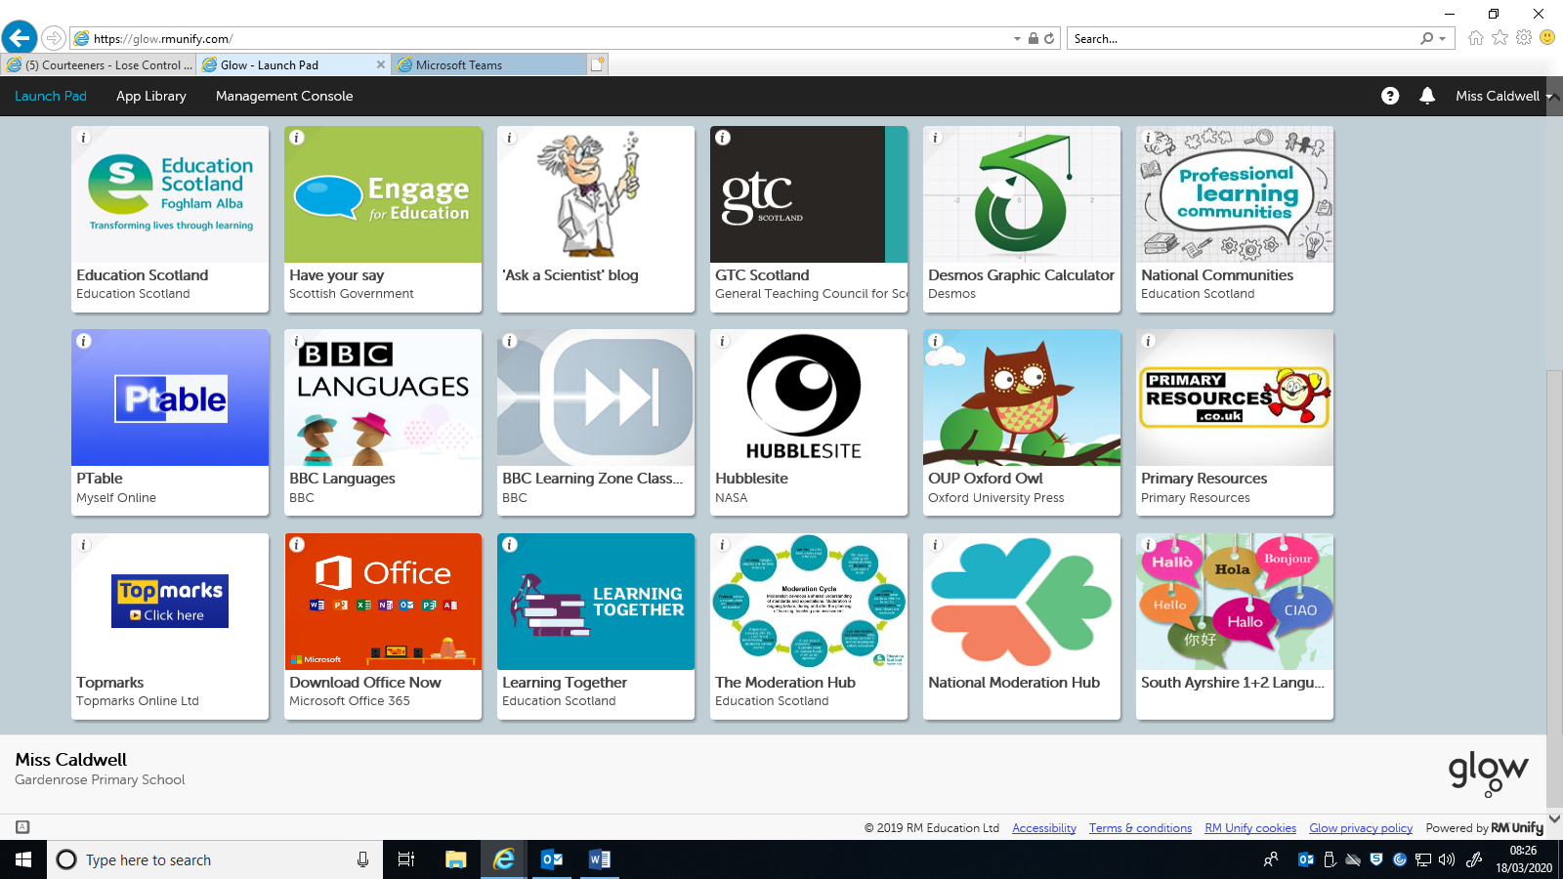
Accessing the app – (on a phone, iPad/tablet)
Use your app store to download the free ‘Teams’ app.
It should look like this:
Once you have downloaded the app and logged in using the same details as earlier, then you should not be required to enter your details each time.
Help!
If you have any issues please contact Miss Caldwell through the school email address or any staff member through our Twitter page or Facebook group.
@gardenroseps
Sophie.Caldwell@south-ayrshire.gov.uk

Gardenrose Primary School
Your child’s class teacher has created a page to allow them to communicate whilst they are at home. We would encourage you to use this page to access work, leaflets, help guides and any information posted by the class teacher.
Please note that you may also receive whole school updates through our Twitter page:
@gardenoroseps

Accessing your child’s class page from home
Use this link:
https://glow.rmunify.com/

OR search for Glow rmunify and click the top result.

Your child’s username has been provided along with their password.
The password for all Gardenrose pupils is: Gardenrose1
- Once logged in you will need to click into the ‘Gardenrose Primary School’ section at the left hand side.
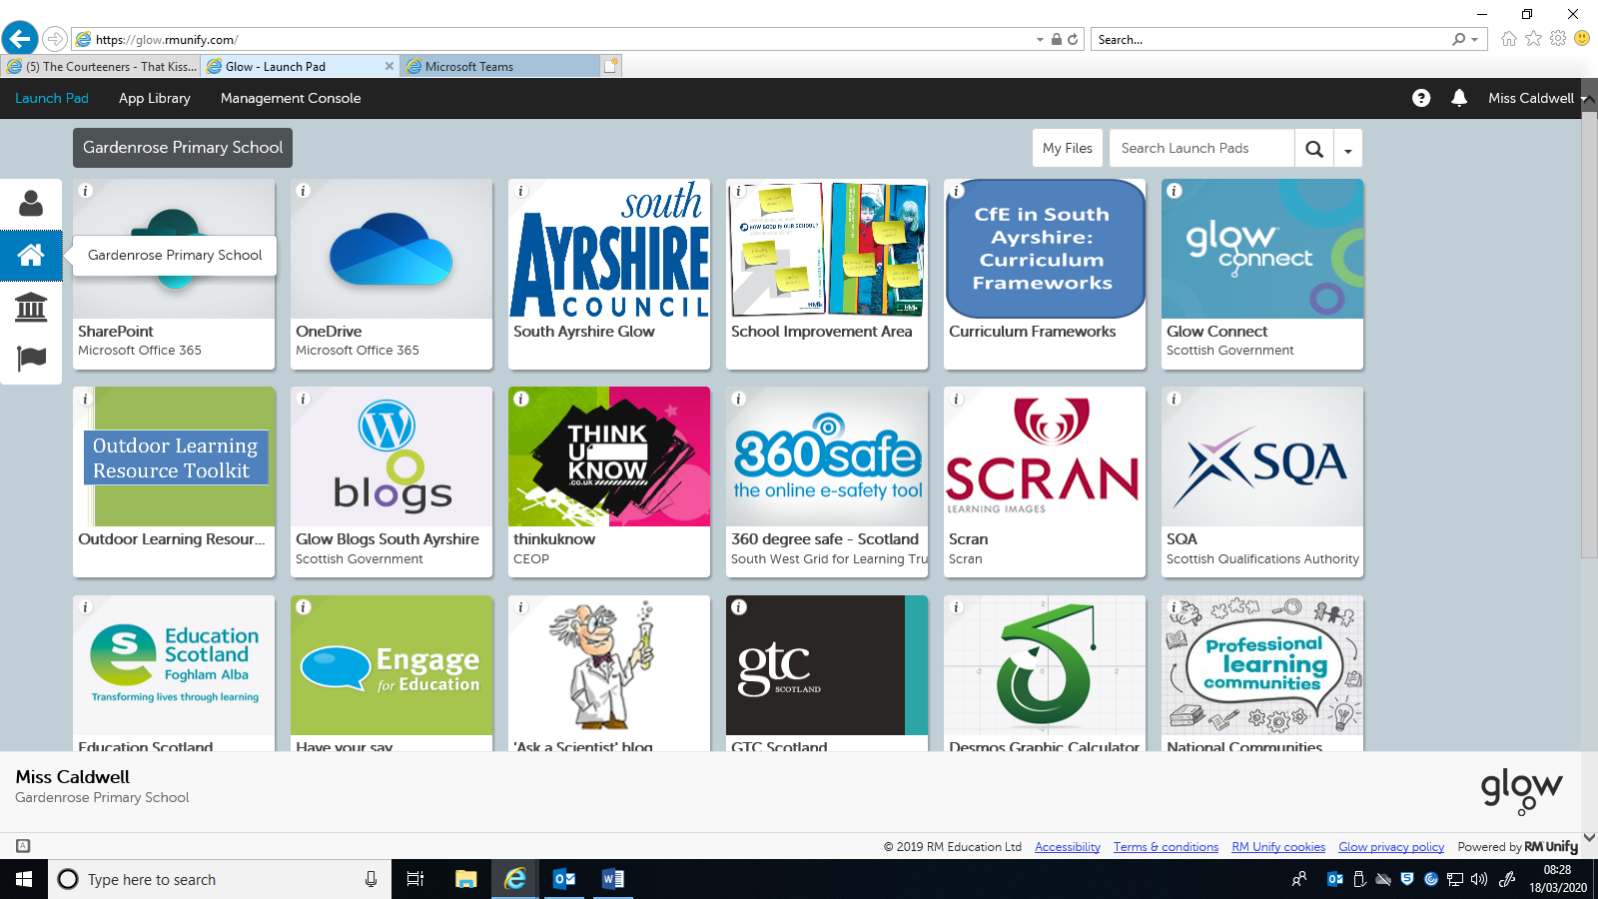
- Within this section, you will find a tile called ‘Microsoft Teams’. Click this tile. If it does not appear – search ‘Teams’ in the search bar.
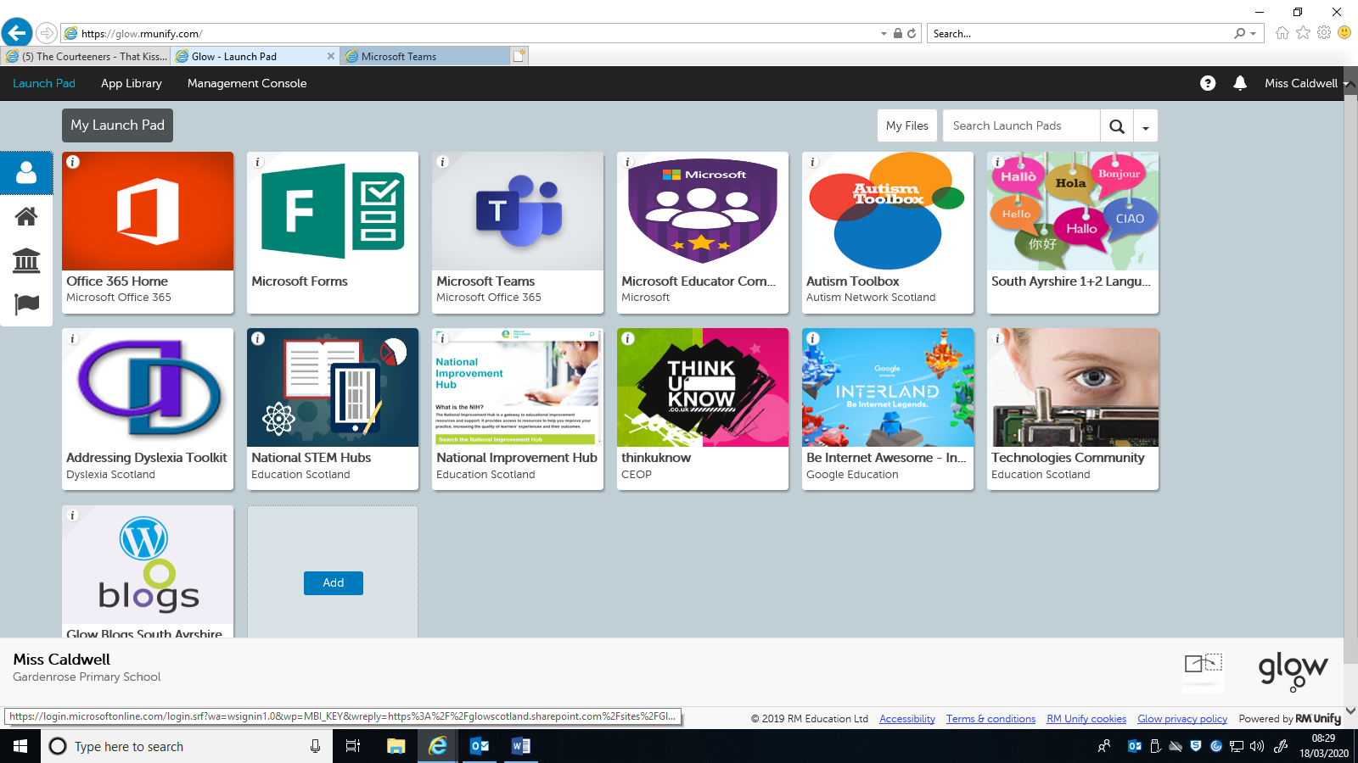
- Your child has been added to their class page so please click on the tile that appears e.g. ‘Primary 7’
- Example Page - ‘Primary 7’

The class page will look like the above screenshot. The class teachers will be able to write comments and messages for the children. There are section headings along the top such as ’files’ where you will be able to access work that can be completed at home. We have also compiled a list of websites and apps that will be useful too. This document is saved within this page also.
