Gardenrose Primary

Newsletter

Term 1 (August to October)



**Dear Parents / Carers,**

The first term back of this session has been very different from normal, but we are delighted to have all of the children back to school. All of the classes from the EYC through to P7 have settled in very well to their new classes and they have adapted very well to the new routines including entering and exiting through their classroom doors, sitting in rows with allocated seating plans, washing and sanitising their hands and cleaning surfaces before and after use.

It has been very challenging for everyone, but the staff and children have been very flexible in adapting to the continual changes as we respond to the latest Government Health advice.

We are all so pleased to be back together as a school community, after such a long time away from school, and we are all working together to ensure the safety of everyone and thank our parents/carers for your cooperation and understanding during these times.

**Parental Communication**

**School and EYC BLOG**

We are uploading all letters and important correspondence to the BLOG in addition to sending them via e-mail. This should make it easier to check anything as all of the information will be in one place. There is also a section for each Class and you will find current information and photographs relating to your child’s class, with updates from this term.

**You will find it at** [**https://blogs.glowscotland.org.uk/sa/gardenroseprimary/**](https://blogs.glowscotland.org.uk/sa/gardenroseprimary/)

We are continuing to use facebook as well as twitter to share highlights of the learning going on throughout the school. South-Ayrshire Council support the use of twitter and we have lots of followers, which is great in order that we are able to share our successes more widely. The twitter posts can be accessed using twitter or from our BLOG. The school facebook page is a closed site so you need to ask to join it. This is to allow us have full control over any inappropriate posts or comments.

**To follow us on Twitter, download the twitter APP and follow us on @GardenrosePS**

We have also introduced SEESAW as a way of sharing the children’s work with you - each parent will be able to view their own child’s work. The children are developing their skills in photographing their achievements and uploading it to their own profile. We have launched this within our EYC as well, so that parents get more regular information, and have the opportunity to share any learning that their child has been involved in at home.

**ICT refresh**

Last year, the school was very fortunate to benefit from the South Ayrshire refresh programme and we received 13 new desktop computers and 4 new laptops. We also added to this from the school budget by investing in more laptops and new iPads to enable the children to have better access to computers and technology within their class, in addition to using the ICT Suite. This session we are planning to invest in more ipads and laptops as well as a storage and charging unit. This term we have just had 4 new interactive promethean panels fitted in classrooms to provide the most up to date technology.

A school survey conducted during lockdown, identified a number of pupils who did not have access to a device to facilitate home learning. Through the Connecting Scotland and Digital Deprivation Programmes, we have secured ipads and chrome books to be provided to these families to support with learning at home. They will be distributed over the coming week.

**Curriculum**

**Assessment**

This term we have been focusing on getting the children back into school and settled into routines. They have all completed assessments in Literacy and Numeracy as well as completing their Health and Well-being Webs. This has generated a range of very useful data which the staff will use to plan each child’s next steps in learning as part of the recovery process to ensure that we are addressing the gaps in their learning as a result of the lockdown.

**Outdoor Learning**

All of the classes are spending time outside engaging in outdoor learning activities, participating in PE and generally making sure that they are getting lots of fresh air and exercise to stay healthy.

P.E. currently is taking place outdoors and the guidelines from Education Scotland is currently under review and we are hopeful that they will allow some indoor sessions, particularly as we move into the winter term. After the October holidays, the children can bring in their PE kit at the beginning of the week and it will be stored in the classroom for use throughout the week. At the moment, we are not able to offer any after school clubs but we are hopeful that we will be able to soon.

**Culzean Outdoor learning sessions**

Primary 1 as part of Early Level Transitions are joining the EYC and will all get the opportunity to enjoy outdoor learning at Belleisle Park in Ayr.

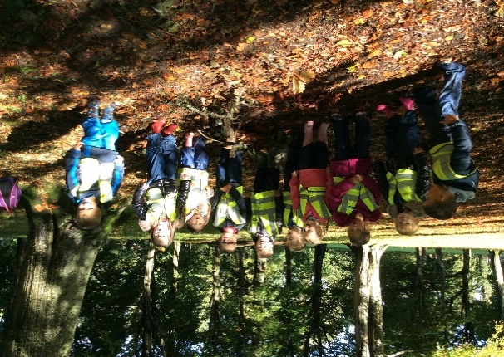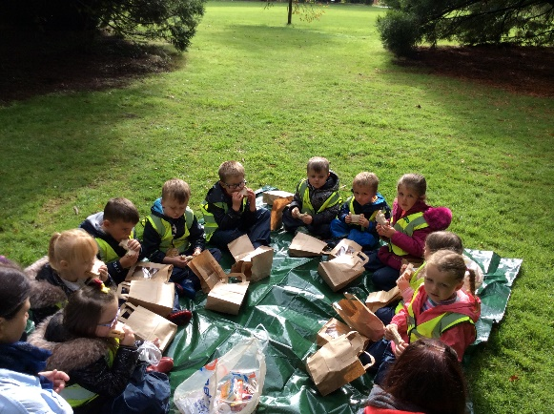

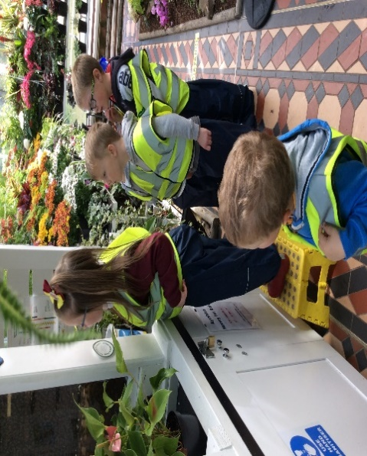

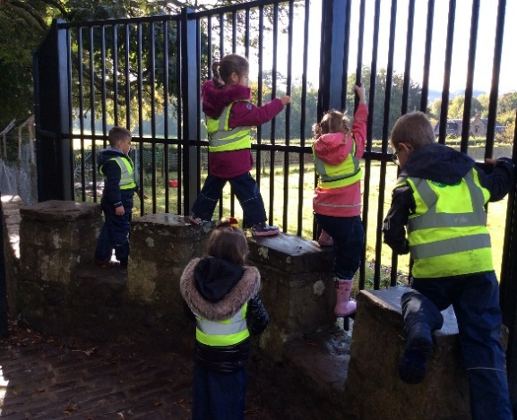

Primary 2 to 7 are all getting the opportunity to attend an outdoor learning session at Culzean Country Park. These sessions are being led by Ryan Douglas, our Active Schools Coordinator, and the main focus of the sessions is to increase physical health; build confidence and self-esteem; develop skills in team working and communication. The pupils will also learn about respecting the environment as well as a variety of curricular topics and life skills through: Orienteering, Rock Pooling, Beach Scavenger Hunt, Bush Crafts, Fire Building and Nature Walks.

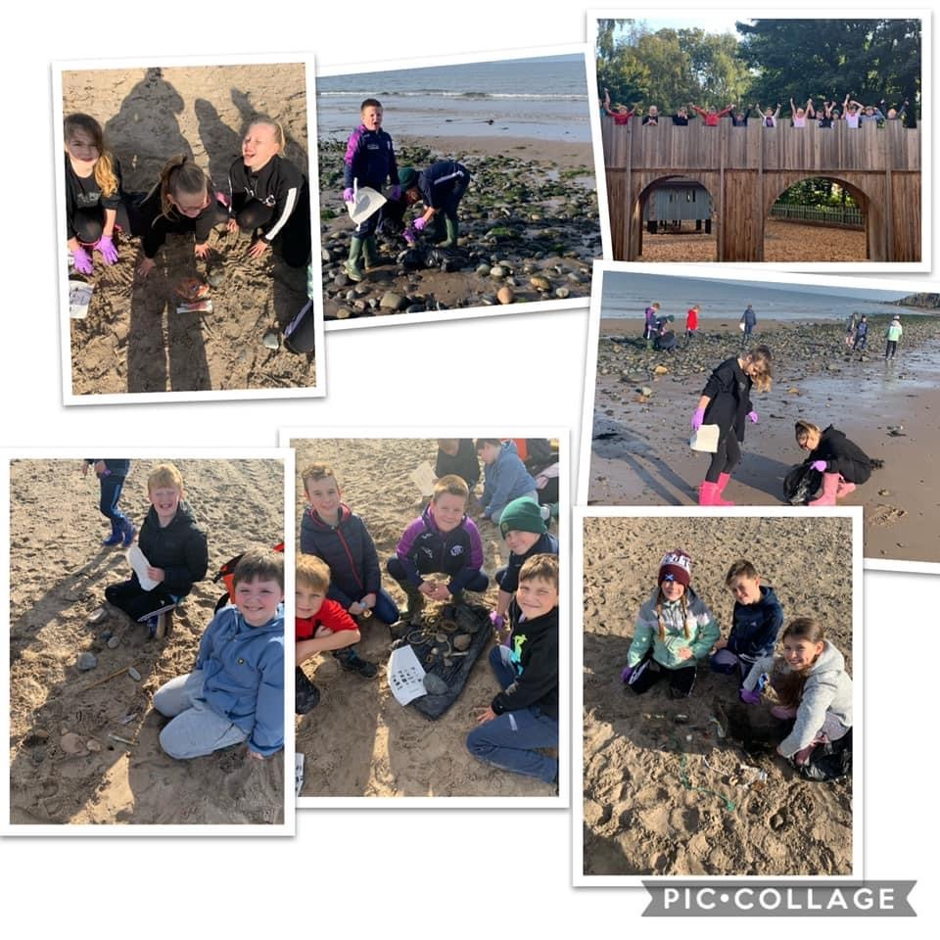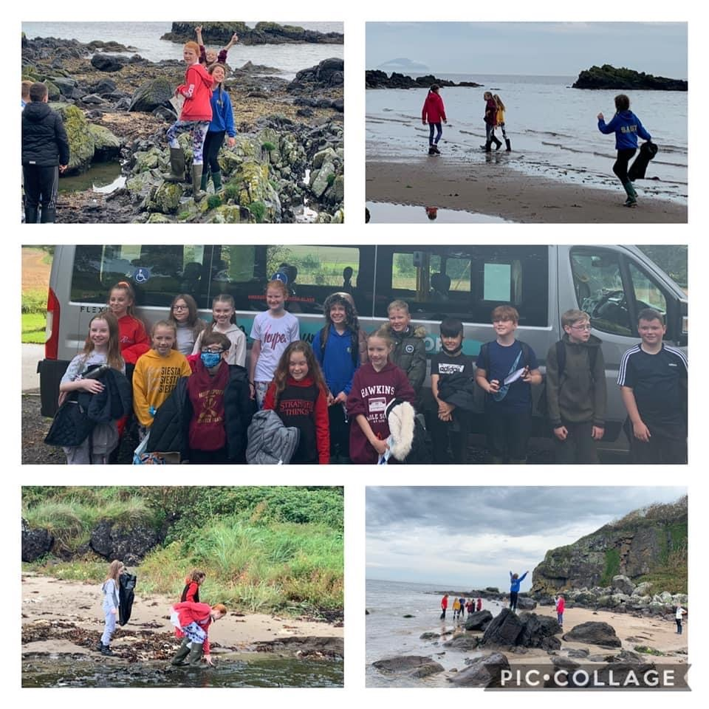

**Parents meetings**

****Due to the ongoing COVID situation, there will not be face to

face parental appointments this term but we have organised

telephone appointments with parents/carers to give yourselves

the opportunity to have a dialogue with the Class Teacher, as

part of our commitment to reporting to parents.

We have also sent home a sample of your child’s work in their own folder, to give Parents/Carers the chance to look at the work that their child has completed this term.

**Scholastic Book Fayre**

The Scholastic Book Fair was due to come to the school as part of Parents’ night evenings in November. We have decided to go ahead with the Book fair as we feel that it is important to give children and families the opportunity to choose books and the school always benefits from the commission on any sales, which we then use to purchase books for our own library.

The arrangements for viewing books will be a bit different but Scholastic have provided us with a lot of advice on running a COVID safe Book Fair.

* All cases have been deep cleaned between school deliveries, and books have been quarantined for 72 hours before delivery to our school.
* Signage will be used to encourage children not to handle the books unless purchasing
* Parents/carers will be able to make cashless payments using Phonepay or they can pre-purchase gift vouchers from our Fairs website(s)
* We will provide a ‘pre-browse’ downloadable order form with a complete list of books available with images of the book covers and prices. This will be available online to download and will be sent out via email to the parents/carers so that parents can help their children with selection and have an idea of the value.

**[](http://www.google.co.uk/url?sa=i&rct=j&q=&esrc=s&source=images&cd=&ved=0ahUKEwij_pzwuajXAhVLKsAKHdBBAwEQjRwIBw&url=http://www.lundavraprimary.co.uk/2016/04/scholastic-book-fair/&psig=AOvVaw1N-xltE6YHetiDQzadwTOs&ust=1510006274406181)**

**School Improvement Priorities 2020-21**

The School Improvement Plan for this session and the Standards and Quality, detailing attainment and achievements from last session will be uploaded to the BLOG once it has been approved by our Quality Improvement Officer.

**What are the key priorities for improvement in 2020/2021 ?**

To raise attainment in literacy for all pupils whilst closing the gap through collaborative dialogue around learning and teaching, data literacy and high quality professional development across the Carrick Cluster.

riority2: RAISING ATTAINMENT IN NUMERACY

To raise attainment in numeracy for all pupils whilst closing the gap through collaborative dialogue around learning and teaching, data literacy and high quality professional development across the Carrick Cluster.

To provide enjoyable learning experiences with appropriate support and challenge, for all learners through addressing the principles of GIRFEC.

To focus on improving confidence and competence of Staff to effectively teach STEM education and provide learners with STEM skills and knowledge that they require throughout their lives.

To ensure that at least 85% of children in their Pre-school year will achieve all milestones in Literacy, Numeracy and HWB by ensuring quality experiences for all children.

To implement our Pupil Equity Fund proposal with a clear focus on targeting our most disadvantaged and vulnerable children who have been identified using a wide range of data and evidence

**Ethos and life of the School**

**MacMillan Coffee morning**

During Term 1, Primary 7 worked hard to host a very successful MacMillan Cancer Support fundraiser. To adhere to current guidelines, we had to come up with creative ways to raise funds. Primary 7 organised a Zoom Coffee Morning where all classes were invited to the hall for cake and juice, kindly provided by the Parent Council. Thank you to all parent/carers who were able to join us in our live call and shared a cake virtually. In addition, using Just Giving, we took donations for raffle tickets and hosted a live stream raffle on Facebook. A huge thank you to all who donated prizes for our raffle and those who bought tickets. Our final fundraising event was a silent auction for an authentic signed ‘Pele’ t-shirt, very kindly donated by Miss Pollock. The shirt sold for £150!

Overall, from our events we managed to raise over £700. An absolutely amazing total that will be very much appreciated by MacMillan Cancer Support Scotland. A huge thank you to all involved.

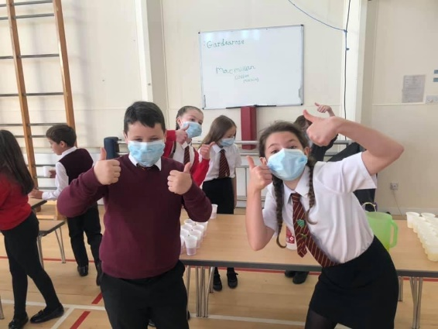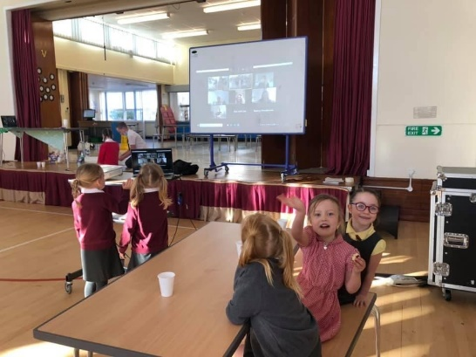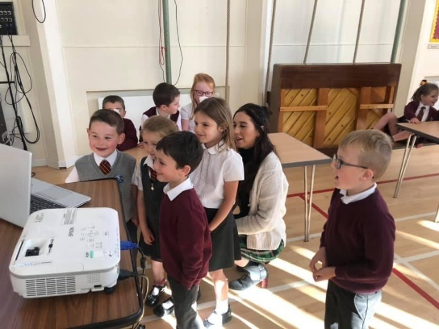

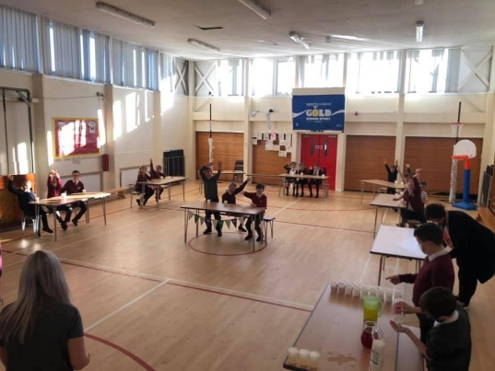

**Parental Concerns**

**Dogs in the playground**

Parents have approached the Parent Council with concerns over the number of Parents/Carers who are bringing their dogs into the playground. I appreciate that Parents/Carers are enjoying walking their kids to school and bringing along the family pet, and we have enjoyed meeting all of the new puppies, but unfortunately we are going to have to ask that you refrain from bringing them into the playground. South Ayrshire policy states that there should not be any dogs in the playground due to some children who may have a fear or an allergy.

**Feedback – we appreciate your comments or suggestions**

**Please e-mail any feedback to :** [**gardenrose.mail@south-ayrshire.gov.uk**](mailto:gardenrose.mail@south-ayrshire.gov.uk)

**Please provide feedback on any of the activities which your children have been involved in during last term.**

**We are also always looking for new ideas and ways to improve the learning experiences for your child so please e-mail any helpful comments or constructive criticism – Be kind ☺ !**

**GARDENROSE PRIMARY**

**DATES FOR YOUR DIARY**

** TERM 2 - October to December 2020**

**October**

*Friday 9th Close for holidays*

*Monday 19th Inservice Day 2 - Staff only (Holiday for children)*

*Tuesday 20th Inservice Day 3 - Staff only (Holiday for children)*

Friday 30th October Halloween Class Activities and Sponsored Walk–details to follow

**November**

Sunday 8th Remembrance Service

Wednesday 11th Armistice Day

Thursday 12th Scholastic Book Fair arrives (1 week)

Friday 13th Children in Need activities – details to follow

Friday 27th Interim Tracking report issued to parents/carers

Monday 30th St. Andrew’s Day class activities – details to follow