Gardenrose Early Years Centre
Newsletter
September
2020

Dear Parents / Carers,

We are all very excited to be back in the Early Years Centre with our friends and the ladies. We are getting used to our new normal and the ladies are so impressed at how well all the children have adapted to their new routine.

School and EYC BLOG
This term we are endeavouring to go paperless. We will now be sharing all important information through our blog, as well as sharing what we have been learning in the Early Years Centre.
https://blogs.glowscotland.org.uk/sa/gardenroseprimary/
To follow us on Twitter, download the twitter APP and follow us on @GardenroseEarly for pictures of our learning journey.
See-Saw
Over the next few weeks, we will be introducing our brand new communication platform, SEESAW. This platform is available through an app and will allow us to share newsletters, photographs, learning updates as well as communicate with our parents/carers.

Curriculum
We are responsive to the interests of the children and this term we have collated many of their ideas.
“It is nearly Autumn after that it will be Winter then Spring again, then Summer”- Emily
“I like worms, my papa uses them when we go fishing” -Grayson
“Animals hunt for food at night time” (Lewis)
“Owls say tweet tweet they eat worms” (David)
We are going to be exploring woodland animals and their habitats. We are looking forward to finding out new information and learning about Autumn through a wide range of activities.
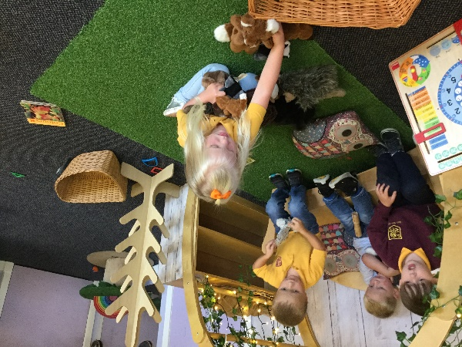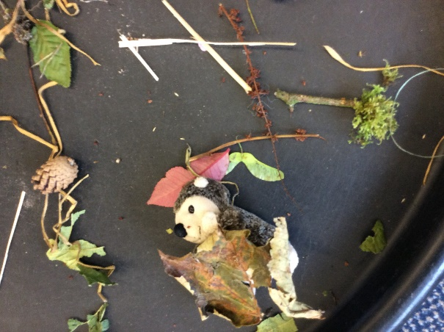

Family Learning
Please let a member of staff know if you would like support from Marie our Early Years Family support worker. She can help support in many areas of your child’s development whether it be eating, toileting, routines or finding out more information in how you can support your child’s development at home. Marie is coming into the Early Years Centre on Friday 25th September to work with groups of children. We will share on our blog and Twitter Marie’s Session.

School Lunches
We are pleased that our hot lunches will resume after the September long weekend. We have missed trying a variety of new tasty meals created by our kitchen staff.

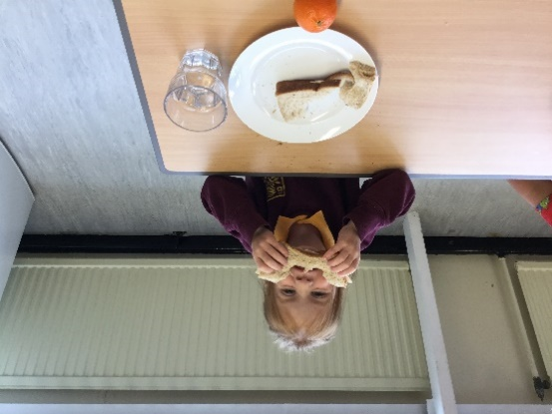
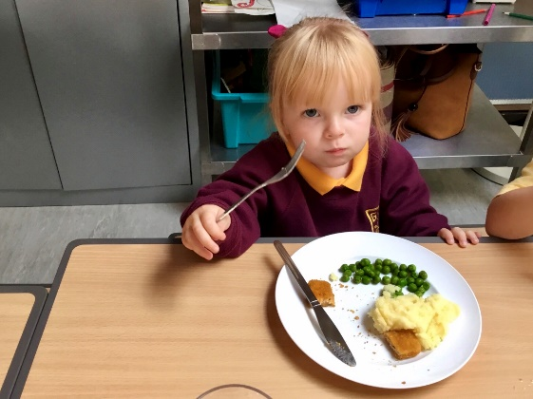

Appropriate Clothing
Please ensure the children are all appropriately dressed for the weather. It gets very windy up the hill so hats, gloves, hoodies and waterproof jacket will keep us nice and warm. Wellies for our pegs are handy too. We can gain independence changing into our wellies before we go outside.

Outdoor Learning
We will soon be starting our blocks of outdoor learning. Susan from the red group will drive us in the South Ayrshire Council community mini-bus alongside 2 members of early year’s staff. We plan to visit Belleisle, Ayr and look for changes in the environment. All parents have communicated permission for outings verbally, however if you do not wish your child to take part in this experience please let a member of staff know. Dates and group details to follow.
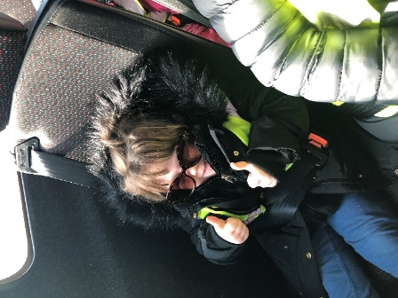
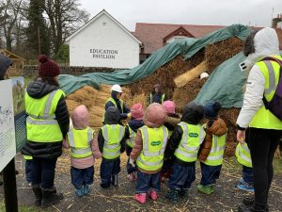
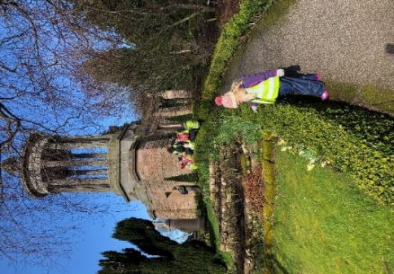

Staff News
We welcome new Early Years Practitioners this term. Abby Colman and Rhian McDermott will be working within the Early Years Centre and supporting play based learning within the infant department. Abby and Rhian will share responsibility for the blue group. We also welcome Zoe Wilson and Julie Taylor who will be working with us up until October holidays both in the Early Years Centre and the infant department.

Dates for the Diary

Friday 18th September 2020 - Holiday
Monday 21st September 2020- Holiday
Friday 9th October 2020– Schools Close
Monday 19th October 2020- Inservice Day
Tuesday 20th October 2020- Inservice Day
Wednesday 21st October – Pupils Return

Outdoor Learning Dates

Group 1  Mon 28th Sept | Group 2  Mon 5th Oct | Group 3  Mon 26th Oct | Group 4  Mon 2nd Nov | Group 5  Mon 9th Nov
Archie | Jordan | Lauren | Jaxon | James
Jack | Layton | Ana | Damian | Alfie
Noah | Harry | Darcey | Ivy | Boston
Oliver | Brooke | Harris | Lily | David
Skylar | Freya | David | Flora | Finn P
Sophie | Novah | Naomi | Maizie | Milan
Cody | Murrin | Eve | Emily | Mia
Olivia | Brodie | Liam | Anna | Jack
Amelia | Lewis | Arthur | Calum | Eilidh
Grayson | Holly | Bethany | Kolten | Finn N
 |  |  | Erin | Sydney
 |  |  |  | Morgan

Feedback – we appreciate your comments

We are also always looking for new ideas and ways to improve the learning experiences for your child so please provide any helpful comments below.

If you wish to e-mail any feedback please send it to:
gardenrose.mail@south-ayrshire.gov.uk

