

Upcoming Dates

**2nd 5th October - - PEEP**

**9th October - EYC Closes at 3pm**

**19th & 20th October - Inservice day**

**(Staff only attend)**

**21st October - EYC reopens**

**23rd December - EYC closes for**

**Christmas**

**6th January 2021 - EYC re-opens**

**Songs we will be learning this month**

Picking up conkers

Twinkle Twinkle

The Grand old Duke of York

**Stories that we will be hearing this month include:**

The Owl babies

Whose bottom is this?

Click or copy link to listen to Owl Babies story online

https://youtu.be/TPQRiSTYFHo

**QUOTE OF THE MONTH**

[](https://www.bing.com/images/search?view=detailV2&ccid=v6YOJOyp&id=D6923E9D4736D9B12D29967684A7C540B7BFDECC&thid=OIP.v6YOJOyp0Z5Fd-DUSfzXaAHaGN&mediaurl=http://3.bp.blogspot.com/-RsVnBwKC0eM/VSU0UbgJNSI/AAAAAAAAR1Q/JZS2zamvby4/s1600/quotes-children-play-3.png&exph=788&expw=940&q=children's+quotes&simid=608006677372339924&ck=AE2D05B377031AF1CA9B4B42928490C7&selectedIndex=0&adlt=strict&FORM=IRPRST)

Dear Parents/Carers

Welcome back to all of our children and their parents.

Hope you enjoyed some of the activities that were posted via emails and on our facebook page for you to do during these very strange times.

This term we will be learning how we can move our bodies and beginning to take small risks and risk assess our play.

We will also be exploring our local environment if the weather allows us so could you please ensure that your child comes suitably dressed should we go outdoors.

As you know there is still a lot of media coverage regarding Covid 19. We ensure that the playroom is both thoroughly cleaned and safe for your child to attend the Early Years Centre each day along with staggered start and pick up times. Unfortunately parents are not allowed to enter the playroom at this time so your child will be met by a member of staff at the door where they will enter and will be dismissed at your allotted pick up time in the same way.

Please read the poster that is displayed on the playroom door regarding prevention. Can you please encourage your child to cover their mouth when coughing and sneezing and to ensure that hands are washed and dried after this. The Carrick Centre has a one way system in place and facemasks are required to be worn when in the building so we ask that you abide by these rules.

If your child is unwell and not attending the EYC

can you, please phone or text staff to inform them.

The EYC number is 07890380642.

Take care and stay safe

Upcoming dates

14th November: Parents meeting (AM)

15th November: Children in Need come

dressed in Pjs if you wish.

15th November: Carrick Centre Xmas Fayre

21st November: Gardenrose PS Xmas Fayre

10th December: EYC parents and children’s

Singalong.

17th December: Tots Xmas Party for both AM

And Pm children.

**\*\*\* Close for Holidays Friday 20th December**

**At 2.30pm \*\*\***

**\*\*\* Re-open Monday 6th January\*\*\***

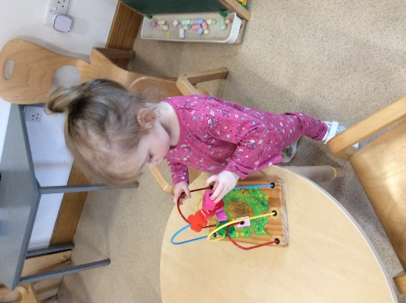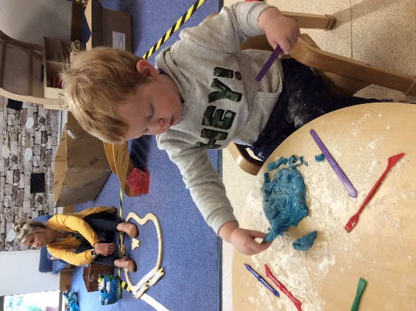

**Using fine motor skills**

**Playing with playdough**

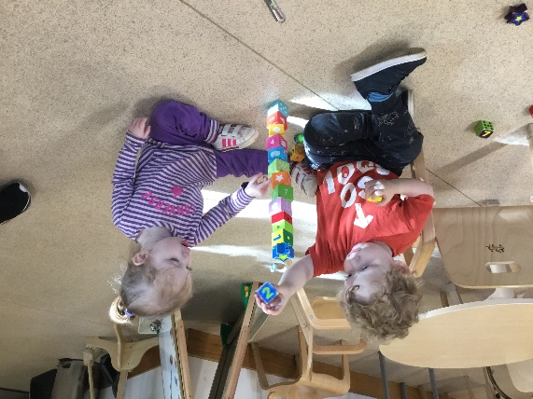

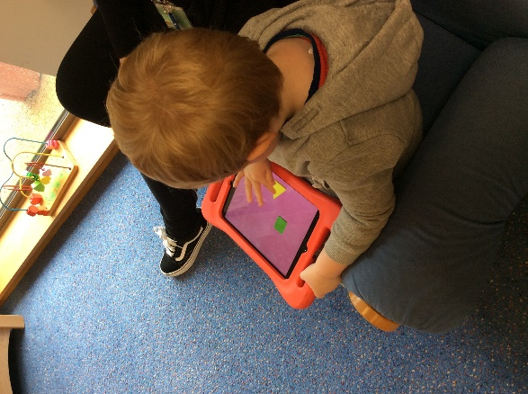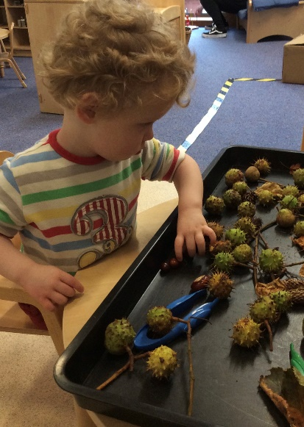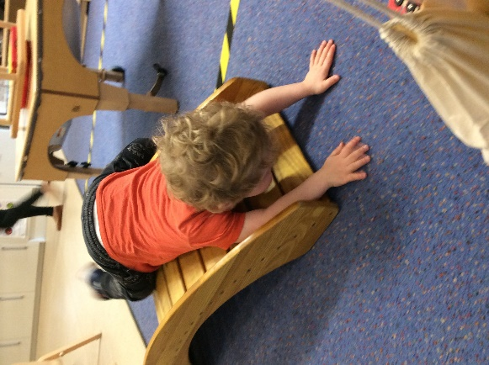

**Investigating the conkers**

**Working together**

**Matching the shapes on the ipad**

**Climbing on the bridge**