‘It hadn’t occurred to me to listen to my small child and give him space and time to talk.’  (Peep Parent)  ‘I’ve discovered how much my child learns through play.’ (Toddler Peep Parent)  “What I love, is spending time with my child at their nursery, seeing them play with other children” (Early years Parent)  “We sing all the songs at home”  “it’s a great way to get to know other parents  “I have loved seeing my childs confidence grow and we look forward to it each week”  “I have learned new ways to help my children learn” (EYC Family)  The groups are relaxed and fun – my child looks forward to it each week (EYC family) |  |  |  |  | supporting parents and children  to learn together |   Family Fun and Learning    South Ayrshire Family Learning Team.
  
  The Peeple Centre
  PO Box 1404
  Oxford OX4 6XW
  Peeple is a charity that trains practitioners and works with families - enhancing children’s development by making the most of play and learning opportunites in everyday life
  Stay in touch
  facebook.com/peeplecentre
  @PeepleCentre
  www.peeple.org.uk
  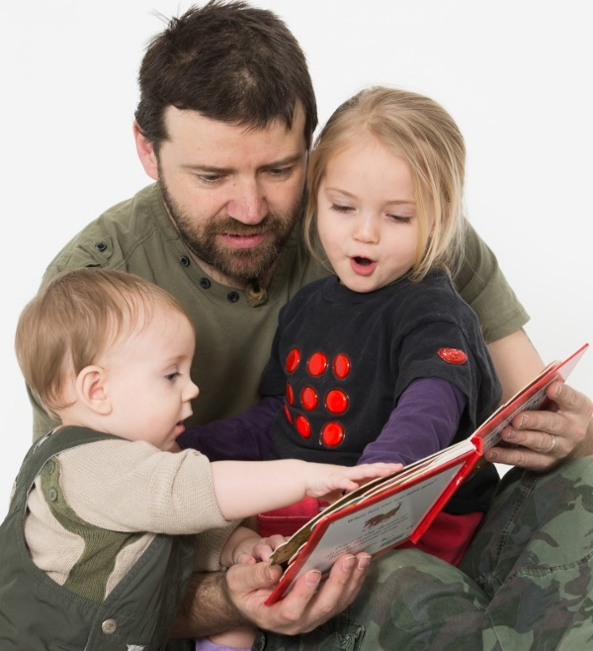
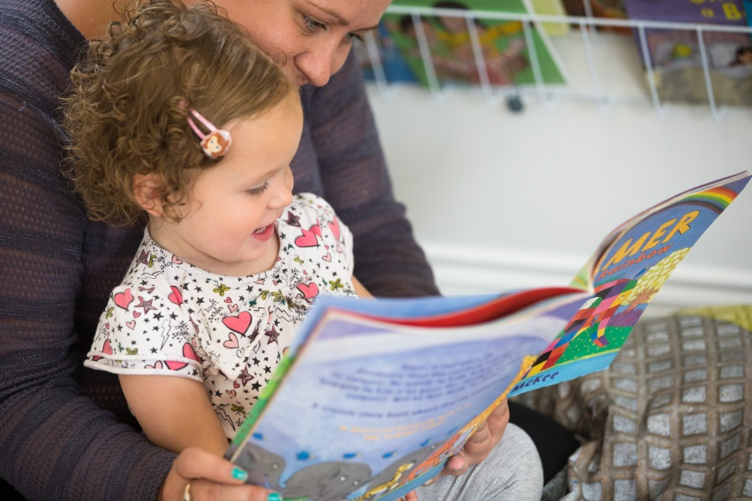  Our Family Fun Sessions support all parents and carers with children in our Early Years Centres.  You can make a real difference to your childs learning and development by talking, playing, singing and sharing books or activities together.  Please join us next time where you and your child will have the opportunity to make new friends and share ideas.. |  |  | Your Family Learning sessions are run by:  Elaine Clinton (Family Learning Team)    Look out for posters and information from your child’s Early Years Centre.  I can also offer 1-1 advice and support on a range of parenting issues and will be very happy to hear from you.  You can contact me at:  Elaine.Clinton@south-ayrshire.gov.uk  I Look forward to meeting you all! |  |  | 