Education Services
Director: Scott Mulholland
Centre Manager: Kimberly Lennox
Forehill Early Years Centre
Cessnock Place
Ayr
KA7 3JU

27th May 2026

Tel: 01292 612461
Email: forehillEYC.mail@south-ayrshire.gov.uk
Website: https://blogs.glowscotland.org.uk/sa/forehilleyc/

Dear Parents/Carers

We are holding our Daisy Pre-schoolers Celebration Day on Thursday 11th June 2026. Please see below for times, if you are unsure of your child’s group please ask their keyworker.
9.30am-10.30am – Purple, Red, Yellow, and Orange
1.40pm-2.40pm Pink, Blue, Green and Lime
Please arrive 15mins before your child’s start time to allow you to be in and seated.
For our celebration event, children are welcome to wear whatever they feel most comfortable and happy in on the day. Diane one of our parents thoughtfully organised through a parent led initiative a celebration t-shirt and these would be a lovely addition on the day. However, there is absolutely no expectation for children to wear them, as we want everyone to feel relaxed, included and able to enjoy the event in a way that suits them best. Some children will have been given glow light up sticks we ask that these are not brought to the celebration day.
Due to space, there is a limit of 2 people per child.
The children have been working very hard on their celebrations and are looking forward to sharing them with you. We are very proud of how hard both the children and staff have worked, and we hope you enjoy watching them in their last nursery performance.

Thank you for your continued support
Kind Regards
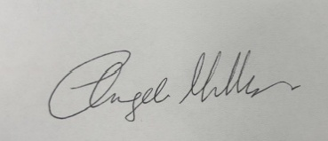

Angela Milligan
Early Years Depute Manager

