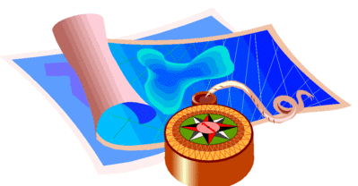
Early Years Centre Home Learning Grid
This week your theme is: ADVENTURE

Literacy  Look out the window and play the I-Spy game together  This Photo by Unknown Author is licensed under CC BY-SA | STEM  Use your knowledge of 2D and 3D shapes to design a vehicle that could take you on an adventure.  What can it do? Drive? Sail? Fly? Dig tunnels? ALL OF THESE!!!  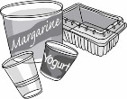  Imagine / draw /  junk model! | Construction  Use Lego, building blocks or any other construction material to create your own adventurous landscape – a fearsome jungle or treacherous ice maze or other-worldly environment! | Art & Design  Build a den using sheets, blankets, throws or towels  Think about what else you could put in your den?
Reading  Read an adventure story together and retell your favourite part – draw a picture of your favourite character | Numeracy  Get adventurous with numbers and head on an adventure round your house.  Look around to see if you can find any numbers, this can be inside or in your garden. Can you identify the numbers? Can you write the numbers? | Health & Wellbeing  Adventurers need to be very fit and healthy to survive in different climates and environments for long periods of time.  Get outside every day for some running, jumping, skipping, hopping and physically active fun. Maybe even make an adventurous obstacle course! | Relax and unwind  Cosy up on the couch and watch and adventure movie.  Talk to your family about what you liked or didn’t like about the movie.
Mrs Hamilton’s Philosophical question of the week:

Can one person change the world?
Given the gloominess of the news, you’d be forgiven for thinking that there’s not much point in doing anything much, and that anything you do won’t make a difference. What about if you just try to make a difference in your tiny bit of the world? There are loads of kids who have done just that and changed laws and lives. Ask yourself what change would you like to see in the world? Then- how can you go about making it happen?

Unless someone like you, cares a whole awful lot, nothing is going to get better, it’s not. - The Lorax

