This week your theme is: People Who Help Us/ Heroes
I think that we all do heroic things, but hero is not a noun, it's a verb. - Robert Downey, Jr.
Literacy | Maths and Numeracy (STEM) | Health and Wellbeing/Other
Make a list of all the people you are aware of in society that are there to ‘help us’.  You could create a table and have one column for the job title, one column with a short description of what they do that is helpful.  Can you make connections between these helpful jobs to ‘needs’ and ‘wants’ ?  Create another column and add:  NEED or WANT  Link explaining needs and wants:  https://kids.britannica.com/kids/article/needs-and-wants/630969 | 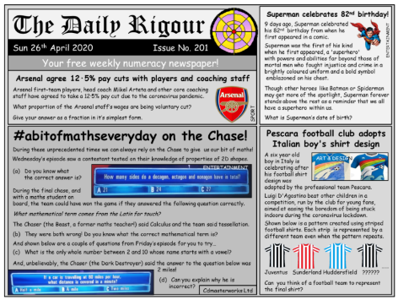  (large picture will be sent separately)  Solve problems:  Give the problems in the Daily Rigour a go! This could be a family activity that you all try and solve together.  For more independent numeracy try logging onto Maths workout:  - 13 Number Machines  - 14 Number Problems and Puzzles | 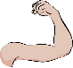  Keep going with your garden fitness. Super heroes definitely need to be fit and healthy.  This Photo by Unknown Author is licensed under CC BY-NC  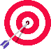  Be a home hero and make a list of things you could do around the house to help. This list could include chores and ways to show kindness. Maybe you could have a super hero chart and make a target to meet. Could there be a reward at the end of the week if you meet your target.  Even super heroes need help to make the right  decisions and actions. Try these yoga videos to help you stay clam and make good, kind choices.  https://www.youtube.com/watch?v=6cxt_Ki4GSo  This is a Harry Potter inspired yoga…  https://www.youtube.com/watch?v=R-BS87NTV5I
Look at your writing and use a highlighter or coloured pencil to indicate nouns and verbs. Use one colour for nouns and a different colour for verbs. Noun – naming word Verb – doing word  Here is a link to help you extend your grammar knowledge further:  https://www.bbc.co.uk/teach/skillswise/word-grammar/zfwfmfr |  | What makes the ultimate super hero? What powers do they have? What values do they promote?  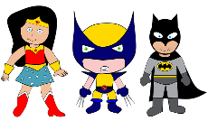  Design and label a new FPS super hero. Could this be our new school mascot?  This Photo by Unknown Author is licensed under CC BY-SA

Philosophical question of the week: Can kindness change the world?

Karma is the idea, put very simply, that if you act well, things will be good, and if you act badly, things will be bad. Do you agree with this? Is it good to be kind all the time to everyone? What do you think would happen if everyone did this? Think about how kindness makes you feel. Is it more important to be kind to yourself or to others, or is it of equal importance? Think about the effect of kindness and unkindness on the world. No act of kindness, however small, is ever wasted.
- Aesop

