South Ayrshire Council
Additional Support Needs Family Forum
Marr College
On Wednesday 19th February from 6:30pm – 8pm
ALL WELCOME at this event – it is open to all parents, carers and families who have a child or young person with any type of ASN – whether it has been identified, diagnosed or not. It is also open to health, education or social care staff who wish to find out more!
The forum will cover the following areas:
Introduction
ASN Family Forum and steering group overview and who’s who – the forum is organised for and by parents / carers.
Workshop 1 - Mental Health and resilience – a practical approach by Sarah Shennan – NHS Health Improvement Practitioner
Sarah will deliver a session focussing on mental health, building resilience and the importance of self-care for parents, carers and families. This session will give an overview of what’s available out there for support including signposting and online resources.
Catch Up Time
This break will allow parents / carers to catch up with each other to share information and knowledge about local resources and supports. Inclusion Coordinators and central education staff will also be available to answer any questions that you may have.
Workshop 2 – ICT
This session will show how to access GLOW, how to download Microsoft Office 365, help those having problems with Read Write Gold (ranging from downloading it to running it) and providing a list of apps that can be used.
Please share - @InclusionSac
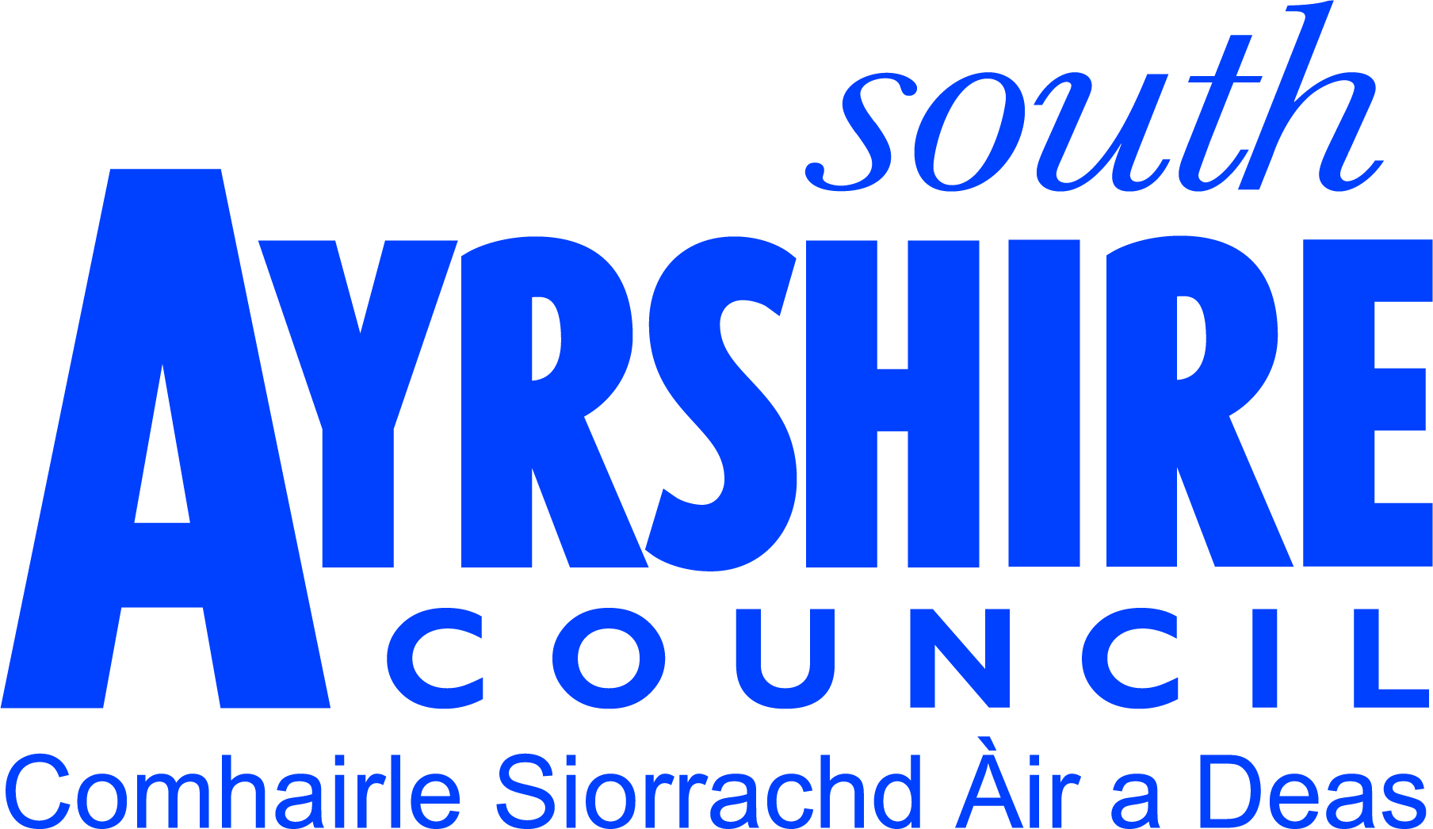If you have any questions or need help or support to get to the above event, please email:- Karen.Miller@south-ayrshire.gov.uk

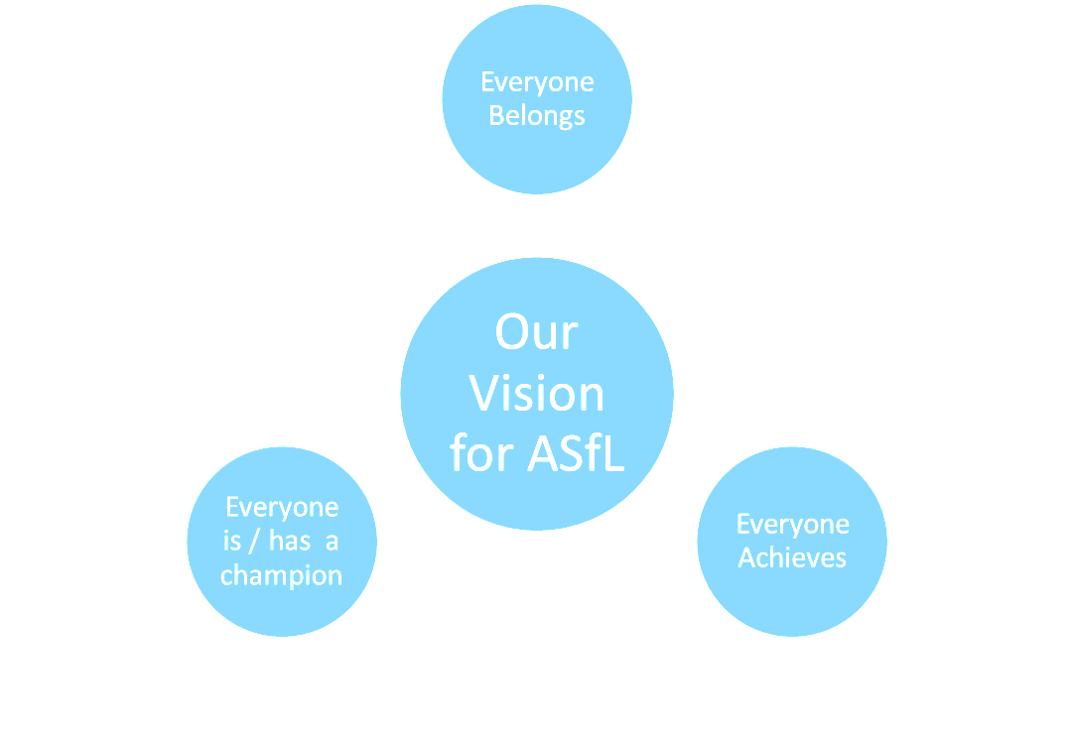

Overview - Additional Support Needs Family Forum
The family forum’s membership is made up, of parents/carers with children and young people who have ASN and staff or community using or involved with education services within South Ayrshire Council. The family forum aims to be a voice to inform service providers of the needs of children who have additional support needs (ASN) (whether it be diagnosed, identified or not) and their families.
It will facilitate two–way communication between parent/carers and services used by children, young people and their families in South Ayrshire. The forum will work to provide feedback on services, offer constructive challenge to current services and input into decision making and planning for future service provision.
The family forum believes that by working co-operatively with local service providers’, they will contribute to improvements in the services delivered for children with ASN.
- Through regular communication with parent/carers’, ensuring they are able to decide whether to be involved in a piece of work/consultation.
- Ensuring a diverse forum membership and representation of diverse views from children with ASN and parent/carers’ from all backgrounds and sectors of the community.
- Promoting a reputation and image of the family forum which reflects its aims and values.

Family forums for 19/20 -
Wednesday 20th November 2019 Girvan Academy 6:30 - 8:00pm
Wednesday 19th February 2020 Marr College 6:30 - 8:00pm
Thursday 7th May 2020 Ayr Town Hall 1:00 – 8:00pm

ASN Family Forum steering group
The business of the family forum is managed by the steering group. The family forum steering group will provide feedback to its membership through regular newsletters and updates on the ASN Family Forum webpage. There will also be updates provided on the ‘SAC Inclusion’ Twitter site and via individual school and early year centres newsletters. This will include outcomes from consultations and participation work undertaken, and in particular the effect on future service provision.

Steering Group meetings for 19/20 -
Thursday 24th October 2019 Forehill Primary’s Lifelong learning suite 6:30pm
Thursday 16th January 2020 Tesco Community Room 6:30pm
Thursday 19th March 2020 Tesco Community Room 6:30pm
Thursday 4th June 2020 Tesco Community Room 6:30pm
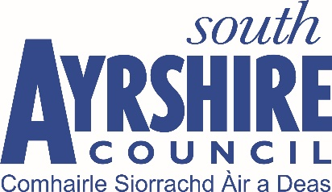
If you would like more information, have any questions or need help or support to access the above events, please email:- Julieann.millar@south-ayrshire.gov.uk

