Write your spelling words in your jotter 3 times.
Choose one other task from the menu below.
Try to choose a different task each week.

Rainbow Write | Silly Sentences | Backwards words | Waterfall Words
Alphabetical order | Story, Story | Fancy words | Spell aloud to an adult
Adding my words | Riddle me | Rhyming words | Colourful words
Word search | Words within words | Magazine words | Look, cover, say, write, check

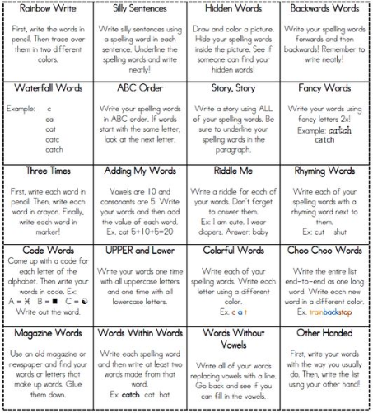
Colourful Words
colours

