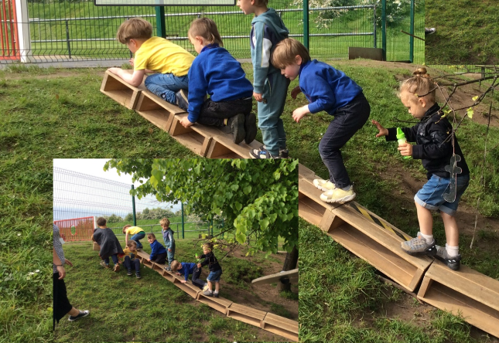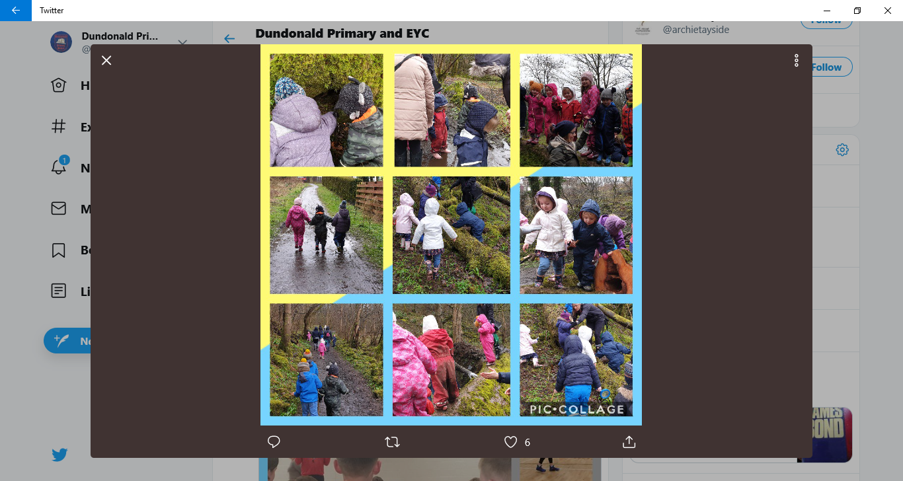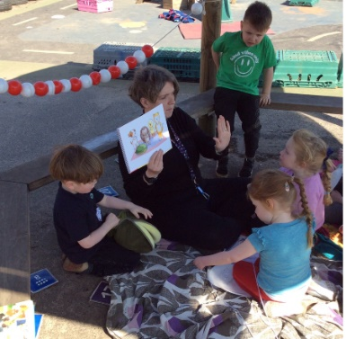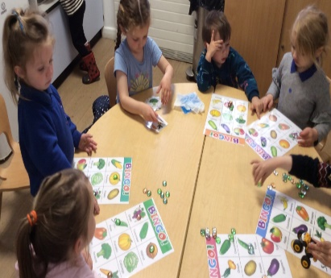

**DUNDONALD PRIMARY AND EARLY YEARS CENTRE**

**EARLY YEARS CENTRE HANDBOOK**

**…………………………**

**SESSION 2023-2024**





## Contents Page

Page 2 Contents page

Page 3 Head Teacher’s Introduction

Page 4 Early Years Centre Class Information

Page 5 Staffing

Page 6 Senior Leadership Team Remits

Page 7 Vision and Values

Page 8 Starting our Early Years

Page 9 Settling your child into Early Years

Page 10 Health and Safety

Page 11 Medicine and School Meals

Page 13 Dressing for Early Years and Outings

Page 14 Illness

Page 15 Early Years Centre Class Curriculum

Page 16 Early Years Centre Class Curriculum (cont)

Page 17 Partnership with Families; Supporting Children

Page 18 How can I help as parent/carer?

Equality

Page 19 Child Protection

Page 20 Further Information/Comments

## Introduction by Head Teacher

Dear Parent/Carer,

Welcome to Dundonald Early Years Centre. I hope you will find this handbook interesting and helpful. It is intended as a short introduction to our Early Years Centre for parents and carers of new, or returning, children.

Through this booklet, we have tried to give you a flavour of life in our Early Years Centre and the ways we will cater for the individual needs of each child. If the answers to your queries are not here, please do not hesitate to speak with our office staff who will arrange for one of our Early Years team to contact you. Please contact us via phone or email. Our telephone number is 01292 690075 and our email address is [dundonald.mail@south-ayrshire.gov.uk](mailto:dundonald.mail@south-ayrshire.gov.uk)

Parental involvement and working in partnership with families is an important feature in our school and Early Years Centre - we actively encourage close working relationships.

Most children will progress from our Early Years Centre to our primary school and therefore we will have a long relationship. I look forward to getting to know your family and hope that you will soon feel a welcomed and valued member of our school and early years community.

Yours sincerely,

**cid:image001.png@01D1FFBA.A9302640**

Mrs Fiona Paterson

Head Teacher

## Early Years Centre Class Information

**Centre Name:** Dundonald Primary and Early Years Centre

**Address:** Castle Drive

Dundonald

KA2 9EP

**E-mail:** dundonald.mail@south-ayrshire.gov.uk

**Location:** The Early Years Centre is situated within the main building of

the school. It has its own entrance to the rear of the building.

An enclosed outdoor play area is available for children.

**Telephone:** 01292 690075

**Working Capacity:** We have 49 places for children aged 2-5 years olds

**Denominational Status:** Non-denominational and co-educational

**EYC Class Hours:** 9am until 3pm Term Time

## Meet our Early Years Team

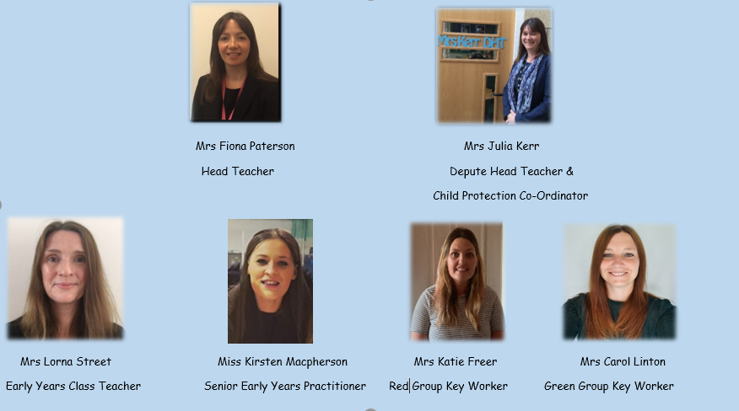

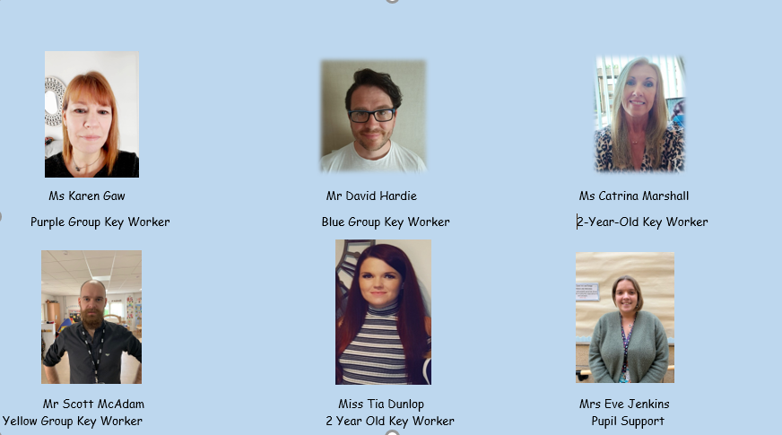

|  |  |  |  |
| --- | --- | --- | --- |
|  |  |  |  |
|  |  |  |  |

## Senior Leadership Team – Roles and Responsibilities

|  |  |  |
| --- | --- | --- |
| **Name** | **Designation** | **Areas of Responsibility include:** |
| Mrs Fiona Patterson | Head Teacher | * Overall responsibility for school and early years centre * Lead and manage learning and teaching * Lead and develop staff * Lead change and improvement in all aspects of the curriculum and school life * Responsibility for quality assurance and self- evaluation * Management of communications * Partnerships with parents and wider community |
| Mrs Julia Kerr | Depute Head Teacher | * Pupil Support including Dyslexia Friendly School, GIRFEC, Inclusion * Child Protection Co-ordinator * Curriculum – Numeracy & Mathematics, French * Assessment * Partnerships with parents and wider community |

## Vision and Values

Our vision and values permeate all that we do in our Early Years Centre. We are a children’s ‘Rights Respecting’ Early Years Centre and have achieved gold level accreditation.

Vision:

We aspire to be a school and Early Years Centre (EYC) of **excellence** that **encourages all** associated with it to be **actively involved** in the life and work of the school and EYC. **All pupils** are encouraged to do their best and to be **positive**, **enthusiastic** and **motivated in their learning** and experiences. We aim for **excellence** in ourselves and others.

**Everyone** is **encouraged to take pride** in our school and EYC through promoting a **pleasant**, **happy**, **calm**, **caring**, **safe** and **attractive environment**.

**Learning** in all areas should be **stimulating**, **interesting**, **challenging** and **enjoyable** for our children, encouraging **creativity and ambition** to ultimately fulfil their role in society. The school and EYC is **embedded in the heart of the community** and strives to continually foster community links.

Values:

***Friendship, Respect, Honesty, Perseverance, Optimism* and *Inclusion*** are the 6 core values that permeate through Dundonald School and EYC. These values help us focus on our aspirational vision and aims for our school and EYC. These values were created and agreed as a school community.

## Starting Early Years

# How and When Do I Apply For an Early Learning and Childcare Place?

Registration week for children who will be aged 3 or 4 (in the new school year) takes place in February each year. Details of when and where to register are widely publicised on South Ayrshire’s website, twitter account, Early Years noticeboards and noticeboards in public places such as libraries and GP surgeries. Parents and carers are requested to make a single application to the EYC/funded provider centre of their choice.

Additional information can be found by visiting South Ayrshire’s *Nurseries and Childcare* webpage. You can access South Ayrshire’s website by searching online for ‘South Ayrshire Nurseries and Childcare’ or by clicking on the following link: <https://www.south-ayrshire.gov.uk/nurseries-and-childcare/nursery-enrolment.aspx>



# When will my child be eligible to start?

## When will my child be eligible to start early learning and childcare?

**4 Year Olds**

If your child's date of birth is on or between 1 March 2019 and 29 February 2020

He/she will be eligible for a funded early learning and childcare place from August 2023

**3 Year Olds**

If your child's date of birth is on or between **1 March 2020 and 28 February 2021** He/she will be eligible for a funded early learning and childcare place as set out as follows:

|  |  |
| --- | --- |
| **1 March 2020 - 31 August 2020** | From August 2023 |
| **1 September 2020 - 28 February 2021** | The first Monday after their 3rd birthday (unless a public holiday or in-service day) |

If your child’s 3rd birthday takes place during the school year, we will contact you a few weeks before your child’s birthday to arrange a time for your child to visit our Early Years Centre.

# After Your Child Starts the EYC – Personal Learning and Care Plan

Within 28 days of your child starting the EYC, you will have the opportunity to speak with your child’s Key Worker over the telephone.

This will be an opportunity to discuss your child’s learning and progress and to create your child’s care plan. Your child’s care plan will then be reviewed as required and updated at least every six months.

**How Can I Help My Child to Settle into Early Years?**

By working together, we can help to ease the children’s transition from home to Early Years.

In order to support your child in starting (or returning to) Early Years, there are lots of practical things which parents can do:

* Start talking to your child about ‘when you start early years…’ and describe all of the fun things we will do, such as: art and craft; playing with water and play-dough; reading stories; playing outside; making new friends;
* Take time to walk up to the Early Years Centre with your child– allow your child time to become familiar with the routine of walking to EYC;
* Speak your child about how much the staff at Dundonald EYC are looking forward to welcoming her/him ☺;
* Encourage your child to talk about Early Years and the things they are looking forward to;
* Reassure your child that we all feel a little nervous when things are new. However, by talking to each other and by knowing that the people around us are here to help, it will be okay;
* Please provide your child with a little back-pack containing a full change of clothes and a carrier bag containing wellington boots;
* Please ensure that all of your child’s belongings are labelled with your child’s name (jacket, wellies, clothes, back-pack).

**Attendance**

Our pre-school children will attend for the full session starting in August. Our ante pre-school and two-year-old children will start in August or the Monday after their second or third birthday. Regular attendance at our EYC is encouraged. If your child is absent from EYC for any reason, parents are required to inform the EYC.

## Health and Safety

**Arrival and Collection**

Children in our Early Years Centre (EYC) should be brought to school and picked up by one responsible adult. When you drop your child off, please let our EYC staff know who will pick your child up. If the adult collecting your child needs to change unexpectedly, please contact the school via telephone.

**Drop-off:** Please enter the EYC playground via the EYC gate. Children and parents are asked to walk round to the EYC playground area, then to kindly wait in a line directly facing the main entrance. Stars painted on the ground will mark the waiting area. A member of our Early Years team will be there to greet you and will welcome your child in to the EYC. At this time, it is not permitted for parents to enter the EYC playroom.

**Pick-up:** Prior to pick-up time, our EYC staff will gather the children in the EYC playroom. This will allow the playground to be available for parents to wait in. When you arrive to pick-up your child, please enter via the EYC gate and form a line in the main EYC playground (same format as drop-off). A member of our early years team will bring your child out to meet you in the playground.

|  |  |  |
| --- | --- | --- |
| Early Years Group | Drop-Off Time | Pick-Up Time |
| Green Group | 8.45am | 2.45pm |
| Purple Group | 8.45am | 2.45pm |
| Yellow Group | 8.50am | 2.50pm |
| Red Group | 8.50am | 2.50pm |
| Blue Group | 9.00am | 3.00pm |
| Orange Group | 9.00am | 3.00pm |

**Car Park**

The school car park is strictly for the use of staff and disabled badge holders. This is to limit the traffic within our car park which helps ensure the safety of all children.

**First Aid**

Where children or staff require first aid, our trained first aiders in our EYC will provide this. Our first aiders will wear the appropriate protective equipment, such as gloves and an apron. Hand hygiene is always carried out before and after providing first aid. Our Early Years Practitioners are trained in Paediatric First Aid.

Arrangements

**Snack**

[](http://www.google.co.uk/imgres?imgurl=http://thehealthblogger.com/milk_smcarton.gif&imgrefurl=http://thehealthblogger.com/milk-good-or-bad/&usg=__7XQ8mRMikjUgOXQS9ENcyua3vHE=&h=511&w=500&sz=9&hl=en&start=27&zoom=1&tbnid=O7jbQxKFj3B8DM:&tbnh=131&tbnw=128&ei=LzCVT8qEOJHa8QPm1ZDNDA&prev=/search?q=milk&start=21&hl=en&sa=N&tbm=isch&itbs=1)Children will be provided with a healthy snack each day in the EYC. Our children enjoy snack time as this is an opportunity to sit down together, to socialise, to chat and to learn about healthy eating.

We provide children with milk every day.

Our Snack Menu for the week is displayed on the EYC snack board – this is located just outside the EYC. Please inform EYC staff if your child has any allergies or dietary requirements. Water is always available as an alternative to milk. Other drinks will only be given if the child has a medical condition.

We ask for a small donation of £1 per week towards the cost of snack. This can either be paid at the beginning of each week or given as a donation for the term.

**Lunch**

**FREE SCHOOL MEALS**

Free school meals are available to **all children** who attend Dundonald EYC.

When you drop your child off in the morning, a member of our early years team will ask you if you would like to order a school meal for your child.

South Ayrshire’s Early Years lunch menu is available in the Parents’ section of our school website or by searching online for ‘South Ayrshire School Lunches Early Years’.

**Packed Lunches from Home**

Children may wish to bring a packed lunch from home. If your child would like to bring a packed lunch from home, please may we ask that your child brings his or her lunch to early years in a plastic box/tub, clearly labelled with their name?

This allows us to place your child’s lunch straight into the fridge.

We will provide water or milk for your child to drink.



We have several children with severe nut allergies in the school and early years centre. Please may we ask for the support of all families in making sure that children’s packed lunches do not contain nuts or nut based products? This includes Nutella, cereal bars or other nut based products.

## DRESSING YOUR CHILD FOR THE EYC

Please dress your child in comfortable clothing for play in the EYC, which also allows easy access to the toilet. Tracksuit bottoms or leggings are great.

Polo shirts printed with our EYC logo are available from: Schoolwear Made Easy (online) or Ayrshire school wear, Kilmarnock

The children have the opportunity to participate in various activities, some of which will be messy.

Our children also have access to the outdoor play area every day – please may we ask that children are dressed warmly – our Scottish weather can be changeable and it can quickly become cold.

**Please send your child to the EYC with a small back-pack each day containing:**

* **a full change of clothing, including socks and pants.**

**We would also be grateful if your child could bring a pair of wellington boots in a carrier bag.**

**Each child has a peg on which we will hang jackets, back-packs and carrier bags containing wellington boots.**

**If your child has a puddle suit which he/she could wear to the EYC, this would be very helpful. For children who don’t have puddle suits, we can help provide these.**

**Please label all of your child’s items of clothing and shoes with his/her name.**

**Suncream**

During the summer months we would also encourage you to apply sun cream when the weather is hot. It helps if children arrive at EYC with their suncream applied, as there will be times when the children are going straight outside to play. We have an “Application of Sun Cream Policy” which is available for you to see at any time.

**Emergency Contacts**

[](http://www.google.co.uk/imgres?imgurl=http://dygrollo.webs.com/emergency-logo.jpg&imgrefurl=http://dygrollo.webs.com/&usg=__bYaz5FQxqDMRIvs_ifeNNUa-ntw=&h=1126&w=1501&sz=146&hl=en&start=12&zoom=1&tbnid=2FRVcfdM8i-JRM:&tbnh=113&tbnw=150&ei=5CyVT8b3LYSD8gOl1a3ODA&prev=/search?q=emergency&hl=en&tbm=isch&itbs=1)When you enrol your child, you will be asked to provide us with the name, address and telephone number of a contact person in case of emergency.

**It is essential that this information is kept up to date should we need to contact you if your child becomes ill.**

**Medical Information / Medication**

If your child has a medical condition – including allergies - please ensure you inform the EYC staff to enable them to provide appropriate care. If your child requires medication during his/her time at the EYC – please discuss this with the staff. It is essential for you to keep us up to date with relevant medical information.

**Minor Accidents/Upsets**

Should any accidents occur when your child is at the EYC, you will either be telephoned or informed when you collect your child. All accidents are recorded in our ‘Accident Record’.

**Illness**

The EYC follows Health Protection Scotland Guidance for Infection Prevention and Control in Childcare Settings. An electronic version of this guidance can be found here: <https://www.hps.scot.nhs.uk/web-resources-container/infection-prevention-and-control-in-childcare-settings-day-care-and-childminding-settings/>

It is very important that parents / carers do not bring sick children to the EYC.

Parents / carers are asked to inform the EYC of any infectious illnesses to allow us to inform other parents and staff if necessary, for example, if your child is ill with slapped cheek or chicken pox.

If your child becomes ill at our EYC, we will contact you through the emergency contact information that you have supplied. If you are unavailable, staff will take appropriate action for the wellbeing of your child. Our Early Years practitioners are trained in Paediatric First Aid.

**Visits by Medical Staff**

**[](http://www.google.co.uk/imgres?imgurl=http://www.ka-net.org.uk/files/school-nurse.gif&imgrefurl=http://www.ka-net.org.uk/policy-procedure/medical&usg=__gzz76Ra3GQkFLFTBOgTSYkHWUD4=&h=567&w=330&sz=11&hl=en&start=45&zoom=1&tbnid=kiE2Jinl2kZWpM:&tbnh=134&tbnw=78&ei=6C-VT62MEcWu8AO78cXNDA&prev=/search?q=nurse&start=42&hl=en&sa=N&tbm=isch&itbs=1)**

All children in the pre-school year will be seen by the orthoptist. Parents / carers will be informed when they visit the EYC.

**Fire Drill**

The EYC class will take part in fire drills as part of the school and will follow practised procedures. We will ensure that all children know what is expected during an emergency.

## Outings

Throughout the year, the children will have opportunities to participate in visits within our local community and beyond. We regularly visit Dundonald woods, Dundonald Castle and our local village – these visits are firm favourites with children, families and staff.

At the beginning of the year, or when your child starts the EYC, you will be asked to sign a consent form for your child to participate in outings.

We will share details of our planned outings with you via letter. We require parent/family helpers when taking the children out for a visit to the woods or an outing – please support us if you can.

Risk Assessments are carried out in consultation with the Head Teacher before every outing.

## Our Early Years Curriculum

**CURRICULUM**

We will aim to provide a broad, general curriculum which:

* Builds on the individual child’s previous experience,
* Works in partnership with parents,
* Creates a welcoming stimulating and positive learning environment,
* Provides a range of carefully planned and child led activities which develop the skills and interests of each child.
* Teaches children to be successful, self-confident and independent through praise and encouragement.

[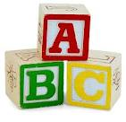](http://www.google.co.uk/imgres?imgurl=http://www.aboundlessworld.com/wp-content/uploads/2009/02/abc_blocks.jpg&imgrefurl=http://www.aboundlessworld.com/the-abcs-of-personal-growth/&usg=__HYBE5DxBfDHoZlHF9k9PCemhvJc=&h=726&w=750&sz=56&hl=en&start=3&zoom=1&tbnid=U9lUig1TtZ2-nM:&tbnh=136&tbnw=141&ei=qjGVT4eqI5Gq8QOw57DODA&prev=/search?q=abc&hl=en&tbm=isch&itbs=1)Children come to our EYC with a wide range of experiences. The EYC staff and parents will work in partnership to provide a suitable curriculum using **‘A Curriculum for Excellence 3 – 18’; ‘Pre-Birth to Three Curriculum’; ‘Building the Ambition’ and ‘Realising the Ambition’** as guidelines. Our practice is also informed by the **‘Health and Social Care Standards’.**

We will offer a wide range of fun and engaging play and activities which enable children to learn effectively. At all times children are encouraged to be successful, self-confident and independent.

Play is at the heart of what we do; we encourage children to learn and develop their skills through play both indoors and outdoors.

In Scotland, our curriculum is defined as the totality of all that is planned for children and young people from early learning and childcare, through school and beyond.

Our curriculum is divided into these main areas:

* Mathematics
* Language – including Literacy and English and Modern Languages
* Health & Wellbeing
* Social Subjects
* Sciences
* Technologies
* Expressive Arts
* Religious and Moral Education

Learning activities are planned in consultation with children, taking into account their previous learning and individual needs.

Staff engage in high quality interactions with the children and seek to enhance the children’s learning through play. Staff observe children daily and take note of achievements and needs of individual children. This information helps inform future planning to support each child’s development. We record each child’s learning and achievements in their profiles – our children call their profiles their ‘Special Books’ – we share these with children and families regularly on an informal and formal basis.

## ICT

In the EYC the children enjoy learning about technology through play. As well as using many interactive toys the children acquire skills through use of the computer, i-Pads and other engaging and interactive forms of technology in the EYC.

## Partnership with Families

Working in partnership with families is our very first priority in Dundonald.

EYC staff are in daily contact with parents / carers and are available to discuss your child’s progress or any concerns you may have.

Throughout the year, there will be the opportunity to be involved in other activities in the life and work of our school community, for example, through Christmas Fayres or by joining us on outings as an adult helper.

EYC news and events is shared via regular newsletters. We value parents / carers comments and we look forward to having the opportunity to discuss ways in which we can enhance our activities in the EYC.



Supporting Children

**WORKING TOGETHER**

If your child requires support with any aspect of his or her learning or development, we are here to help. We work in close partnership with families at all times and we have a child-centred approach to supporting each and every child.

We also work in close partnership with your child’s named person, the Health Visitor, who (for most of our children) is Jenna Sim. Our EYC also has close links with other support services, such as: Speech and Language Therapy; Educational Psychology and Occupational Therapy.

Positive Behaviour

C:\Documents and Settings\sa99sjack\Local Settings\Temporary Internet Files\Content.IE5\0YWY3X0X\MC900423171[1].wmfOur policy in Dundonald Primary and EYC is to promote Positive Behaviour through praise and encouragement. We reinforce good behaviour and children learn to share, take their turn and respect the feelings of others.

## How can I help as a Parent/Carer?

In Dundonald EYC, we are extremely grateful for the support which we receive from families. Parents and carers help by:

* Working in partnership with the EYC to enhance their child’s experience.
* Keeping us up to date with any changes to address, telephone number, email address or medical conditions.
* Informing us if emergency contact number changes.
* Clearly labelling their child’s clothing/footwear.
* Informing us if a child is being collected by another adult.
* Letting us know if their child may be upset by something which has happened at home e.g. death of a pet or illness of a family member.
* Encouraging their child to talk about their experiences at the EYC.
* Using designated entrances for the EYC.
* Encouraging their child to move carefully within the school, to use toilets properly and to respect other people’s belongings.
* Supporting the work of our Parent Council.

**Supporting Your Child’s Learning:**

Parents are the first, and most vital, teacher any child has. Research shows that children do better at School and throughout life when parents take part in their learning.

In Dundonald Primary and EYC, we are committed to working in close partnership with parents.

Our aim is to support parents / carers as their children's first and most important educators by involving them in their children's education and in the full life of the setting.

There are many different ways in which you can support your child’s learning, examples include:

* talking together and sharing a story
* talking to children about how they feel and what they’ve enjoyed learning or exploring
* praising them if they do well
* using numbers in everyday life e.g. counting objects, counting forwards and backwards, telling the time, using money
* encouraging and supporting involvement in groups and activities in the local area

The Scottish Government’s ‘Parentclub’ website contains ideas for games and activities to try with your child. It is packed full of tips and tricks for parents and carers. Please search online for ‘ParentClub Scottish Government’ to access the site.

The Education Scotland website also offers useful resources for supporting your child, including Curriculum for Excellence, ‘Every day's a Learning Day’ and Pre Birth to Three. This can be found at:

<https://education.gov.scot/education-scotland/scottish-education-system/early-learning-and-childcare-elc/>

## Equality

Within our School and EYC, we promote equal opportunities and social justice by aiming to ensure that no child, parent or member of staff receives less favourable treatment than any other on the grounds of race, colour, nationality, ethnic or national origins, religion or disability.

In providing equality of opportunity for all we give consideration to each child and his/her individual circumstances.

In terms of the United Nations Convention on the Rights of the Child (UNCRC) and the national law and policy, our school is committed to respecting children’s rights to have equal opportunities and to be included.

Full account is taken of relevant national and local guidance. The national legislation around equal opportunities and social inclusion includes:

* Children and Young People (Scotland) Act 2014;
* Education (Additional Support for Learning)(Scotland) Act 2004 (as amended 2009) ‘ ASN Act;
* Equality Act 2010;
* Disability Discrimination Act;
* Human Rights Act 1998
* Children (Scotland) Act 1995

## Child Protection

EYC staff provide support to children in their daily activities and have a vital role to help protect them from harm. The School and EYC has a designated Child Protection Co-ordinator, Mrs Kerr, who will co-ordinate the school’s response to concerns for children’s safety and wellbeing.

If you have any concerns about the safety and wellbeing of a child in the EYC, please speak to the EYC staff. All EYC staff take part in regular Child Protection training.



## ANY QUESTIONS?

We hope that the information contained within this guide for families has been helpful.

We hope that you feel reassured that our staff team here in Dundonald has thought carefully about how we safely re-open our EYC.

Please do not hesitate to get in touch with Mrs Paterson, Mrs Kerr, Mrs Street (Early Years Teacher), Miss Macpherson (Senior Early Years Practitioner), or your child’s key worker if you have any concerns or questions. We are all here to help.

## Additional Information/Comments

**SUGGESTIONS AND COMPLAINTS**

At Dundonald EYC, we are committed to maintaining and improving our service. If you have any suggestions to make about the EYC, please contact the EYC staff in the first instance.

Similarly, if you have a complaint about any aspect of the service you should contact Mrs Fiona Paterson, Head Teacher.

If you feel your complaint has not been satisfactorily resolved with the Head Teacher, please contact:

## Visit one of South Ayrshire Council’s Customer Service Centres, or any local office.

* Phone South Ayrshire Council Customer Services Team on 0300 123 0900
* E-mail: [listeningtoyou@south-ayrshire.gov.uk](mailto:listeningtoyou@south-ayrshire.gov.uk)
* Write to: Customer Services, South Ayrshire Council, Freepost NAT 7733, Ayr, KA7 1DR

## Anyone can make a complaint to us, including the representative of someone who is dissatisfied with our service.

If you have a concern (early years and childcare only) and wish to complain to the Care Inspectorate directly, please write to:

Care Inspectorate, Renfrewshire House, Cotton Street, Paisley, PA1 1BF

**PLEASE NOTE**

Although the information in this handbook is correct at the time of printing there could be changes affecting any of the matters dealt with in it, either before your child’s placement begins or during the course of their placement. The head of establishment will tell you of any important changes to the information.

(Information correct at time of print)