DUNDONALD P.S. & EYC – HOME LEARNING – PRIMARY P5
Week beginning Monday 8th February 2021
Literacy
Reading | Spelling | Writing
We are learning to read for enjoyment.  We are learning to extract information from a text. | We are learning to spell singular words and their plurals  (f – ves). | We are learning to write a factual report about a Scottish animal of your choice.
Task:  Choose a book or online text and read for enjoyment for at least 20 minutes each day.  Audible  Audible provides free access to selected children’s books during remote learning. To access Audible, please open Google Chrome then click on the following link: https://stories.audible.com/start-listen  David Wallliams audio stories are available to listen to each day from 11am.  https://www.worldofdavidwalliams.com/elevenses/  Kahoot Challenge  Try this book trivia Kahoot.  Use your name and I will  announce the winner on  Teams.  Game PIN: 08130426  Task – Bug Club  In your home learning pack, you will have a login for Bug Club.  Please read your allocated book and when you see this little bug  Click on it and complete the activity.  *Complete a literacy task from the booklet each day. *  If you are unable to complete your bug club task – please create a character profile from a book of your choice. | Spelling words:  Scan this code QR Code or Click on the link to listen to a spelling rap!  Click Here for Spelling Rap.  Wow Words – knife, knives, loaf, loaves, leaf, leaves, wolf, wolves, shelf, shelves  Cool Connectives – knife, knives, loaf, loaves, leaf, leaves, wolf, wolves, shelf, shelves  Amazing Adjectives –Begin your new words in the spelling booklet in your home learning pack.  Task 1 – Write sentences for your common words.  Task 2 – Choose a spelling task to practice your words each day such as rainbow writing, pyramid writing etc  Ask someone at home to give you a spelling test on Friday and send me your results on teams. | Task: Report Writing  We have made a video of this lesson – to watch it, please click here: Click here for Writing Lesson  Create a report on a Scottish animal of your choice.  Step 1: Research an animal of your choice. Gather facts on this animal. Here are some headings to think of:  - Habitat  - Diet  - Description – size, colour, appearance etc.  - Place in the food chain  - Behaviour  - Basic needs  Step 2: Plan your report and organise your notes. You can use the template in your home learning workbook or create your own.  Step 3: Use your information to write a report on your animal. You may wish to handwrite your report or you can type it up on a word document.  Success criteria:  - Use a title and write an opening paragraph, which informs the reader about your topic.  - Sort your notes into relevant headings and subheadings  - Use factual language  - Include a table, diagram related to your animal  - Write a conclusion- summarising your key points

Numeracy
Mental Arithmetic | Core Numeracy Learning | Mathematics – Additional Challenge
We are learning to calculate mentally with speed and accuracy. | We are learning to round numbers the nearest 10, 100 and 1000. | Task:  Continue to enjoy some countdown practice, this is the website we use in class:  http://happysoft.org.uk/countdown/numgame.php  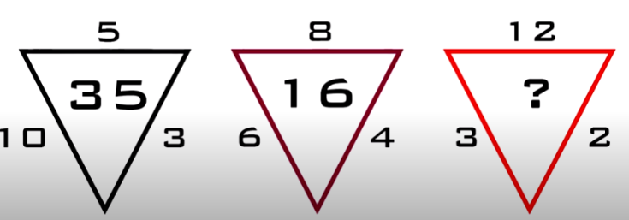
Task:  Log onto Sumdog (use Google Chrome or Firefox to get to the Sumdog website – Sumdog works better with Chrome/Firefox). Play games of your choice for at least 20 minutes, 3 times per week.  Add a Number Talks solution to our class notebook on Teams.  (Class notebook – Collaborative space – Number Talks)  Complete the 6 x Table Numeracy Ninjas each day.  Remember to stick to the 5-minute time limit.  Will you be a Grandmaster? | Task:  Log onto Education City. Complete the activities in the Homework folder. There is a learn screen followed by a game. This game will unlock after you have watched the learn screen.  *Complete a Numeracy task each day from your booklet*  Check the class notebook (Contents Library) for resources to support your learning and for recorded PowerPoints to explain rounding to the nearest 100 and 1000.  Click the links to see a video for these lessons or visit the content library: Click here for Rounding with Mrs Spraggs  Play Rocket Rounding on Topmarks to Practise.  Scan the Qr Code or  Click Here to play.  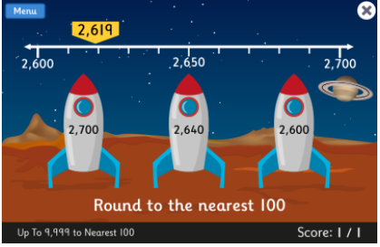

Personal Project: Scottish Wildlife
We are learning about Scottish Wildlife
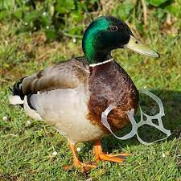
Scottish Wildlife – conservation
Scotland produces 15,000 tonnes of litter a year and sadly, too much of it makes its way into our natural environments. The RSPCA receive around 5,000 calls a year regarding litter and unfortunately, our wildlife are the main victims when it comes to people's rubbish - particularly wild birds.
Activity – Create a Leaflet
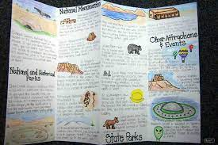
Your task is to create an information leaflet to make people aware of how litter affects local wildlife and what people can do about it.
This leaflet should be bright and colourful, include headings and pictures. This task can be completed on paper or electronically and when finished uploaded to Teams.

Some useful websites for research:
https://www.wikihow.com/Make-a-Brochure-for-a-School-Project
https://www.rspca.org.uk/adviceandwelfare/litter#:~:text=Fishing%20litter%20is%20responsible%20for,the%20local%20wildlife%20and%20environment.
https://scottishwildlifetrust.org.uk/2017/03/know-uk-35-million-plastic-bottles-discarded-everyday/
https://www.forgerecycling.co.uk/blog/how-litter-harms-our-wildlife/#:~:text=Litter%20can%20be%20very%20tempting,their%20heads%20stuck%20inside%20them.&text=However%2C%20wildlife%20can%20become%20trapped,themselves%20on%20the%20sharp%20metal.
https://www.bbc.co.uk/bitesize/topics/zp22pv4
https://www.johnmuirtrust.org/our-work

Nature Photography Challenge
We are very lucky to live an area of with lots of beauty spots because of this lots of TV and Film productions have used this area to film in. Nature is often used in films and animations – to set the scene, add drama and provide characters. See if you can create your own dramatic photographs, using your own minifigures and toys. You could use films like Jurassic Park for inspiration and try to recreate the scenes!
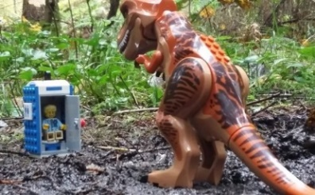

Transient Art
Can you create a piece of art work using things you find outside. Perhaps you could go on a scavenger hunt in the woods or at the beach to collect some natural materials. You could create your artwork here, take a picture and then return the things you have used to their natural environment.

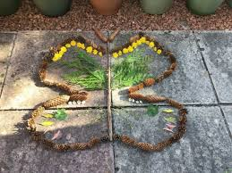
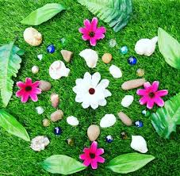

Health and Wellbeing
We are learning the importance of a healthy life style including sleep, the mind and the body.
Sleep

Sleep is very important for both our bodies and our minds. It is extremely important to try to get a good quality sleep every night.
In the current situation, it can be easy to fall out of routine and begin bad habits staying up late during the week and either sleeping in or feeling tired during the day.
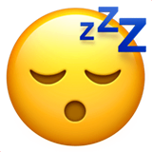
- What makes a good quality sleep?
- How much sleep should you have?
- Does everyone need the same amount of sleep?
- What can you do to ensure a good quality night’s sleep?

Create a mini poster or mind-map that show the answers to these questions.
Try completing the sleep log on the grid to evaluate the quality of your own night’s sleep. Are you getting enough?
Playlist Challenge

Music can help us feel better when we feel anxious, sad, or stressed. Choose 3 songs that are important to you or always help to cheer you up.
Share them on Teams and together we can make a class feel good playlist!

Active

Remember to stay active every day – go outside for a walk or cycle or try one of the links below:
Oti Mabuse Dance YouTube Channel
Click Here for Oti Mabuse Dance

Joe Wicks YouTube Channel
Click Here for Joe Wicks

Youth Sport Trust
Click Here for Youth Sport Trust activities

Sleep Challenge
Day  1 | What time did you go to sleep?  __________ p.m. | What time did you wake up?  __________ a.m. | How many hours of sleep did you get?  _______ hours | On a scale of 1-5 how energised did you feel during the day?
Day  2 | What time did you go to sleep?  __________ p.m. | What time did you wake up?  __________ a.m. | How many hours of sleep did you get?  _______ hours | On a scale of 1-5 how energised did you feel during the day?
Day  3 | What time did you go to sleep?  __________ p.m. | What time did you wake up?  __________ a.m. | How many hours of sleep did you get?  _______ hours | On a scale of 1-5 how energised did you feel during the day?
Day  4 | What time did you go to sleep?  __________ p.m. | What time did you wake up?  __________ a.m. | How many hours of sleep did you get?  ____  hours | On a scale of 1-5 how energised did you feel during the day?
Day  5 | What time did you go to sleep?  __________ p.m. | What time did you wake up?  __________ a.m. | How many hours of sleep did you get?  _______ hours | On a scale of 1-5 how energised did you feel during the day?
How many hours of sleep can you get?

