

Doonfoot Primary School and Early Years Centre

IMPROVEMENT PLAN: 2026-2027

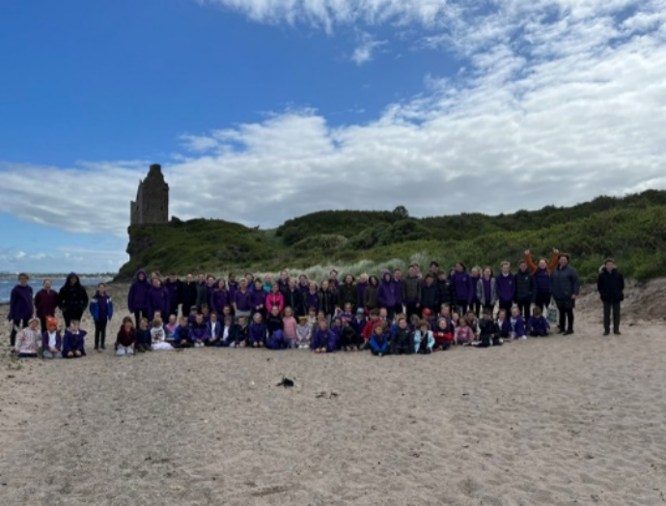
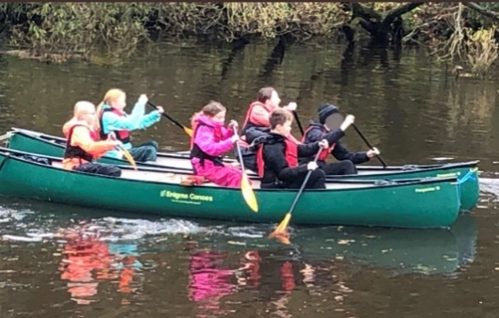
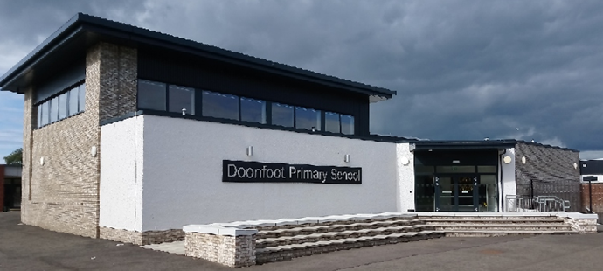

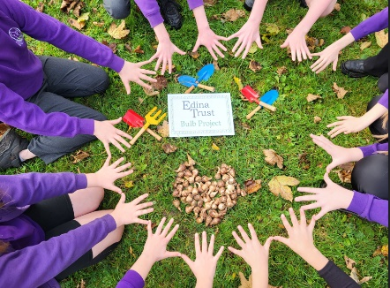







Articles 1, 2, 3, 12, 18, 23, 25, 28, 29, 30, 31

Our vision and ambition in South Ayrshire Educational Services is to achieve excellence and equity. We have the highest expectations for all learners so that they achieve their potential regardless of their circumstances. We want to achieve this in a context where we act with integrity in a climate of mutual trust and respect and have the highest ambition for every learner. It is our ambition to close the attainment gap while constantly stretching and challenging children and young people who are attaining at the highest levels to achieve more. Closing the gap while challenging every learner will guide and define the work of the educational services.
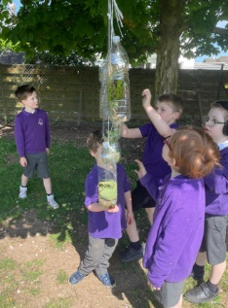
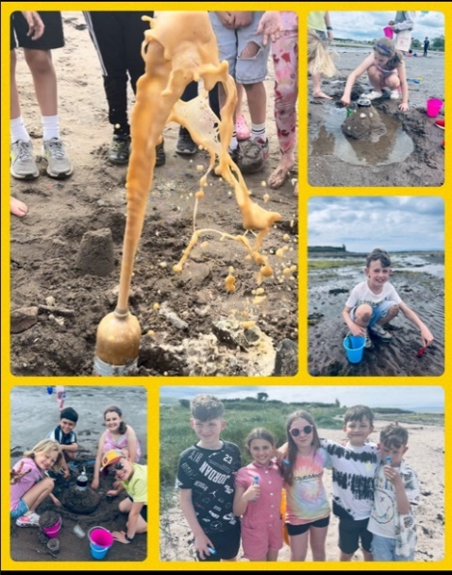
Doonfoot Primary and Early Years Centre Vision and Values

At Doonfoot Primary School we are proud to provide an inclusive, nurturing and stimulating learning environment where our pupils feel valued and inspired to achieve their full potential.

Our unique and stimulating environment provides all learners with the lifelong skills to meet the challenges of the future. Our vision, “Education without walls” demonstrates there are no barriers to our pupils’ learning and the unique setting of our school, beside the beach, Greenan Castle, the River Doon and local parks, allows our pupils to experience a range of outdoor learning opportunities right on our doorstep.

Values

Following consultations with our school community, we continue to embed our school values. We are proud to be part of the Doonfoot community and we expect all within our community to uphold our values at all times:
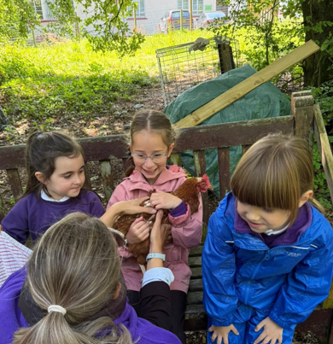
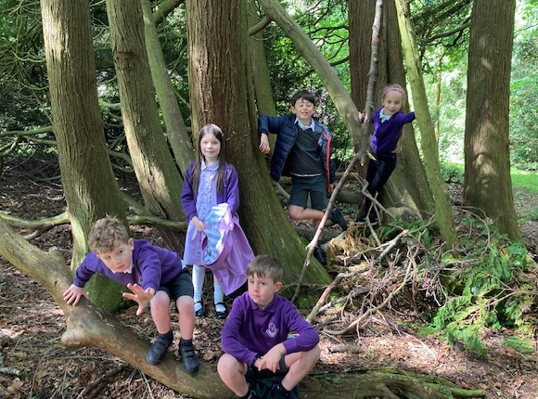
- RESPECT
- HONESTY
- KINDNESS
- INCLUDED
- RESILIENCE

How evidence for our School Improvement Plan was gathered

  - Feedback from HMIE inspection findings
  - Self-evaluation through quality indicators within HGIOS4, HGIOELCC and HGIOURS
  - Annual monitoring calendar
  - Observations of learning and teaching and pupil voice
  - Pupil Committees
  - School Peer Review/Improvement visits
  - Moderation built into planning and assessment processes
  - Monitoring of jotters
  - Pupil Progress meetings to track pupil attainment and interventions for support and challenge
  - Setting of appropriate targets with identified pupils on staged intervention
  - Review of school policies
  - CLPL programmes and feedback
  - Professional review and development/ Professional Update
  - Child, parent, staff and stakeholder surveys
  - Summative and formative assessments
  - Engagement and professional dialogue between staff during meetings
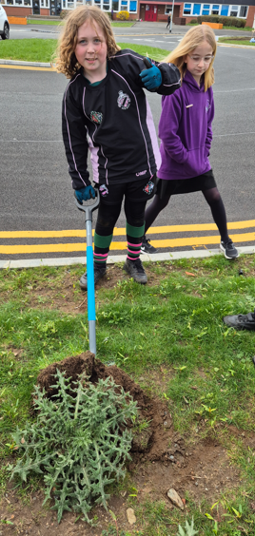
  - Monitoring Pupil Equity Funding, by evaluating progress of interventions
  - Team with The Family Meetings for pupils
  - Evaluation of School Improvement Plan and PEF Action Plan
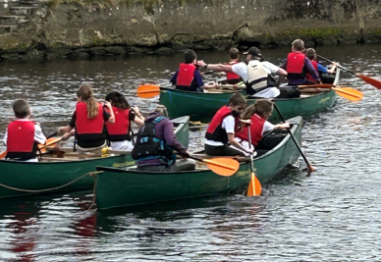
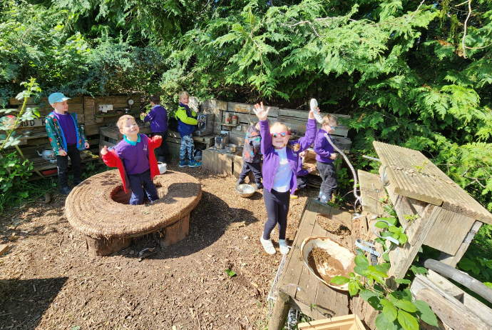
C
South Ayrshire Council Plan

Children's Services Plan
Education Services Priorities

National Improvement Framework Priorities
- Placing the human rights of every child and young person at the centre of education
- Improvement in children and young people’s health and wellbeing
- Closing the attainment gap between the most and least disadvantaged children and young people
- Improvement in employability skills and sustained positive school leaver destinations for all young people
- Improvement in attainment, particularly in literacy and numeracy
- Included, engaged and involved
- Delivering excellence in learning, teaching and assessment
- Transforming our curriculum
- Towards a self-improving education system

- The Promise: Our commitment to Keeping the Promise
- Family: Promoting whole family wellbeing
- Included: Early help for children with diagnosed or undiagnosed additional support needs
- Healthy: Improving physical and mental health for children and young people
- Voice: Involving children and young people in local decision making
- People: Collaborative learning and reflection opportunities for the work force

MAINTENANCE AGENDA 2026/2027
LEARNING AND TEACHING | CFE / RAISING ATTAINMENT | ASSESSMENT AND ACHIEVEMENT | SELF-EVALUATION | CLUSTER | Authority
- AifL strategies  - MTV  - Dyslexia and inclusive practice  - Numeracy- CPA approaches and Number Talks  - Talk 4 Writing  - Communication Friendly Learning Environments | - Adaptive Teaching  - ‘Choose to Improve’ jotters  - Literacy, numeracy and health and wellbeing interventions  - Boost groups  - Attainment tracking | - Staged Intervention- setting, evaluating and recording targets  - Peer/self-assessment  - GL/NSAs  - Assessment and Moderation  - Eco Schools  - RRS Re-accreditation Gold Award  - Dyslexia and Inclusive Practice Award  - Tracking wider achievements | - HGIOS4, HGIOELCC and HGIOURS  - Continued review of learning teaching and assessment policy  - Sharing good practice and further moderation events | - Transition programmes  - Moderation Activities | - The Promise  - South Ayrshire Reads (Year 1)


Priority 1: Authority Priority-Improving Our Curriculum

South Ayrshire Service Plan Priority
Priority 1: Improving Our Curriculum

ALL SOUTH AYRSHIRE SCHOOLS 2025-2026
Aims | Actions | Intended Impact | Resources | Measures | Completion  Date
To increase all teacher understanding of the purpose and relevance of the CIC and the rationale behind curriculum reform. | - The school will identify a curriculum lead to support the implementation of curriculum reform and act as a link with authority-wide developments.  - The curriculum lead will participate in authority Train-the-Trainer professional learning to ensure consistent messaging and build internal capacity.  - All staff will engage in planned CLPL to build understanding of curriculum reform during the two allocated twilight sessions using materials created by Curriculum PTs. | Staff are clear on the key terminology around curriculum and educational reform.  Staff can clearly articulate why curriculum change is being made.  All staff are clear on the national timeline for implementation of the CIC | Presentation created by Curriculum PTs | Staff survey (pre and post twilight sessions)  Evaluation | August 2026  September 2026  January 2027
To provide clear and consistent communication for all staff and stakeholders in relation to Scotland’s Curriculum | - Staff will access the authority’s central digital hub for curriculum resources, exemplars and professional learning materials.  - All staff will attend the relevant authority curriculum conference.  - Content will be created centrally to raise awareness of the CIC and used by schools to engage wider school community.  - The Curriculum PTs will offer support with parental engagement as requested.  - School leadership team will receive regular CIC information via director’s education update.  - All Head Teachers will attend two authority HT Curriculum Conferences. | Staff will feel supported during the early stages of transition.  Staff feel well informed and confident in discussing curriculum changes with colleagues, learners and families.  Parents and stakeholders will better understand Scotland’s curriculum and the future changes. | Central digital padlet  Exemplars and professional learning materials  Schools preferred media platforms | Analytics from shared online space (comments, resources, access to the toolkit and materials | June 2027  May 2027  December 2026  June 2027
To establish an understanding of a concept-based curriculum and to introduce the Know-Do-Understand model. | - ‘Curriculum of Hope’ professional reading distributed during the ‘Train-the-Trainer' session to key leads.  - Values from the ‘Curriculum of Hope’ text shared with all staff during twilight sessions .  - Key leads to gather staff feedback at the beginning of the first twilight.  - Key leads to repeat the staff survey at the end of the second twilight to gauge progress. | All staff understand the principles of a concept-based curriculum.  All staff will have had opportunities to engage with the values and principles of ‘A Curriculum of Hope’. | ‘A Curriculum of Hope’ professional reading  Microsoft form for twilight | Pre/Post Survey Data | October 2026  February 2027

Priority 2: Authority Priority- South Ayrshire Reads


Improvement Planning 2026-2027

Education Services Improvement Plan Priority 2: Outstanding Learning, Teaching and Assessment Educational Services Improvement Plan 2023 - 2027
SAR Strategic Plan Priority: To raise attainment in literacy and to significantly reduce the reading attainment gap between the most and least disadvantaged children and young people in South Ayrshire South Ayrshire Reads Strategy Document
PHASE 3 SOUTH AYRSHIRE SCHOOLS
2026-2027
SAR Strategic Aim | Actions | Intended Impact | Resources | SAR Lead | Completion  Date
To develop confident and skilled readers in South Ayrshire with a lifelong love of reading and the confidence to access all aspects of education, culture and society  To support and develop all education staff in South Ayrshire to implement best practice through a culture of shared knowledge, collaboration and enquiry  To promote the implementation of an excellent reading curriculum which prioritises best practice, challenge and adapted teaching for children with additional support needs  To gather, use and analyse data effectively to drive change and improvement in children’s reading skills, reading confidence and reading attainment | By June 2026, ALL schools will have reviewed the role of their reading leader and, in collaboration with the South Ayrshire Reads team, planned how this role will be used to support reading development over the coming year. | The aims of South Ayrshire Reads are beginning to embed across Phase 3 School Communities  The values, vision and aims of  South Ayrshire Reads  is consistent and clear to all stakeholders | - Role of reading leader reviewed at planning meeting.  - Reading Leader meeting dates shared and agreed.  - Reading leader workshop dates agreed.  - RL MS TEAM accessed for updates, relevant information and collaboration. | SAR PTs | June 2026
 | By June 2027, ALL Phase 3 schools will have participated in at least two Reading Leader-led workshops within their own setting, with Reading Leaders taking full responsibility for identifying workshop needs, planning these sessions and leading them to support the ongoing embedding of reading practice. |  | - All Reading Leaders may attend four sessions (September 2026, November 2026, February 2027, and April 2027) focused on building capacity and providing the knowledge and skills needed to lead impactful change.  - All Reading Leaders will plan, create and deliver reading workshops within their own schools - both with staff and with parents -as part of a wider drive to raise attainment in reading. | LW  Reading Leader | June 2027
 | By June 2027, ALL Phase 3 schools will have had the opportunity to engage in collaborative activity - whether through partnership CLPL, as part of the Phase 3 cohort, or via peer school visits -to strengthen collective efficacy and support an outward-looking approach to improvement. |  | - Bespoke partnership CLPL responsively planned and reviewed in line with contextual needs.  - Meeting & discussion with SLT around peer school visits  - Peer visit pre-workshops/discussion/observation guides | SAR PTs | June 2027
 | By August 2026 Phase 3 schools will work with the SAR Team to identify new or returning staff requiring catch-up support, plan how to close gaps drawing on in-school knowledge, and will have the opportunity to:  - Send staff to ‘Fast Track’ sessions  ensuring all staff are equipped with the knowledge and skills to support reading development effectively. |  | - Meeting & Discussion with Phase 3 schools to identify new/returning members of staff and their stages  - Existing members of staff in Phase 3 schools to support, through coaching, modelling and collaborative discussions  - Fast Track sessions agreed & planned by SAR Team | SAR PTs | August 2026
 | By June 2027 ALL Phase 3 education staff will have had the opportunity to engage in bespoke high-quality CLPL. |  | All CLPL will be based on the Science of Reading and will:  - Deepen existing work on word recognition by adding morphology, positioning phonology, structure and meaning as one connected system  - Move on to language comprehension with an initial focus on the background knowledge and vocabulary strands. | SAR PTs | June 2027
 | By June 2027 ALL Phase 3 education staff will have had the opportunity to engage in additional high-quality CLPL in an area of interest. |  | - Additional online sessions planned, created and delivered by SAR Team in response to need  - Additional sessions will be advertised through the monthly CLPL Bulletin and Reading Leader channel on MS Teams. | SAR Team | June 2027
 | By June 2027 ALL Phase 3 education staff will have had the opportunity to develop their practice in collaboration with the SAR team. |  | - Collaboration activities including workshops and professional discussions as requested | SAR Team | June 2027  June 2027  June 2027  June 2027
 | By June 2027 ALL Phase 3 schools will have had the opportunity to engage with assessment implementation, data analysis and self-evaluation, using HGIOR (How Good is Our Reading) to drive teaching and learning. |  | - Reading Leader- Led Workshops focused on the interpretation, analysis, and evaluation of learner attainment to measure impact and inform next steps.  - Reading Leader-Led Workshops using HGIOR as a self-evaluation tool. | SAR Team | June 2027  June 2027  June 2027  June 2027
 | By June 2027 ALL Phase 3 schools will have had the opportunity to engage with and access support to implement and embed additional related SAR priorities. |  | - Reading Schools Accreditation  - Communication Friendly Environments  - Developing Writing through SAR  - Giglets  - Lending Library | SAR Team | June 2027  June 2027  June 2027  June 2027
 | By June 2027 ALL parents will have had further opportunity to engage with workshops and learning sessions based on supporting their child’s reading development. |  | - Support for RL, as required, from SAR team for workshop and parent events | Reading Leaders | June 2027  June 2027  June 2027  June 2027
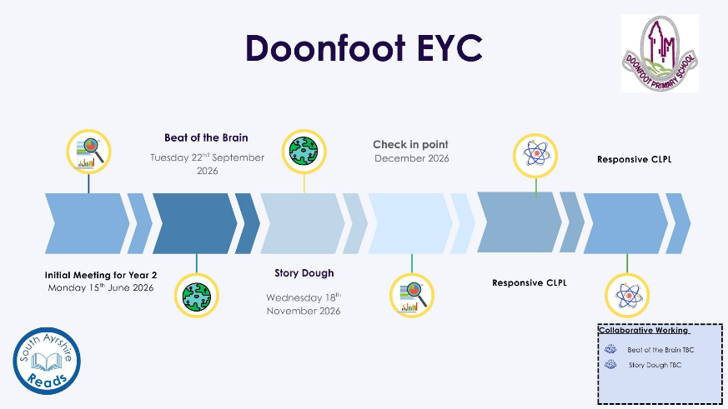

Priority 2 continued: School Priority- Reading

Priority 2: To Raise Attainment in Literacy and significantly reduce the reading attainment gap between the most and least deprived (Reading for Enjoyment and Enhanced Comprehension).

What Outcomes Do We Want To Achieve? | How Will We Achieve This?  (Intervention Strategies) | Lead Person | Start and Finish Dates | How Will We Measure Impact On Children and Young People?  (Include Where Possible Current Measure and Target)
Reading  To encourage a whole school culture of reading for pleasure which will benefit learners’ reading attainment.  To improve attainment levels in reading through a consistent approach to the teaching of reading skills. | Reading for Enjoyment and understanding  - Embed Accelerated Reader across the school to encourage reading for enjoyment and improved comprehension.  - Infant staff to be trained in using Accelerated Reader and how to analyse results of assessments.  - Re-launch assembly for Accelerated Reader and celebration of achievements in reading to be shared weekly at wider achievement assembly.  - Use assessments such as star reader to assess comprehension.  - Giglets to be introduced into all classes to support reading comprehension. | Caroline Keir e | Aug 2026- June 2027 | - STAR assessments will show that almost all pupils have improved their reading age from the baseline assessment.  - Children entitled to PEF funding will improve their reading age by at least 5 additional months in a 4–5-month period.  - The number of children achieving the appropriate band in reading scores in NSAs will increase by 3% in P1, P4 and P7.  - Almost all children in P3 and P6 will achieve a standardised GL reading score of 90 or above.  - Reading motivation questionnaire/survey will show an improvement in scores from baseline.  - Reading attainment will increase by a further 3% from last session for P1,4 and 7 combined.  - Reading achievements will be shared at assemblies and pupils will receive certificates of progress.  - The Reading Committee will ensure the school achieves Reading Schools Accreditation from the Scottish Book Trust and Education Scotland.  - Children will participate in a range of reading activities which encourage motivation to read.  - Staff will demonstrate a greater understanding of reading pedagogy to support their teaching of reading.  - Classroom observations will evidence the positive impact of reading lessons.  - Pupil feedback will demonstrate a wider range of texts available for reading for enjoyment.
 | Reading Schools Award- Journey to Silver  - Staff to take part in CLPL modules around reading for enjoyment (min 2x2hr sessions)  - Staff to engage in the pedagogy and contemporary research around reading for pleasure.  - All staff to attend Book Discovery CLPL to support finding, sharing and funding diverse new books.  - Staff to deliver reading lessons and share good practice across the school.  - Reading committee to continue to take responsibility for the library, provide topic related books and continue to encourage a positive and inclusive reading culture.  - Link with local library and invite librarian in to work with children on reading projects.  - Ensure pupils are able to access a diverse range of books from the dyslexia and inclusion library section.  - Pupils to access the mobile library for a wider range of texts.  - Pupil consultation around the purchase of new books especially for learners requiring further challenge.  - Celebrate Book Week Scotland, World Book Day and Reading Schools Week  - Continue on the journey to becoming a Reading School by gathering evidence towards silver accreditation.  - Classroom observations to be carried out with a focus on reading. | Diane Buchanan

Priority 3: Communication Friendly Interactions and Sensory Informed Practice

Priority 3: To embed consistent, sensory-informed practice across Additional Support Needs schools and provisions (Local Authority ASN priority).

What Outcomes Do We Want To Achieve? | How Will We Achieve This?  (Intervention Strategies) | Lead Person | Start and Finish Dates |  | How Will We Measure Impact On Children and Young People?  (Include Where Possible Current Measure and Target)
South Ayrshire Communication Friendly Environments Project  To improve language and communication skills across the school.  To support the communication of everyone who accesses the school environment. | Use self-evaluation paperwork to evaluate and achieve:  - Supportive Learning Approaches  - Adult Interaction Styles  - Nurturing Communication  - Career-long professional learning  - CLPL for staff around adult interactions and nurturing approaches during Inservice Day to whole staff team.  - Nurturing non-negotiables to be added to classroom monitoring paperwork.  - Meeting with mentor to review evidence.  - Action plan/accreditation provided by local authority  - Communication Friendly Buddy Training will take place for P7 in Term 1 and training for P6 in Term 3.  - Administer Pre and post questionnaire to older buddies.  - Continue with Makaton sign of the week for home and school.  - Makaton choir to perform for whole school events. | Audrey Gray | Aug 2026-  June 2027 |  | - School, Communication Base and EYC will achieve further communication friendly accreditation.  - Over 85% of children in the EYC and communication base will achieve their communication and language, developmental milestones.  - Listening and talking attainment levels across P1,4 and 7 will increase by at least 2% (from 93% to at least 95% by June 2027).  - P6 and 7 pupils will demonstrate an improvement in the pre and post questionnaires linked to buddy training.  - Pupil understanding of communication needs will increase and help build confidence when supporting others.  - School community will be confident in Makaton signing, which will ensure continuation of inclusive practice.
Sensory Informed Practice  - To develop a shared understanding of sensory processing across ASN schools and provisions.  - To strengthen pupils’ sensory regulation, readiness to learn, emotional wellbeing, and engagement, while increasing staff confidence and consistency. | - Adopt the Derbyshire Sensory Toolkit as the shared assessment method.  - Training on sensory processing, the Derbyshire Toolkit, and the impact of sensory needs on learning and behaviour (4 x 1 hour training sessions).  - Use moderation sessions to compare profiles and calibrate understanding. | Inclusion Coordinator  Audrey Gray  Azlan Morrison |  | April 2026-  June 2028 | - Audit visits for each school by ASN QIM, Inclusion Coordinator and peer ASN Leader at start and end of each session. First audit visit carried out with data.  - Monthly discussions with ASN leaders.  - Greater consistency and accuracy in sensory assessments will be shown through:  - moderation outcomes, improved alignment between staff assessments.  - leadership reviews confirming that the Derbyshire Sensory Toolkit is being used reliably across classes and provisions- discussions to take place at monthly ASN Leadership meetings.  - Stage 5 links will develop and will support collegiate working.
 | - Create consistent sensory profile (Derbyshire toolkit)  - Training for school staff on how to carry out sensory assessments which will feed into the profile (Derbyshire Toolkit training).  - Implement, monitor and refine strategies.  - Individual sensory profiles created for identified pupils, including personalised regulation strategies. | ASN Leaders and school staff  Inclusion Coordinator |  | April 26-  June 27 | - Higher-quality and more consistent sensory profiles, evidenced through:  - leadership moderation  - increased staff confidence in carrying out sensory assessments.  - Effective use and refinement of strategies over time, demonstrated through:  - staff feedback  - monitoring feedback  - termly reviews showing that strategies are being applied consistently, adapted appropriately, and leading to better pupil outcomes.
 | - Through staff training on Environmental audits, Communication Friendly Environments and use of sensory equipment, the school will achieve:  - Quiet/calm zones  - Low stimulus corridors  - Visual clutter reduction  - Sensory friendly lighting  - Clear signage  - Shared sensory rooms with consistent expectations and equipment use.  - SCERTs training by Speech and Language Therapists.  - Practical workshops on sensory strategies delivered by Occupational Therapy, Educational Psychology and AOT (movement, tactile, proprioceptive, vestibular, environmental adaptations)  - Shared digital resource folder with templates and sensory strategies.  - Audit tool to be created to measure impact | Inclusion Coordinator  ASN Leads  Autism Outreach  Occupational Therapy  Speech and Language Therapy  Educational Psychologist |  | April 2026-  June 28 | - Environmental audit scores show measurable improvement, with repeated audits (baseline → end-year) demonstrating:  - clearer signage  - reduced visual clutter  - calmer zones  - consistent use of sensory rooms (Audit will be carried out by QIM, Inclusion Coordinator and ASN peer leader)  - Consistency across settings will confirm that sensory strategies and environmental expectations are being applied reliably across classrooms, corridors, and shared spaces. This will be evidenced through:  - leadership monitoring  - peer observations  - case-study reflections
 | - High quality training sessions using a multi-agency approach will be delivered to staff.  - SLT training on SCERTS, Board maker, Visuals. (SLT training programme).  - Whole ASN In-service day based on sensory regulation- multi-agency training with AOT, Educational Psychologist, SLT and OT.  - Regular opportunities for shared practice case studies in the ASN leadership meetings and in schools.  - Embed structured reflection including case study discussions, feedback cycles and collective problem solving. | Inclusion Coordinator  ASN Leaders  School Staff  ASN Inclusion Teams  OT  Ed Psych  SLT |  | April 26-  June 27 | - Staff confidence and competence data will improve over time and will be shown through:  - pre- and post-training surveys self-evaluation tools  - reflective questionnaires completed after joint training and shared-practice sessions.  - Observable changes in practice, such as increased use of sensory informed strategies and greater consistency across staff and settings will be evident through:  - learning walks  - peer observations  - leadership monitoring.
. | - Implement personalised sensory regulation strategies consistently across the day, ensuring pupils have access to the right sensory input, environmental adaptations, and predictable routines that support calm, regulated behaviour  - Use ongoing observation and data (engagement scales, behaviour logs, ABC monitoring, staff feedback) to refine strategies, reduce triggers, and strengthen approaches that increase participation, emotional regulation, and readiness to learn. | ASN Leaders  School Staff |  | Jan 27-  June 28 | - Improved pupil regulation and reduced incidents, shown through:  - decreases in behaviour logs and fewer crisis-driven interventions.  - smoother transitions  - observations of increases in calm, settled behaviour during learning and unstructured times.  - Higher engagement and participation, demonstrated through:  - improved engagement scale scores (Leuven scale or equivalent).  - increased time on task  - positive staff feedback on strategy effectiveness.  - consistent evidence that personalised regulation strategies are being used successfully across the day.

Priority 4- Outdoor Learning, Eco Schools and Digital Learning

Priority 4: To strengthen our curriculum and pedagogy through outdoor learning and digital innovation, ensuring all learners develop the knowledge, skills and values needed to contribute to a sustainable and equitable world.

What Outcomes Do We Want To Achieve? | How Will We Achieve This?  (Intervention Strategies) | Lead Person | Start and Finish Dates | How Will We Measure Impact On Children and Young People?  (Include Where Possible Current Measure and Target)
Outdoor Learning  - To ensure all children will experience regular, high quality outdoor learning that is planned, progressive and clearly linked to the curriculum.  - To effectively use Outdoor environments to raise attainment across the curriculum, particularly in literacy, numeracy and STEM.  - To enable children to build a strong understanding of sustainability and the natural environment, developing respect for their local community and wider world.  - To ensure outdoor experiences promote inclusion and equity. | - Following the pilot with Undersky, staff will utilise the progressive lesson plans for visits to Culzean.  - Create more opportunities for parents to be involved in outdoor learning opportunities.  - Continue with the development of progressive outdoor learning lessons across the EYC and school ensuring the development of all meta-skills.  - Continue with EYC to P1 Outdoor transition project. | Diane Buchanan | August 2026-June 2027 | - Children will experience regular, high quality outdoor learning that is planned, progressive and clearly linked to the curriculum.  - Learners will develop confidence, resilience and independence through opportunities to explore, take managed risks and solve problems in real-life contexts.  - Outdoor learning will support improved engagement and motivation, leading to increased participation and positive attitudes towards learning.  - Children will enhance their health and wellbeing, benefitting from increased physical activity, fresh air and opportunities to manage emotions.  - Children in the EYC will demonstrate a smooth transition into P1 (Staff and parent feedback will confirm this).  - Learners will develop skills for life and work, including teamwork, communication, creativity and critical thinking. This will be evidenced through outdoor learning plans being monitored.  - Outdoor environments will be used effectively to raise attainment across the curriculum, particularly in literacy and STEM.  - Children will build a strong understanding of sustainability and the natural environment, developing respect for their local community and wider world.  - Staff will demonstrate increased confidence and consistency in delivering outdoor learning, using a wide range of approaches and resources (Staff survey).  - Outdoor experiences will promote inclusion and equity, ensuring all learners can access and succeed in different ways.  - Clear progression in skills and experiences will ensure continuity across stages from the EYC to P7, supporting long-term learner development.  - Journey towards achievement of 7th Eco flag.
 | - Refresh of topics for the upper classes:  - P5 - Leaf Zoom (Sci Seedlets)  - P6 - Kite Works (Primary Engineer)  - P7 - Amazing Maize (Sci Seedlets)  - Resources to be sourced and developed for the delivery of the new topics.  - Pupils and staff to maintain the wildflower meadow.  - Clearing and allocating planters in the poly tunnel; EYC, Lower Base, Upper Base, Infant Dept, Upper Dept and for competitions.  - Clearing and revamping the outdoor planters with Gardening Group (small group of children who require active, outdoor nurture opportunities).  - Gardening club/Eco Committee to work in partnership with the Parent Council around the re-development of the school sensory garden.  - Whole school fundraising/grant applications to take place to support the re-development of the sensory garden.  - Development of the Sensory Garden to encourage wildlife and connect learners with ASN to the outdoors.  - General maintenance and development of the school grounds for wildlife.  - Eco committee will set new priorities at the start of the school session following consultation with the new committee.  - Global goals will feature in assembly inputs.  - Collaboration with a parent on Royal Biological Society outreach project within the school grounds | Jenn Cowan  Caroline Keir | August 2026-June 2027
Digital Technology  To enhance pupils learning across the school though the use of digital technology and skills for lifelong learning.  To upskill staff to ensure digital technology is enhancing pupil experiences and adding benefit to their learning.  Enhancing learn | Digital Technology  - CLPL for staff with 20 min Tech Tips Tuesdays.  - A clear progression of digital skills to be developed across each stage of the school with links to IDL topics (e.g. Living in a digital world P4)  - Pupil Digital Leaders to continue to support children across the school.  - Some of the current P6 digital leaders to remain as part of the digital leader team and take responsibility for coding club/digital clubs overseen by Digital Lead.  - Support new P6 pupils towards entering the Lego League.  - Assist all pupils to become more familiar with all the digital equipment that is available for use in the school.  - Ensure all pupils become more familiar with any equipment that is borrowed from the digital lending library.  - The Digital leaders will teach other classes how to use Microbits and extension packs.  - Dyslexic learners to be provided with appropriate digital resources to support learners. | Liz Cairns | August 2026-June 2027 | - Pupil digital leaders will upskill staff and other pupils in the use of digital technology including microbits, coding and Lego spike prime.  - Pupils will have access to a range of digital devices, clubs and competitions.  - Staff will be upskilled in the teaching of digital technology to enhance different areas of the curriculum.  - A clear digital progression will be evident in planning files.  - IDL topics will evidence where digital opportunities can be provided.  - Dyslexic learners will utilise digital tools which will support and improve their attainment in literacy.  - Lego Legue team will achieve success at the Lego league event.

Priority 5: Included, Engaged and Involved Part 1- Improving Attendance in Scottish Schools.

Priority 5: To continue to improve attendance and reduce late coming for all pupils by working in partnership with families and agencies.

What Outcomes Do We Want To Achieve? | How Will We Achieve This?  (Intervention Strategies) | Lead Person | Start and Finish Dates | How Will We Measure Impact On Children and Young People?  (Include Where Possible Current Measure and Target)
To embed a culture where attendance is a core driver of wellbeing, safeguarding and attainment.  To increase overall attendance and reduce late coming across the school.  To improve engagement in learning due to consistent attendance and punctuality. | - All staff will engage with the Scottish Government’s document, Included, Engaged and Involved Part 1.  - Refresh Attendance Policy after consultation with pupils, parents, staff and outside agencies.  - Create QR code for videos of pupils encouraging improved attendance.  - Share the policy with the school community.  - Ensure that both the Early Years Centre and the communication base are appropriately represented within the policy to reflect their context.  - Regularly share attendance messages with the whole school community through assemblies, Parent Council, and online platforms.  - Pupils to create a one page leaflet on the importance of attendance, sharing statistics each month.  - Continue to share supports to improve attendance- e.g. soft starts, hub, sensory, walking bus  - Staged intervention paperwork will be used to reflect attendance targets.  - Staff to become familiar with agreed reduced attendance (ARA) paperwork and the procedures around this. | Kirsten Auld |  | - Consistent understanding of attendance expectations for the whole school community.  - Attendance embedded in inclusion and safeguarding culture and policies.  - Pupil voice will be evident within the new attendance policy.  - Reduction in the number of pupils with attendance dropping below 90%  - Attendance will increase by 1% next session from 93.8% to (94.8%).  - Measurable reduction in late coming across all stages of the school.  - Narrowed gap in attendance between targeted groups and peers.  - Positive feedback from pupils and parents regarding attendance supports.  - Evidence of consistent, effective practice across the school.  - STINT targets and Wellbeing plans will reflect attendance supports being utilised and will show improvement in attendance in a timely manner.  - PEF Plan has a clear focus on attendance for targeted cohort.  - ARA paperwork will be used appropriately if required for anyone with reduced attendance.
 | *See PEF plan for further information on attendance*

Pupil Voice
What Outcomes Do We Want To Achieve? | How Will We Achieve This?  (Intervention Strategies) | Lead Person | Start and Finish Dates | How Will We Measure Impact On Children and Young People?  (Include Where Possible Current Measure and Target)
Pupil Council  To share our school improvement plan in a child friendly and communication friendly version. | - HT to share school improvement plan with Pupil Council.  - Pupil Council to create a child friendly/digital version.  - Pupil Council to share the plan with the Parent Council.  - Create a wall display to evidence the impact of School Improvement Plan.  - Communication crew to create a communication friendly version using boardmaker symbols.  - Use HGIOURS to evidence progress with targets. | Pupil Council/ Elle Gibson/Sarah Flint | Aug 2026– June 2027 | - All children and families will be aware of our school improvement priorities.  - Pupils will lead learning and will share the impact of school improvements with the school community.  - Progress will be evidenced through HGIOURS consultations with pupils.
P7 Ambassadors  To lead areas of school improvement based on pupil interests and suggestions. | - Ambassadors to apply for various roles in the school, including base ambassadors, expressive arts and sports ambassadors.  - Ambassadors and House Captains to carry out pupil surveys of views. | P7 Ambassadors/ Captains/Fraser Baird | Aug 2026– June 2027 | - Pupil ambassadors will evidence their impact on the ‘You said…We did…’ board.  - Pupil consultation will show that pupils feel their views are valued and are acted upon.
Attendance Committee  To improve attendance and late coming across the school. | - Pupil consultation around attendance and late coming to take place at start of session  - Create list of supports that are currently having a positive impact on attendance.  - Create videos on attendance for families.  - Share one page statistics each month with the school community. | Attendance Committee/Kirsten Auld | Aug 2026– June 2027 | - Pupil voice will be evident within the updated attendance policy.  - Attendance will increase by a further 1% next session.  - There will be a clear reduction in late coming across the school on the attendance tracker.  - Supports will be reviewed based on pupil consultation.

PEF Funding
The school continues to receive £31,850 of Pupil Equity Funding this session. This will be used to fund an additional half day per week of the pupil support teacher. Her role will be to oversee the PEF plan and to monitor the delivery of a range of Literacy, Numeracy and HWB interventions and their impact on attainment. She will track attendance and late coming and the impact of the walking bus. We have also allocated additional school assistant hours to support the delivery of targeted literacy, numeracy and HWB interventions. 2.5 hours of school assistant time will be used to support the walking bus to improve pupil attendance, reduce late coming and ensure wellbeing check ins. | Interventions include:  - Nurture  - 5 min box (Literacy and numeracy)  - Nessy spelling  - Toe by Toe/ WordWasp  - Resources for dealing with anxiety and anger  - Access to the Hub and Sensory Room  - Attendance and Late Coming-Walking bus | Kirsten Auld | Aug 2026- June 2027 | Full details on how these interventions will be implemented and measured can be found within our PEF action plan.

