[](https://www.google.co.uk/url?sa=i&url=https%3A%2F%2Fblogs.glowscotland.org.uk%2Fsa%2Fdoonfootprimary%2F&psig=AOvVaw1nJI8ecg16rsnIfbYnTbvT&ust=1629476863442000&source=images&cd=vfe&ved=0CAcQjRxqFwoTCMDc777AvfICFQAAAAAdAAAAABAE)Doonfoot Primary School and EYC

**Promoting Positive Relationships Policy**

We are fortunate at Doonfoot Primary and EYC that we do not experience many instances of negative behaviour. We do however feel it is important to maintain high standards and a consistent approach to promoting positive relationships amongst our school community.

**Our School Values**

Following consultation with our school community our school values are: RESPECT, KINDNESS, HONESTY, INCLUDED and RESILIENCE.

**Examples of Positive Behaviour/Relationships**

* Demonstrating the School Values
* Being Respectful/Good manners- saying please, thank you, holding the door open
* Asking other children to join in a game
* Reacting in a positive way to a situation/making the right choice

**Examples of Positive Behaviour Rewards**

* Verbal Praise
* Class rewards
* House points/tokens
* Stickers/Positive notes/Certificates
* Positive phone call home
* Extra Playtime

**Promoting Positive Relationships**

When a member of staff sees a child modelling one of the school values, the child will receive a coloured house token. This will then be put into their house token jar and converted to points. House Captains will count up the tokens at the end of the week and they will display a running total on the House Board. Each term the winning house will receive a reward.

There will be an extra playtime on a Friday for children who have demonstrated the school values throughout the week.

**Dealing with Negative Behaviours or Relationships**

1. Show Purple “Think about it” card- Encourage the child to think about the situation and to make a positive change
2. Show Yellow Card- Quiet Time Out (next to an adult or a designated area). Encourage the child, for a second time, to reflect and change the behaviour
3. Show Red Card- Child should be sent to speak to a member of the management team

All children who receive a red card will meet with a member of the senior leadership team on a Friday. Conversations should be based on restorative practice and should be conducted away from other children. This is a time to reflect on the negative choice that has been made and to discuss ways to move forward. All conversations should relate to the school value that has not been upheld. All adults should address specific behaviours and not the child.

\**All children should have the opportunity to earn back their cards if they manage to improve their behaviour throughout the week. This allows them the opportunity to earn back their extra playtime\**

**When to use each card:**

Purple Card- first instance of negative behaviour eg. inappropriate language, lack of respect, not following rules or values

Yellow Card- repeats the previous behaviour or escalates behaviour

Red Card- continuing to repeat the behaviour or any form of physical aggression or violence towards another pupil or staff member (eg. Hitting, kicking etc)

*\*Any incident which involves* ***physical aggression*** *towards another child or adult should be reported to SMT* ***immediately*** *and recorded on a pastoral note. This should not wait till the Friday. The parent will be informed by the class teacher or a member of SMT through a phone call or meeting\**

**Equality versus Equity**

We are aware that there are children with additional support needs who require adaptations to this policy. This is done on an individual basis and these children have an individual positive relationship plan which is shared with the pupil, parent/carer and staff.

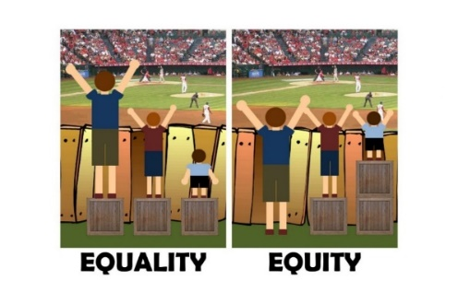The school will continue to reinforce the message of equality versus equity to ensure that all pupils feel incidents have been dealt with fairly.

It is important that all members of staff follow this process to ensure a consistent approach across the school.

Updated: December 2023 in consultation with the children at assembly.