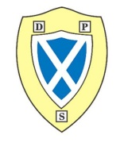
September Newsletter

P2/3D
Highlights
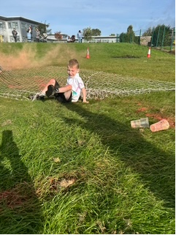
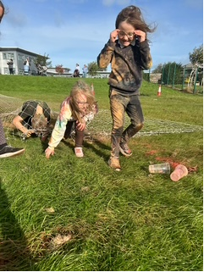
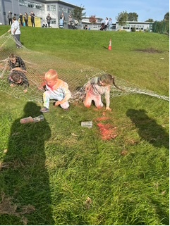
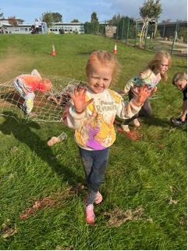
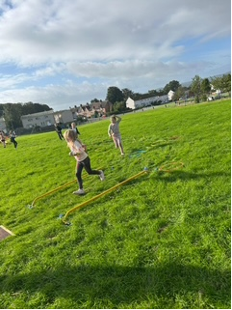

We had a great time at our sponsored colour run! Thank you to the parent council for a fantastic event. 😊
Our Learning
Health and Well -Being
We have been making friends and learning how to be a good friend. We work as a team to follow our rules. We made a class charter using jigsaw pieces.
In PE we have been focusing on team games and fitness.
We have been looking at the zones of regulation and how to identify what zone we are in.
Numeracy
We have been learning about place value and the importance of zero. We are beginning to learn addition and subtraction strategies.
Literacy
We are revising initial sounds and reading/writing CVC words. The new sounds we have learned are sh ch th wh qu ng ee ai and ay. We have also been working on personal and imaginative writing.

Hot Chocolate people for August and September so far have been;
Olivia, Mila, Thomas K, Karter and Corey
We are excited to see who will be next to get it.

Upcoming events
Monday 6th October & Tuesday 7th October – School Photos
Tuesday 7th October – Flu Immunisation
Thursday 30th October – Halloween disco (Afternoon)
Reminder gym is on a Tuesday.
Thank you
Miss Devlin

