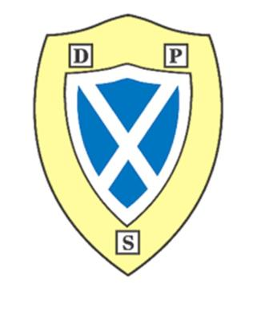
September Newsletter

P1M
Highlights
All children have settled really well into the rules and routines of the P1 classroom. They are engaging well with tasks.

Our Learning- Health and Wellbeing
In class we have been making friends and learning how to be a good friend. We work as a team and follow rules. We made our class charter.

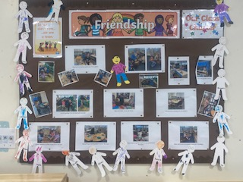
Numeracy- At maths time we have been counting forwards and backwards to 10, learning to write our numbers and counting out these quantities. We enjoyed our work on 2d shape and creating a shape pattern/picture in our jotter. We have been learning to name the 2d shapes.

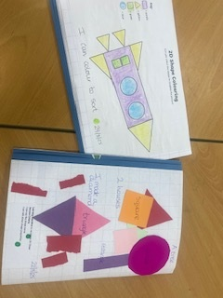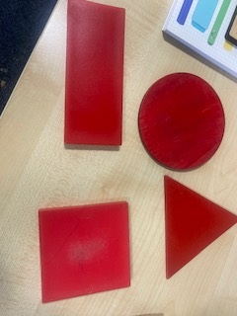

Literacy
At literacy time we are learning lots of new sounds and are enjoying learning the songs and actions that go with each one. These are the sounds we know so far: s,a,t,i,m. We are learning to write these letters and draw objects that begin with each sound.


Hot Chocolate people for August and September have been;
Elise, Nyla and Armani.
We are excited to see who will be next to get it.

Upcoming events
This term we will be looking at our topic of The Sea. We will be learning about the seaside, animals that live there and even pirates.

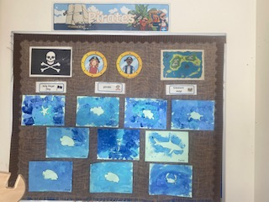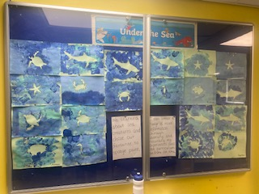

We will have our colour run on Thursday 18th of Sepotember from 2:30 to 2:50pm for P1M and P1/2R pupils. Parents are encouraged to come and support their child and can be taken home after the event from the P3-4 playground.
Reminder gym is on a Friday.

Thanks Miss Melrose

