DALMILLING PRIMARY SCHOOL

CHILD PROTECTION POLICY

February 2024
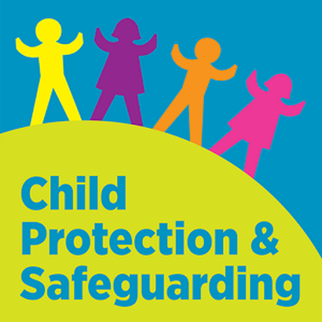

CHILD PROTECTION POLICY

INTRODUCTION
This policy describes responsibilities and expectations for all involved in protecting children in Scotland. This outlines how we should work together with parents, families and communities to prevent harm and to protect children from abuse and neglect.
Dalmilling Primary School actively promotes the welfare and wellbeing of its employees and pupils. This policy provides the framework within which all staff, individually and collectively, can understand their responsibilities in relation to safeguarding/child protection and promoting the welfare of children.

Our policy has been revised in light of Getting it Right for Every Child, the West of Scotland Child Protection Procedures, Commissioner for Children Scotland and the National Guidance for Child Protection in Scotland 2021, all of which highlight the importance of a child-centred, multi-agency approach to meeting the needs of children and young people.

OUR PRINCIPLES
• The welfare of all children is always the primary concern
• Protecting children is everyone’s responsibility
• Every child should be treated as an individual and has a right to a positive sense of identity
• All children have the right to be protected from all forms of abuse, neglect and exploitation
• All children have the right to express their views on matters affecting them

OUR VISION, VALUES AND RULES
Our Child Protection Policy is encompassed within our school vision, values and rules

OUR VISION – Inspire, Engage and Succeed Together

OUR VALUE – We Care

OUR RULES - Ready, Respectful, Safe

POLICY AND LEGISLATION

There have been significant legislative changes affecting children and young people in Scotland, since the introduction of the Children’s Hearing system in the 1960’s, including:

- Getting it Right for Every Child
- Social Work (Scotland) Act 1968
- Children (Scotland) Act 1995
- The Protection of Children and Prevention of Sexual Offences (Scotland) Act 2005
- Commissioner for Children and Young People (Scotland) Act 2003
- Education (Additional Support for Learning) (Scotland) Act 2004/2009
- Children’s Hearings (Scotland) Act 2011
- Children and Young People (Scotland) Act 2014
- Children (Equal Protection from Assault) (Scotland) Act 2019
- The Human Trafficking and Exploitation (Scotland) Act 2015
- Child Exploitation and Protection Online (CEOP)
- United Nations Convention on the Rights of the Child (Incorporation) (Scotland) Act 2021

WHAT IS CHILD PROTECTION?
Child protection is the safeguarding of children from violence, exploitation, abuse, and neglect. Article 19 of the UN Convention on the Rights of the Child provides for the protection of children in and out of the home.

WHAT IS ABUSE AND NEGLECT?
Abuse and neglect are forms of maltreatment. Abuse or neglect may involve inflicting harm or failing to act to prevent harm. Children may be maltreated at home; within a family or peer network; in care placements; institutions or community settings; and in the online and digital environment. Those responsible may be previously unknown or familiar, or in positions of trust. They may be family members. Children may be harmed pre-birth, for instance by domestic abuse of a mother or through parental alcohol and drug use.
- Physical abuse
- Emotional abuse
- Sexual abuse
- Criminal exploitation
- Child trafficking
- Neglect
- Female genital mutilation
- Forced marriage

COLLECTIVE RESPONSIBILITIES

The Health & Wellbeing Across Learning: Responsibilities of All Experiences and Outcomes within Curriculum for Excellence, alongside the GIRFEC wellbeing indicators, summarises how practitioners, pupils, parents and communities must work together in protecting and promoting children's rights, wellbeing and safety. This includes helping children develop in their ability to keep themselves and others safe; and helping them learn how to get help and support if they need it.

All staff will:
- Undergo stringent safe recruitment procedures, including PVG checks
- Have ready access to appropriate, relevant and up-to-date guidance, which tells them what action to take if they are concerned about a child or young person’s wellbeing, welfare and safety
- Be trained to help them understand what, how and when to report and share information to keep children safe, and be able to do so (annually in person and on Coast)
- Be clear that a guarantee of absolute confidentiality cannot ever be given to a child or young person
- Cooperate fully with other partner agencies
- Have appropriate support from Child Protection Coordinators, Named Persons, Lead Professionals and Line Managers, when they are concerned about a child or young person
- Take action to respond to disclosures, allegations, suspicions or incidents of abuse:
- Stay calm and reassuring
- Observe carefully the child or young person’s behaviour and demeanour
- Listen to what the child says without shock or disbelief
- Do not apportion blame, make any suggestions or ask any questions
- Allow the child to talk freely
- A guarantee of secrecy or confidentiality must not be given to the child
- The child must be told that the Child Protection Coordinator (CPC) will have to be informed
- Stress that it was the right thing to tell
- Explain what has to be done next and who has to be told
- Record facts immediately afterwards using the exact words spoken; these should be signed and dated
- Report suspicions or disclosure immediately to the Child Protection Coordinator

CHILD PROTECTION COORDINATORS
The Child Protection Coordinators require appropriate levels of awareness, knowledge and skills within an establishment. These include recognition of neglect, mental health problems, parental alcohol and drug use, under-age sexual activity, child sexual abuse and exploitation, honour-based abuse, forced marriage, female genital mutilation and bullying.
The Child Protection Coordinators (CPC) have both general and particular responsibilities with regard to child protection, including to:
- Record in detail what the staff member has seen and heard and when
- Any signs of physical injury should be described in detail or sketched
- Co-ordinate action within the establishment in relation to specific children about whom concerns have been raised;
- Liaise with other agencies, (e.g. Police, Social Work, Children’s Reporter, Health staff)
- On general issues relating to child protection
- Support investigations, Court proceedings, Children’s Hearings and case referrals or Significant Case Reviews
- Listen and respond to general concerns raised by staff, children, young people and parents or carers in relation to child protection
- Organise staff briefings and training on child protection and wellbeing, for the 'Specific Contact Workforce' in accordance with the National Framework for Child Protection Learning and Development in Scotland, Scottish Government
- Oversee the planning of any curricular provision designed to give children the knowledge and skills to keep themselves safe from all forms of abuse
- Ensure accurate record keeping of all information, related to a child or young person’s wellbeing and protection is carefully recorded using a chronology of significant events, together with relevant documentation
- Ensure child protection files and all confidential sensitive and personal information are securely stored in accordance with up-to-date File Management Guidance and the Data Protection Act 2018 and the General Data Protection Regulation
- Ensure that all child protection chronologies are reviewed at least once every term; and whenever possible, attend all Child Protection, multi-agency meetings and Children’s Hearings or delegate the Named Person to do so
- Even when no formal referral has been made to the Health and Social Care Partnership, education notes should be kept in a confidential record in Pastoral Notes on SEEMiS and if relevant an Ayrshare record created

CONFIDENTIALITY

All staff understand that child protection issues warrant a high level of confidentiality, not only out of respect for the child and staff involved but also to ensure that information being released into the public domain does not compromise evidence. Staff should only discuss concerns with the designated persons or Head Teacher. That person will then decide who else needs to have the information and they will disseminate it on a “need-to-know” basis.

RECORDS AND CHRONOLOGIES

Child Protection (CP), Looked after Child (LAC) or Additional Support Needs (ASN) files must be securely stored separately from a pupil's Educational record (PPR), and clearly labelled on the front as, “Confidential” LAC, ASN or Child Protection' with the child's full name and date of birth. A chronology should be at the front of the file and separate sections should be kept to make for easy access to relevant reports. Should this information require to be shared on a multi-agency basis an AYRShare record should be created. In addition, electronic pastoral notes will be held within SEEMiS.

SCHOOL AND EYC PRECAUTIONS

School Buildings and Playground Security
Our school has secure entry; visitors are required to sign in and out, wear visitor badges, are monitored whilst on the premises and never left alone with children

Break times and lunch times are monitored by staff to keep children safe and monitor any visitors to the school grounds during these times

Intimate/Personal Care
Children’s dignity will be preserved, and a level of privacy given. The normal process of nappy changing should not raise child protection concerns.
There are no regulations that indicate that a second member of staff must be available to supervise the nappy changing process or personal care to ensure that abuse does not occur; however, where possible, we do ask that staff leave doors open or work in pairs to ensure that they do not leave themselves vulnerable.

Volunteers
Any parent or other person/organisation engaged by the school to work in a voluntary capacity with pupils will be subjected to all reasonable vetting procedures and a disclosure undertaken.

Volunteers supporting on school trips need not be disclosed; however, they should not be left unsupervised with children at any time. Volunteers will be subject to the same code of conduct as paid employees of the school.

ALLEGATIONS AGAINST STAFF MEMBERS

Where an allegation is made against a member of staff, it must always be taken seriously, and the principles and procedures outlined in this policy must always be followed:

• The person receiving the allegation must inform their line manager or Child Protection Coordinator, who will inform the Director of Education
• Upon receiving the information, the Director of Education will take any necessary action, which may include informing the Police and Social Work services
• Where the allegation is being made against the line manager, Head Teacher or the Child Protection Coordinator, the member of staff receiving the allegation must directly inform the Director of Education

The Director of Education will advise the Head Teacher or Centre Manager, on any decisions:

• Whether to remove the member of staff from direct access to children and young people
• Suspend the member of staff
• Inform the parents or guardians of the child or young person concerned
• Inform the parents of all children and young people, with whom the member of staff has come into contact and to inform the children’s reporter, where it is known that the child or young person is ‘looked after’ and is alleged to have been abused

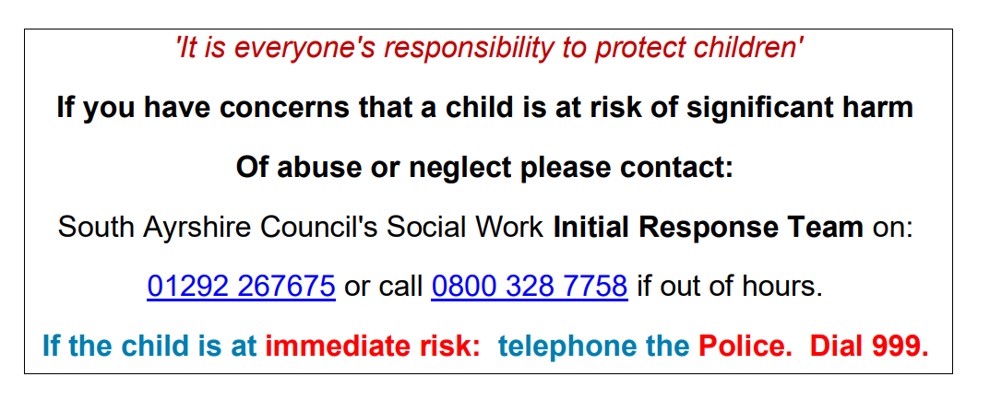

Reviewed in February 2024.
The policy will be reviewed again in August 2024.

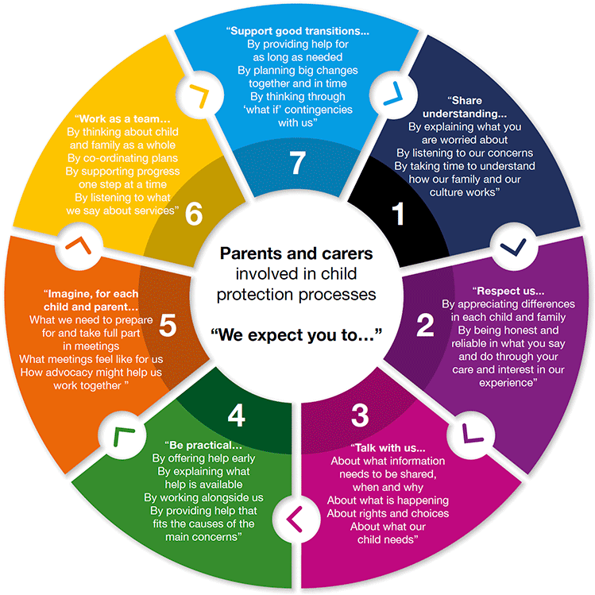
CHILD PROTECTION

