
Family Fun and Learning PEEP sessions for Dailly Early Years Families.
Join me with your wee one and enjoy singing, rhyming and story time as well as carrying out a weekly activity.
The children will love to see you and share this special time with you.
Sessions are open to local 2-year-old children and their parents or carers within the Dailly Community.
Family Fun will be a block of 4 weeks starting on Thursday 6th November to Thursday 27th November

9.15am -10.15m
These sessions will be led by Shevon Moran, I can't wait to see you all
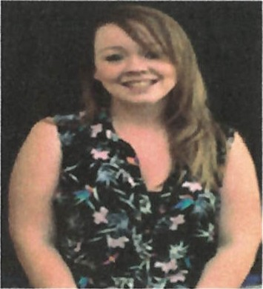
Don't miss out on a chance to have fun with your wee one in their learning environment. Please speak to your child's key worker to add your name to the list.
