Culzean Early Years Centre  Child Protection |  | 
Principles | “We have a responsibility towards keeping children safe from harm” | Realising the Ambition: Being Me, 2020
Principles | I am safe and protected from harm, abuse and neglect. Practitioners caring for me understand their roles and responsibilities in keeping me safe. | SHANARRI –  Safe
Principles | “I am protected from harm, neglect, abuse, bullying and exploitation by people who have a clear understanding of their responsibilities”. | Health and Social Care Standards, 2018
Principles | “Use established processes and procedures to report allegations of harm and challenge and report exploitation and any dangerous, abusive or discriminatory behaviour or practice.” | SSSC Codes of Practice
Principles | Children should not be separated from their parents unless they are not being properly looked after – for example, if a parent hurts or does not take care of a child. Children whose parents don’t live together should stay in contact with both parents unless this might harm the child. | UNCRC,  Article 9
Aims | To ensure that all children at Culzean EYC are:  - Protected from harm and abuse.  - Supported to be successful learners, confident individuals, effective contributors and responsible citizens.  - Enabled to be safe, healthy, achieving, nurtured, active, respected, responsible and included.
Implementation | Child protection is everyone’s concern.  All staff working and supporting education in Culzean EYC must:  - Be aware of arrangements protecting children and adults;  - Be alert to children’s needs;  - Be clear about their own role in ensuring the safety of all.  All staff will:  - Have access to appropriate, relevant and up-to-date guidance, which tells them what action to take if they are concerned about a child or young person’s wellbeing, welfare and safety;  - Be trained to help them understand what, how and when to report and share information to keep children safe;  - Be clear that a guarantee of absolute confidentiality cannot ever be given to a child or young person;  - Co-operate fully with other partner agencies;  - Have appropriate support from Child Protection Co-ordinators, Named Persons, Lead Professionals and Line Managers, when they are concerned about a child or young person;  - Where appropriate attend or provide information to support an inter-agency referral discussion (IRD).  Responding to a concern  Whoever receives the information from the child or other person should:  - Listen carefully, let the child speak.  - Not show disbelief or panic  - Take the allegation seriously, reassure the child and ask how they feel.  - Avoid expressing views on the matter.  - Record facts immediately using the exact words spoken.  - Not guarantee confidentiality, whilst explaining the reasons for this.  - Explain that she/he will have to share this information with the Child Protection Co-ordinator and keep the child or young person informed.  - Not question the child – this is the responsibility of agencies trained to carry out investigative interviews of children. Questions inappropriately phrased could be thought to be suggestive and then lead to evidence being held as inadmissible in possible future court proceedings.  All instances of disclosure should be reported immediately to the Child Protection Coordinator.  If the Child Protection Coordinator is not available, seek advice from the Head Teacher or the Depute Child Protection Coordinator.  Child Protection Coordinators  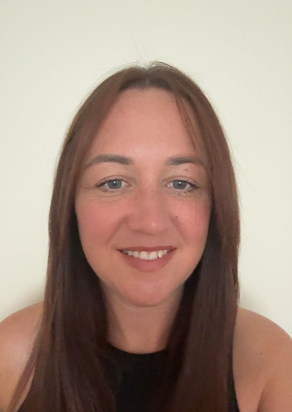    Fiona McDougall Natalie Monteith  Child Protection Coordinator Depute Child Protection Coordinator  The Child Protection Co-ordinator (CPC) at Culzean EYC, has both general and particular responsibilities with regard to child protection, including to:  - Co-ordinate action within the EYC in relation to specific children, about whom concerns have been raised.  - Liaise with other agencies, (e.g. Police, Social Work, Children’s Reporter, Health staff) on general issues relating to child protection.  - Support investigations, Court proceedings, Children’s Hearings and case referrals or Significant Case Reviews.  - Listen and respond to general concerns raised by staff, children, young people and parents or carers in relation to child protection.  - Record in detail what the staff member has seen and heard.  - Organise staff briefings and training on child protection and wellbeing, for the 'Specific Contact Workforce’ in accordance with the National Framework For Child Protection Learning And Development In Scotland Analysis Of Consultation Findings  - Oversee the planning of any curricular provision designed to give children the knowledge and skills to keep themselves safe from all forms of abuse;  - Ensure accurate record keeping of all information, related to a child or young person’s wellbeing and protection is carefully recorded using a chronology of significant events, together with relevant documentation.  - Ensure child protection files and all confidential sensitive and personal information are securely stored in accordance with up-to-date File Management Guidance and the Data Protection Act 2018 and the UK GDPR guidance and resources | ICO  - Ensure that all child protection chronologies are reviewed at least once every term.  - Whenever practicable, attend all Child Protection, multi-agency meetings and Children’s Hearings or delegate the Named Person to do so.  Records and Chronologies  In Culzean EYC, Child Protection (CP), Pupils who are care experienced (LAC) or Additional Support Needs (ASN) files must be securely stored separately from a pupils Educational record (PPR) and clearly labelled on the front as “Confidential” with the child’s full name and date of birth.  A chronology should be at the front of the file and separate sections should be kept making for easy access to relevant reports. The Senior Leadership Team and Guidance staff must ensure a secure, up to date and accurate chronology is kept for all children.  Safeguarding Protocols  The EYC Building  Culzean EYC is a secure building. The main entrance is electronically locked and visitors have to buzz in using the door entry system. Visitors are required to sign in and out at reception. They are also issued with a visitor ID badge that must be worn at all times when they are in the building.  Our Campus Police Officer, PC McGinlay, will regularly patrol the area outside the EYC. She will monitor the interactions of the young people and liaise with local residents and businesses.  Non-Culzean EYC Staff and Volunteers  Any person working with our children will be subject to vetting procedures and a disclosure undertaken.  Technology and Online Safety  Parents and carers must complete a consent form that allows them to consent or to withhold consent for their child to be photographed or videoed. Staff should not use images or videos unless express permission has been sought and obtained. All photographs and videos should be stored securely and deleted when no longer needed.  Child Concern  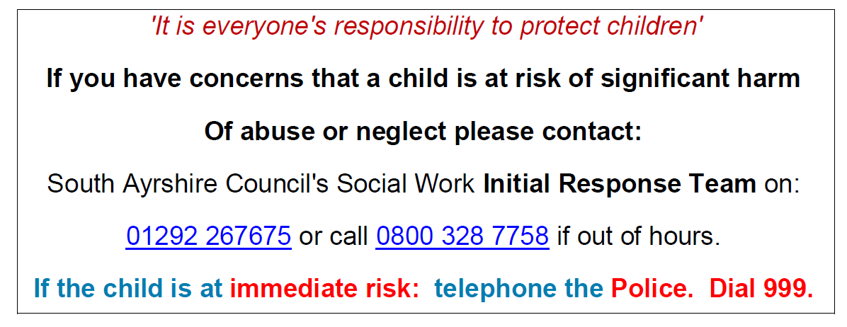  Child Concern Flowchart  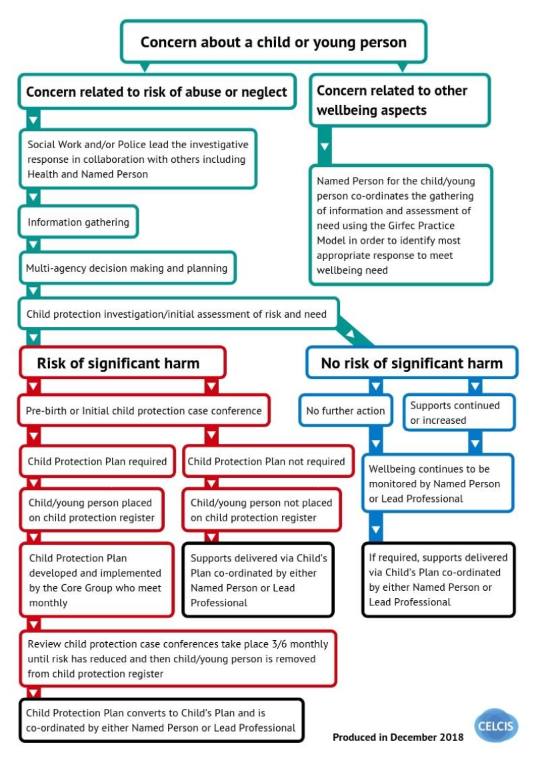
Review | This policy will be reviewed annually or as required in light of experience or any new national/local initiatives. | Date - August 2023
Review |  | Updated – May 2024
Review |  | Updated -October 2025
Review |  | Signed -Natalie Monteith

