Culzean Primary



Child Protection Policy
April 2025

Background
This policy is for all staff working with young people in Culzean Primary. The policy aims to ensure that all children and young people at Culzean are:
- Protected from harm and abuse.
- Supported to be successful learners, confident individuals, effective contributors and responsible citizens.
- Enabled to be safe, healthy, achieving, nurtured, active, respected, responsible and included.
All staff working at Culzean Primary have a duty of care to ensure that all children and young people are safe from abuse, neglect and exploitation, regardless of their role.
Legislation
There have been significant legislative changes affecting children and young people in Scotland, since the introduction of the Children’s Hearing system in the 1960’s, including:

Social Work (Scotland) Act 1968
GIRFEC | Getting it right for every child | Supporting Ayrshire's Young People
Children (Scotland) Act 1995
Commissioner for Children and Young People (Scotland) Act 2003
Education (Additional Support for Learning) (Scotland) Act 2004
Children's Hearings (Scotland) Act 2011
Children and Young People (Scotland) Act 2014
Children (Equal Protection from Assault) (Scotland) Act 2019
Human Trafficking and Exploitation (Scotland) Act 2015
UN Convention on Rights of a Child (UNCRC) - UNICEF UK
MG - Child Protection Safeguarding and Wellbeing - Version 2
What is Child Protection?
“Child protection” means protecting a child or young person from abuse or neglect. Abuse or neglect need not have taken place; it is sufficient for a risk assessment to have identified a likelihood or risk of significant harm from abuse or neglect. Protecting children involves preventing harm and/or the risk of harm from abuse or neglect. Child protection assessments are triggered when the impact of harm is deemed to be significant.

What is abuse and neglect?
Abuse and neglect are forms of maltreatment of a child. Somebody may abuse or neglect a child by inflicting, or by failing to act to prevent significant harm to the child. Children may be maltreated at home; within a family or peer network; in care placements; institutions or community settings; and in the online and digital environment. Those responsible may be previously unknown or familiar, or in positions of trust. They may be family members. Children may be harmed pre-birth, for instance by domestic abuse of a mother or through parental alcohol and drug use.

There are also 4 main definitions of abuse:

- Physical abuse
- Sexual abuse
- Neglect
- Emotional abuse

Collective Responsibilities
Child protection is everyone’s concern.
All staff working and supporting education in Culzean Primary must:
- Be aware of arrangements protecting children and adults;
- Be alert to children’s needs;
- Be clear about their own role in ensuring the safety of all.
All staff will:
- Have ready access to appropriate, relevant and up-to-date guidance, which tells them what action to take if they are concerned about a child or young person’s wellbeing, welfare and safety;
- Be trained to help them understand what, how and when to report and share information to keep children safe;
- Be clear that a guarantee of absolute confidentiality cannot ever be given to a child or young person;
- Co-operate fully with other partner agencies;
- Have appropriate support from Child Protection Co-ordinators, Named Persons, Lead Professionals and Line Managers, when they are concerned about a child or young person;
- Where appropriate attend or provide information to support an inter-agency referral discussion (IRD).

Responding to a concern
Whoever receives the information from the child or other person should:

  - Listen carefully, let the child speak.
  - Not show disbelief or panic
  - Take the allegation seriously, reassure the child and ask how they feel.
  - Avoid expressing views on the matter.
  - Record facts immediately using the exact words spoken.
  - Not guarantee confidentiality, whilst explaining the reasons for this.
  - Explain that she/he will have to share this information with the Child Protection Co-ordinator and keep the child or young person informed.
  - Not question the child – this is the responsibility of agencies trained to carry out investigative interviews of children. Questions inappropriately phrased could be thought to be suggestive and then lead to evidence being held as inadmissible in possible future court proceedings.

All instances of disclosure should be reported immediately to the Child Protection Coordinator.
If the Child Protection Coordinator is not available, seek advice from the Head Teacher or the Depute Child Protection Coordinator.

Child Protection Coordinators
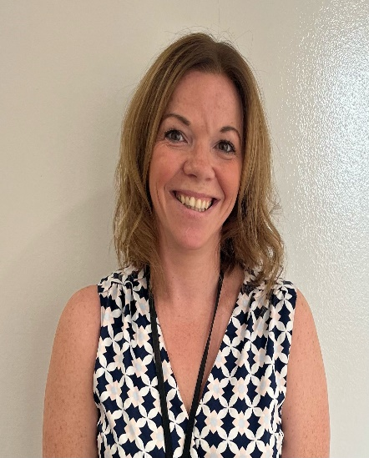


Fiona McDougall Carol Kay
Child Protection Coordinator Depute Child Protection Coordinator

The Child Protection Co-ordinator (CPC) at Culzean, has both general and particular responsibilities with regard to child protection, including to:

- Co-ordinate action within the school in relation to specific children or young people, about whom concerns have been raised.
- Liaise with other agencies, (e.g. Police, Social Work, Children’s Reporter, Health staff) on general issues relating to child protection.
- Support investigations, Court proceedings, Children’s Hearings and case referrals or Significant Case Reviews.
- Listen and respond to general concerns raised by staff, children, young people and parents or carers in relation to child protection.
- Record in detail what the staff member has seen and heard.
- Organise staff briefings and training on child protection and wellbeing, for the 'Specific Contact Workforce’ in accordance with the National Framework For Child Protection Learning And Development In Scotland Analysis Of Consultation Findings
- Oversee the planning of any curricular provision designed to give children and young people, the knowledge and skills to keep themselves safe from all forms of abuse;
- Ensure accurate record keeping of all information, related to a child or young person’s wellbeing and protection is carefully recorded using a chronology of significant events, together with relevant documentation.
- Ensure child protection files and all confidential sensitive and personal information are securely stored in accordance with up-to-date File Management Guidance and the Data Protection Act 2018 and the UK GDPR guidance and resources | ICO
- Ensure that all child protection chronologies are reviewed at least once every term.
- Whenever practicable, attend all Child Protection, multi-agency meetings and Children’s Hearings or delegate the Named Person to do so.

Records and Chronologies

In Culzean Primary, Child Protection (CP), Pupils who are care experienced (LAC) or Additional Support Needs (ASN) files must be securely stored separately from a pupils Educational record (PPR) and clearly labelled on the front as “Confidential” with the child’s full name and date of birth.

A chronology should be at the front of the file and separate sections should be kept making for easy access to relevant reports. The Senior Leadership Team and Guidance staff must ensure an up to date and accurate chronology is kept for all students using electronic pastoral notes within Click & Go. If a child has multi agency involvement, an AYRSHARE record should be created and updated appropriately.

Safeguarding Protocols

The School Building

Culzean Primary is a secure building. All main entrances are electronically locked and visitors have to buzz in using the door entry system. Visitors are required to sign in and out at the main reception. They are also issued with a visitor ID badge that must be worn at all times when they are in the building.

During interval and lunchtime, the social spaces and playground are supervised by members of staff.

Our Campus Police Officer, PC McGinlay, will regularly patrol the area outside the school. She will monitor the interactions of the young people and liaise with local residents and businesses.

Non-Culzean Primary Staff and Volunteers

Any person working with our pupils will be subject to vetting procedures and a disclosure undertaken.

Technology and Online Safety

Parents and carers must complete a consent form that allows them to consent or to withhold consent for their child to be photographed or videoed. Staff should not use images or videos unless express permission has been sought and obtained. All photographs and videos should be stored securely and deleted when no longer needed.

Our pupils are educated on the risks posed by technology to help keep themselves safe. They have regular inputs in HWB and by the campus police officer.

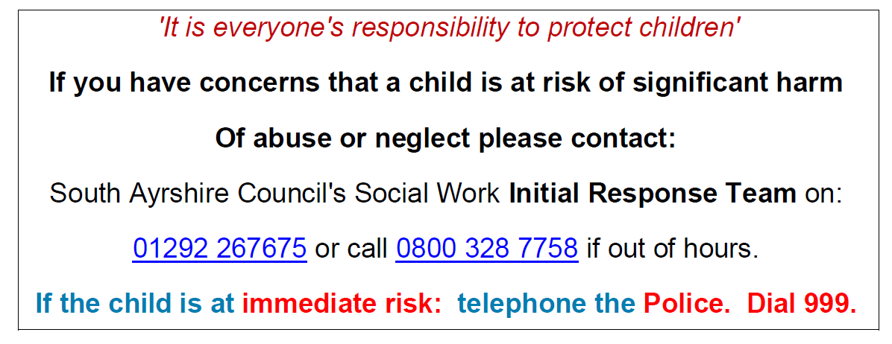

Appendix 1 – Child Protection Concern Form

CHILD PROTECTION - CONCERN FORM
Please use this form to formalise any child protection referral telephone call. A copy should be placed in the child’s file, emailed to the person to whom the referral was made and to the InitialResponseTeam@south-ayrshire.gov.uk and EducationSecure@south-ayrshire.gov.uk

1 |  | Establishment:
 |  | Name of Referrer: |  | Designation:
 |  | Named Person (if known)
 |  | Lead Professional: (if relevant)

2 |  |  | CHILD’S DETAILS
 |  |  | Surname: |  |  |  |  | Date of Birth:
 |  |  | Forename(s)
 |  |  | Address:
 |  |  | Post Code:
 |  |  | Parent/Carer details:
3 |  |  | LINE MANAGER / SOCIAL WORKER INFORMED
 |  |  | Time / Date of Incident / Concern |  |  | Name of Social Worker Contacted:
 |  |  |  |  |  | Time / Date Contacted
 |  |  | Name of Supervisor informed |  |  | Designation of Supervisor Informed of Concern
 |  |  |  |  |  | Time / Date informed
4 |  |  | Suspicion/Risk of: |  | Suspicion/Risk of:  (factors relating to child) |  |  |  | Suspicion/Risk of:  (factors relating to parents/guardians)
 |  |  | Please delete as appropriate |  | Please delete as appropriate |  |  |  | Please delete as appropriate
 |  |  | Physical Abuse | NO/YES | Absconding |  | NO/YES |  | Alcohol Abuse |  |  | NO/YES
 |  |  | Emotional Abuse | NO/YES | Child Safety |  | NO/YES |  | Asylum Seeking/Refugees |  |  | NO/YES
 |  |  | Neglect | NO/YES | Education |  | NO/YES |  | Domestic Abuse |  |  | NO/YES
 |  |  | Sexual Abuse | NO/YES | Emotional Care/Development |  | NO/YES |  | Drug Abuse |  |  | NO/YES
 |  |  |  |  | Health/Illness/ Disability |  | NO/YES |  | Housing/Accommodation |  |  | NO/YES
 |  | Suspicion/Risk of: |  | Suspicion/Risk of:  (factors relating to child) |  | Suspicion/Risk of:  (factors relating to parents/guardians)
 |  |  |  | Physical Care/ Neglect | NO/YES | Mental Illness | NO/YES
 |  |  |  | Self-Harm | NO/YES | Parenting | NO/YES
 |  |  |  | Sexual Exploitation | NO/YES | Physical Illness | NO/YES
 |  |  |  | Offending Behaviour | NO/YES | Poverty/  Financial | NO/YES
 |  |  |  | Substance Misuse | NO/YES | Other (please specify below | NO/YES

DETAILS OF CONCERNS
Please summarise the reasons for the referral

5 |  | ADDITIONAL BACKGROUND INFORMATION
 |  | Please provide a summary of relevant child information, additional risk factors - ASN/ Wellbeing Assessment/ significant chronology details/family circumstances etc.

Appendix 2 – Child Concern Flowchart
