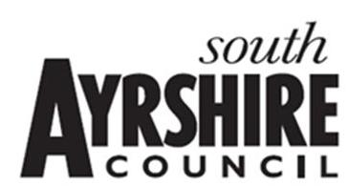

Ballantrae and Colmonell Primary School and Early Years Centres

IMPROVEMENT PLAN: 2022-2023

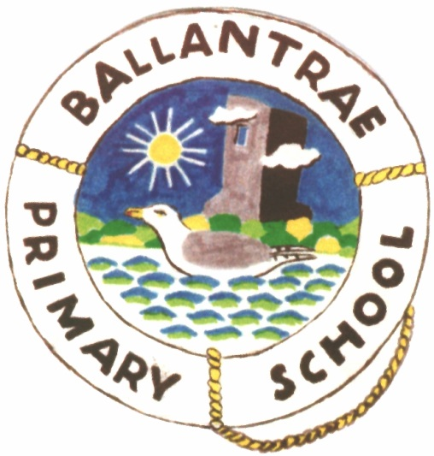
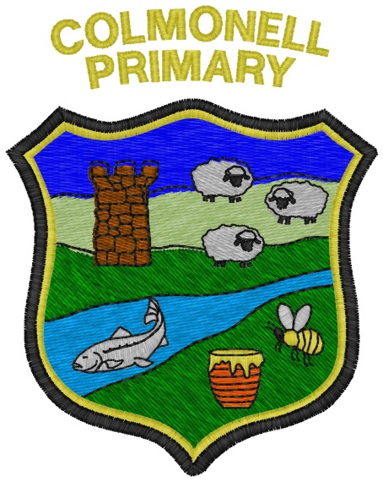

VISION – to be revisited this session

A safe place to be where we are responsible and respectful and have no limits to our learning. (To be updated)

Lifelong Limitless Learning

VALUES – new values as decided by children

Wisdom Compassion Justice Integrity

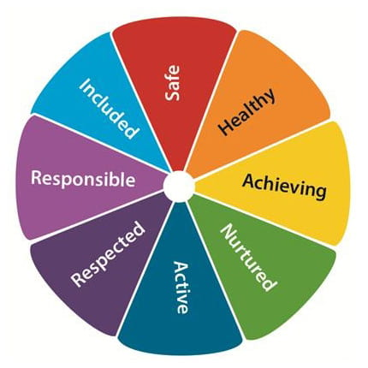

Current Aims – to be re-evaluated this session.

- To create a safe, happy and caring environment where children, staff and parents can work together to ensure that everyone is encouraged to have a voice and is valued as a member of our school community and enable all to become confident individuals.

- To continually encourage and support high standards of personal achievement in all aspects of life, in school and out, fulfilling each child’s individual potential, enabling all to become successful learners.

- To ensure that communication with staff, parents, children and wider community is open and transparent, making regular contact with all through newsletters, school website and involvement in wider community activities and enable all to become effective contributors.

- To nurture our universal health and wellbeing, encouraging positive respectful behaviour in all, to allow everyone to become responsible, global citizens.

- To inspire and support high standards of teaching and learning through continuous self-evaluation of all school work, ensuring all staff are given opportunities to continually develop their skills within a collegiate, cooperative and supportive community.

National Improvement Framework

Rationale for Improvement

Key priorities of the National Improvement Framework
- Placing the human rights and needs of every child and young person at the centre of education √
- Improvement in children and young people’s health and wellbeing √
- Closing the attainment gap between the most and least disadvantaged children and young people √
- Improvement in skills and sustained, positive school-leaver destinations for all young people √
- Improvement in attainment, particularly in literacy and numeracy. √

Our Improvement Plan, this session, focuses on the priorities of the National Improvement Framework first and foremost. Our School Improvement Plan’s priorities, reflect the NIF in the following ways:

School Priority 1 – Children’s Rights – a focus on achieving our Gold RRSA. (NIF Priority 1)
School Priority 2 & 3 – Learning for Sustainability and Curriculum Rationale – (NIF Priority 2 & 4)
School Priority 5 – Curricular Areas – (NIF Priority 5)
PEF – NIF Priority 3

Our whole school evaluation recognises the impact that Covid19 has had on the whole school community. For us, the most significant impact has been on our engagement with parents, families and community, and we consider our re-engagement with our school community as our most significant priority. Our Curriculum Rationale Priority focuses on refreshing “who are we as a school community?” and “what do we represent?” Within this priority, we will refresh our vision, values and aims and consider our school context – what will learning be like for us. Curriculum Rationale will also focus on Pupil Voice and sharing our experiences with parents. We are introducing a new form of digital journaling – Learning Journals – which will allow us to track children’s progress and achievement, in the moment, and be able to share the learning with parents. This is a two way journal, which allows families to share the children’s learning from home too.

Inevitably, linked to this has to be work around Children’s Rights and therefore this has become another significant priority. Colmonell and Ballantrae Primary Schools had both achieved their Silver RRSA and before Covid had begun to work towards the Gold Award. We will revisit what a Rights Respecting School looks like and what we need to do to get there. This also recognises the importance of Children’s Voice. Part of RRSA also included Children’s Agency. This links with our reinstatement of Community Action Groups. These groups allow children to identify a topical environmental/sustainable issue and allow them to campaign in a variety of ways to make a difference.

In terms of curricular areas, our Cluster Improvement will continue to focus on Science. Our schools currently have implemented a base line approach to learning and teaching skills and approaches to science via TAPS activities. Our next step requires us to moderate planning, learning, teaching and assessment within science ensuring consistently high standards of science achievement.

Improvements in literacy and numeracy will focus on those aspects identified from GL assessments as being weaker – spelling and problem solving.

A coherent and progressive skills approach to Art will also be implemented as over the last few years, art has become an ad hoc approach.

Returning to the Quality Indicators in HGIOS 4 and a Quality Framework for Early Level will support regular on-going self-evaluation both in the Primary and in Early Years:

HGIOS 4:

- Leadership and Management: How good is our leadership and approach to
improvement?

- Learning Provision: How good is the quality of care and education we offer?

- Successes and Achievements: How good are we at ensuring the best
possible outcomes for all our learners?

Quality Framework for Early Years:

- How good is our care, play and learning?
- How good is our setting?
- How good is our leadership?
- How good is our staff team?

This School Improvement Plan is part of a three year plan.

Year 1 – Vision, Values, Aims

Year 2 – Learning and Teaching and Assessment

Year 3 – Curriculum

- Children’s Rights

What Outcomes Do We Want To Achieve? | How Will We Achieve This?  (Intervention Strategies) | Start and Finish Dates | Personnel responsible | How Will We Measure Impact On Children and Young People?  (Include Where Possible Current Measure and Target) | January 2023 Review
Children will have:  - Improved self-esteem and wellbeing  - Improved relationships and behaviour (reductions in bullying and exclusions and improved attendance)  - Improved engagement in learning  - Positive attitudes towards diversity in society and the reduction of prejudice  - enhanced moral understanding  - support for global justice  - be more involved in decision-making in schools. | - See attached Rights Respecting School Gold Award Action Plan | August ‘22 – June ‘23 | Principal Teachers  Class Teachers  Support Staff  EYP | Tracking children’s views from wellbeing wheel.  Analysis of wellbeing wheel scores - termly  Evaluation reports from teaching staff on implementation of Rights Respecting School’s Journey.  Termly analysis of bullying/anti-social behaviour incidents in school.  Analysis of pupil questionnaire RRSA  Evaluation of Learning Journals

- Learning for Sustainability

What Outcomes Do We Want To Achieve? | How Will We Achieve This?  (Intervention Strategies) | Start and Finish Dates | Personnel responsible | How Will We Measure Impact On Children and Young People?  (Include Where Possible Current Measure and Target) | January 2023 Review
Children will act on Sustainable Development at a local level.  Children will be equipped with the knowledge, skills and attributes to act more thoughtfully, ethically and responsibly as citizens and contributors of a global society.  Children will become aware of, appreciate and value nature, urban greenspace and wild landscapes  Children’s personal development and health and wellbeing will be enhanced through outdoor experiences.  Early Years Class  Children will have positive outdoor experiences accessing their own outdoor play areas and the natural environment locally.  Children will have:  - Improved physical health  - Improved wellbeing  - Enhanced child development  - Improved connection to nature | - Reinstate Community Action Groups  - Connecting Classrooms Project will continue at a whole school level through links with LfS Scotland and British Council.  - Implementation of Peace Prevails programme within each school will enhance pupils’ ability and confidence to make positive changes.  - The development of a coherent and progressive Whole School Outdoor Learning Programme, incorporating SAC Overview of Outdoor Experiences, will ensure that children will continue to experience regular outdoor learning in their immediate locality and further afield.  - John Muir Award:  Proposal form completed by staff and HT  CLPL through online training opportunities for staff.  Four Challenge Review completed by key members of staff  Certificates requested.  - EYC Outdoor Learning – revisit outdoor learning experiences being offered to our younger children. Staff to revist:  Delivering High Quality Play and Learning Environments outdoors, Care Inspectorate  My World Outdoors, Care Inspectorate  Out to Play, Care Inspectorate.  Staff to develop clear planning and recording of outdoor experiences.  HT to cascade learning from Forest Kindergarten Training to inform EY Outdoor Learning Policy | August ‘22 – June ‘23 | Community Action Groups:  HT, Principal Teachers, Class Teachers, Support Staff  Peace Prevails:  all teaching staff  Outdoor Learning:  HT, Principal Teachers, Teaching staff, support staff and EYP  John Muir Award – Key Staff: HT, Principal Teachers and P4-7 Teachers  EYP and HT | Termly Evaluation of Community Action Group Action Plans  Learning Journals  Analysis of Peace Prevails Programme Evaluation  Termly Evaluation of Outdoor Learning Plans  Analysis of Achievement in John Muir Award  Out to Play – Journal reflection of EYP outdoor learning  Outdoor learning plans  Outdoor learning experiences in Learning Journals

- Curriculum Rationale

What Outcomes Do We Want To Achieve? | How Will We Achieve This?  (Intervention Strategies) | Start and Finish Dates | Personnel responsible | How Will We Measure Impact On Children and Young People?  (Include Where Possible Current Measure and Target) | January 2023 Review
Pupil voice will be enhanced. Children will develop a sense of agency.  Parental voice will inform the rationale of the curriculum and the school.  Leadership at all levels will be integral to the day to day working of the school. | - Review school values and what they mean to us.  - Review current aims – do they still apply?  - Revisit current Rationale for Curriculum for Primary and EY – what still applies? What no longer applies? What needs to be included?  - Create a new and refreshed vision statement for both schools.  - Review rationale for school houses/teams – what purpose do they have, what expectations do pupils and staff have, what responsibility do pupils and staff have; how is team work managed? (Possible link with SDGs, Action Groups, Outdoor Learning, LfS)  - Review role of Parent Council. How can parents become active participants in the life and ethos of the school? What impact does our parental involvement have on attainment and achievement? | August 2022  November 2022  December 2022  January 2023  September 2022 – evaluation and next steps February 2023 | Head Teacher  Principal Teachers  Class Teachers  Support Staff  Pupils  Parents | Monitoring of termly planning and evaluation of Community Action Groups  Feedback from House Captains and Vice Captains  Feedback at staff meetings  Feedback from Parent Council meetings. | Evaluation of Progress at February 2023

Literacy and Numeracy and other Curricular areas
Refresh/Revisit Current Programmes

What Outcomes Do We Want To Achieve? | How Will We Achieve This?  (Intervention Strategies) | Start and Finish Dates | Personnel responsible | How Will We Measure Impact On Children and Young People?  (Include Where Possible Current Measure and Target) | January 2023 Review
Children continue to make very good progress from prior levels of attainment in literacy  Children continue to make very good progress from prior levels of attainment in numeracy  Children will experience high quality learning and teaching in art.  Children will be skilled in art techniques.  Children’s skills and abilities in art will be enhanced, built upon prior learning and through opportunities to experience a progressive and coherent art programme. | Numeracy  - Specific links in maths being made with science development i.e. data handling, graphs etc  - School based CLPL – developing practical maths skills  - Use of GL assessment at all primary stages from P2-7 to identify areas of gaps in learning.  - Practical problem-solving activities to become a feature of mathematical activities.  Literacy  - Review of spelling programme to ensure it is meeting the needs of all learners  - Revisit PM Writing – to ensure coherence, progression and high standards of expectations.  Art – Implement refreshed Art programme from First and Second level | September – November 2022  August 2022 – June 2022 | Principal Teachers  Class Teachers  Support Staff  HT  Class Teachers  Support staff | SNSA analysis of results for P1, P4 and P7  GL analysis of results  Maths and numeracy experiences tracked within Learning Journals  Classroom monitoring visits  Tracking of writing assessment in writing jotters.  Teachers’ review of PM Writing programme  Evaluation of art portfolios.  Evaluation of teacher formative assessment in art.  Classroom observation. | Evaluation of Progress

Appendix

Staff – Ballantrae | Staff - Colmonell
HT – Yvonne Templeton | HT – Yvonne Templeton
PT – Clare Sloan | PT – Peter Low
Early Years Teacher – Michaela Brough | Early Years Teacher – Kimberley MacKintosh
Class Teacher – Marco Sisi
Class Teacher - Natalie Howie | Class Teacher – Rachel McAllister
Class Teacher – Sarah Gregg
EYP – Paula Lorimer | EYP – Louise Shedden
EYP – Bonnie Clark | EYP – Emma Gibson (0.6FTE)
EYP – Yasmin McMillan | Support Staff – Margaret McNeill
EYP – Gillian Baillie (P1/2) PEF | Support Staff – Joel Robertson
Support Staff – Jade McCathie

