Making The Right Choice

Andrea and Julie are in the house and their parents have gone out.
Andrea tells Julie that there are some bottles of beer in the cupboard.
She wants Julie to have a secret drink with her.

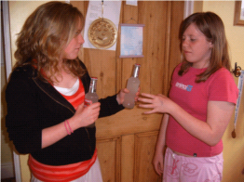

What are the risks involved?
________________________________________________________________________________________________________________________________________________________________________________________________________________________________________________________________________________________________________________________________________________________________

If you were Julie how would you make the right choice?
____________________________________________________________________________________________________________________________________________________________________________________________________________________________________________________________________________________________________________________________________________________________________________________________________________

Name__________________________

