Name . . . . . . . . . . . . . . . . . . . . . . . . Date: . . . . . . . . .

Fractions, Decimals and Percentages

Fill the missing field in the table so that each row contains equivalent values:

Fractions | Decimals | Percentages
 | 0.8
 |  | 24%
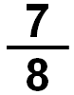
 |  | 45%
 | 0.14
 |  | 5%
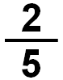
 | 0.02
 |  | 60%
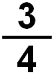
 | 0.94

